**A.**I am a **green frog.**

**B.**I am a **brown horse.**

**C.**I am a **black and white cow.**

**D.**I am a **grey donkey.**

**E.**I am a **yellow and green duck**

**F.**I am a **black sheep.**

**Hayvanlarla cümleleri eşleştiriniz, doğru renklere boyayınız.**

**Verilen cümleler doğruysa “True” (T) ,yanlışsa “False”(F) işaretleyiniz.**

[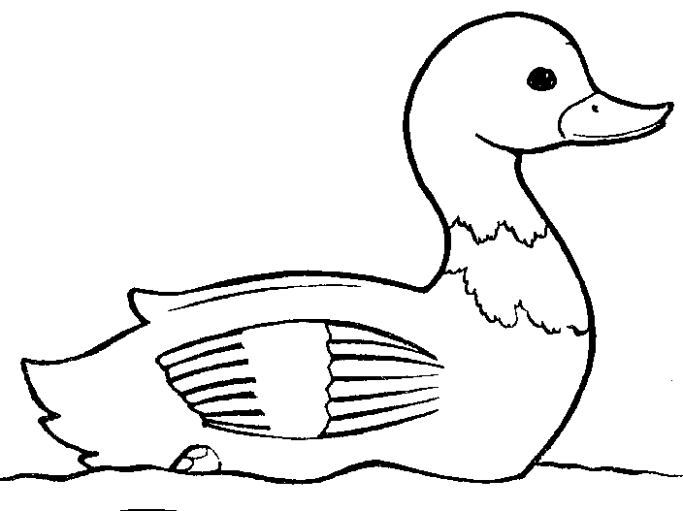](http://bestclipartblog.com/clipart-pics/duck-clip-art-3.gif) 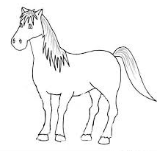 [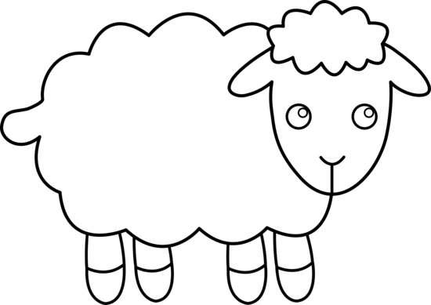](http://sweetclipart.com/multisite/sweetclipart/files/sheep_line_art.png)

[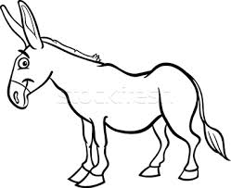](http://www.google.com.tr/url?sa=i&rct=j&q=&esrc=s&frm=1&source=images&cd=&cad=rja&uact=8&docid=69KnA3iP7M_ZkM&tbnid=KsOamRc7Q7Hl0M:&ved=0CAUQjRw&url=http://tr.stockfresh.com/image/2555951/farm-donkey-cartoon-for-coloring-book&ei=0lA-U4O-DMrLPcDVgJgO&psig=AFQjCNHgGx4XGSyL6lgIp8ih07nu_GoixQ&ust=1396679213313215) 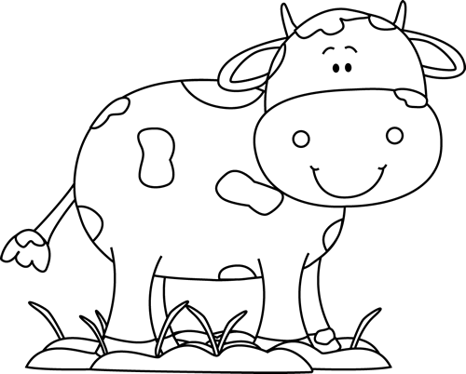

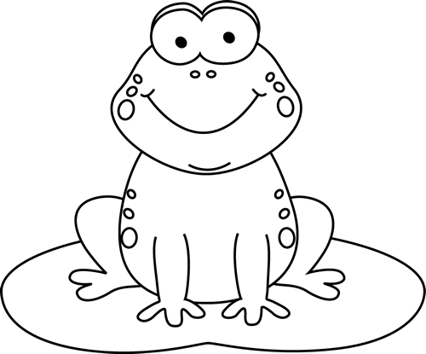

**T**

**F**

**F**

**F**

**F**

**T**

**T**

**T**

1.  This is a **cow.**

2. [](http://bestclipartblog.com/clipart-pics/duck-clip-art-3.gif) This is a **horse.**

3.  This is a **sheep.**

4. 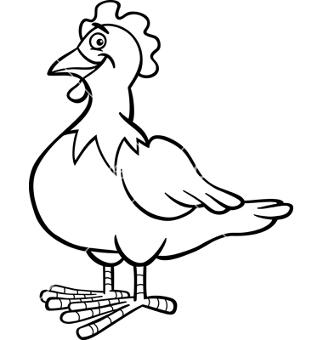 This is a **chicken.**