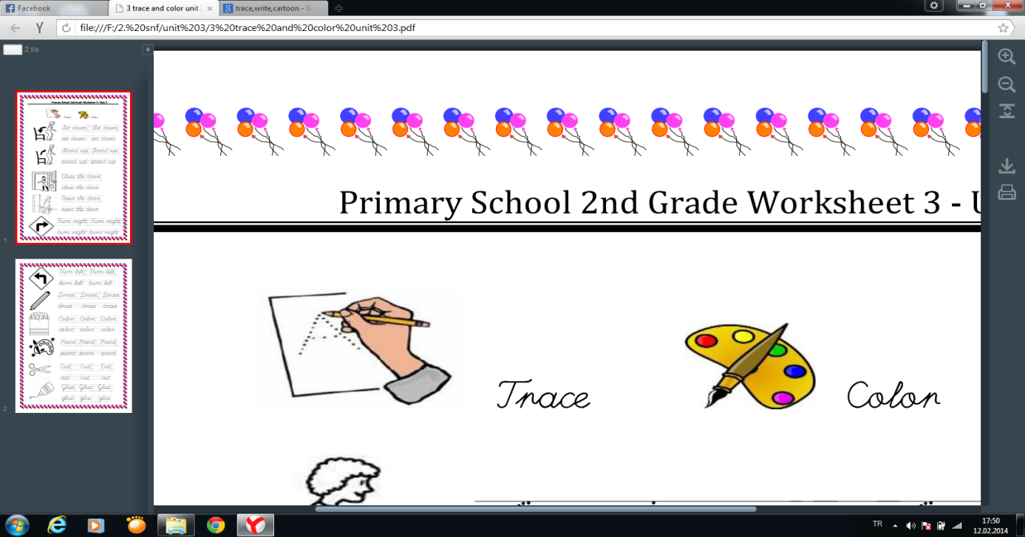

[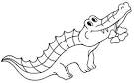](https://www.google.com.tr/url?q=http://www.colorkiddo.com/cute-crocodile-with-flower-coloring-page/&sa=U&ei=dRZRU6CUFrGV7AbBjoCYAw&ved=0CDAQ9QEwAQ&usg=AFQjCNE-bLFlYAQyOGHOLumdAELQ0crRWw)

Crocodile

[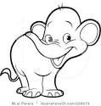](https://www.google.com.tr/url?q=http://www.illustrationsof.com/228073-royalty-free-elephant-clipart-illustration&sa=U&ei=GRlRU5_NCaif7AbgloGgAw&ved=0CEYQ9QEwDDgU&usg=AFQjCNHjA_rM-uZ2Ble5d6ZK7oxIGqOYNw)

Elephant

[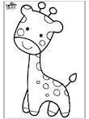](https://www.google.com.tr/url?q=http://funny-pictures.picphotos.net/funnycoloring-com-animals-coloring-pages-zoo-giraffe-3/funnycoloring.com*img*giraffe-3-b4357.jpg/&sa=U&ei=-F1jU6vrDZOW0QXL14GIDQ&ved=0CEwQ9QEwDzgo&usg=AFQjCNFmP03CEPTKPegPYMcbQuBjeC27Og)

Giraffe

[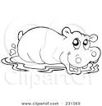](https://www.google.com.tr/url?q=http://www.bestcoloringpages.net/cute-hippo-coloring-pages.html&sa=U&ei=BV9jU4SOKaOI0AWnlYGYBw&ved=0CFIQ9QEwEjgU&usg=AFQjCNFte59Z_2sHZjaSimkry8uOcagWRA)

Hippo

Lion

[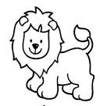](https://www.google.com.tr/url?q=http://pagestocolor.net/506-cute-duck-coloring-pages-for-girls-animals/&sa=U&ei=B2BjU7yqDamx0QW7voHYDA&ved=0CDoQ9QEwBjhk&usg=AFQjCNG2mqqsOpA6t-PYsN-eLdC1A-2Biw)

Monkey

[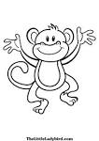](https://www.google.com.tr/url?q=http://printncolor.coolphotos.in/color/tag/monkey-coloring/page/2&sa=U&ei=XE81U53aLuuv7AaWu4DACg&ved=0CEwQ9QEwDw&usg=AFQjCNGNSQJmsyLfDrgZLEaktDAYd4jk2A)

Donkey

[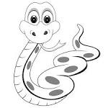](https://www.google.com.tr/url?q=http://coloringpagesactivity.com/snake-coloring-page-wallpaper-hd-download.html&sa=U&ei=5mBjU7POCpD-yAPEroBg&ved=0CEgQ9QEwDQ&usg=AFQjCNF1ZWZ0lkQ_GLRB2BBDabNvc5S06g)

Snake

[](https://www.google.com.tr/url?q=http://coloringpagesactivity.com/snake-coloring-page-wallpaper-hd-download.html&sa=U&ei=5mBjU7POCpD-yAPEroBg&ved=0CEgQ9QEwDQ&usg=AFQjCNF1ZWZ0lkQ_GLRB2BBDabNvc5S06g)

Doğru seçeneği işaretleyiniz.

**1. ** A) monkey B) elephant C) snake **4.**  A) lion B) snake C) crocile



**2. **A) lion B) crocodile C) giraffe **5.** [](https://www.google.com.tr/url?q=http://coloringpagesactivity.com/snake-coloring-page-wallpaper-hd-download.html&sa=U&ei=5mBjU7POCpD-yAPEroBg&ved=0CEgQ9QEwDQ&usg=AFQjCNF1ZWZ0lkQ_GLRB2BBDabNvc5S06g)A) tiger B) snake C)hippo

**3.** Verilenlerden eşleştirmelerden hangisi **6.** Aşağıdaki boşluğa hangisi gelmelidir?

yanlıştır?

a) [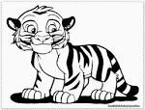](https://www.google.com.tr/url?q=http://www.laptopezine.com/cute-tiger-coloring-pages/&sa=U&ei=YnpjU8aCHa75yAOE3ICwDw&ved=0CEIQ9QEwCg&usg=AFQjCNFemafz07GGgK2hZXU-Y234XQFRqQ) tiger b) [](https://www.google.com.tr/url?q=http://www.bestcoloringpages.net/cute-hippo-coloring-pages.html&sa=U&ei=BV9jU4SOKaOI0AWnlYGYBw&ved=0CFIQ9QEwEjgU&usg=AFQjCNFte59Z_2sHZjaSimkry8uOcagWRA) hippo c) [](https://www.google.com.tr/url?q=http://funny-pictures.picphotos.net/funnycoloring-com-animals-coloring-pages-zoo-giraffe-3/funnycoloring.com*img*giraffe-3-b4357.jpg/&sa=U&ei=-F1jU6vrDZOW0QXL14GIDQ&ved=0CEwQ9QEwDzgo&usg=AFQjCNFmP03CEPTKPegPYMcbQuBjeC27Og)frog a) giraffe b) crocodile c) lion

[](https://www.google.com.tr/url?q=http://funny-pictures.picphotos.net/funnycoloring-com-animals-coloring-pages-zoo-giraffe-3/funnycoloring.com*img*giraffe-3-b4357.jpg/&sa=U&ei=-F1jU6vrDZOW0QXL14GIDQ&ved=0CEwQ9QEwDzgo&usg=AFQjCNFmP03CEPTKPegPYMcbQuBjeC27Og)

Hi! I am a ………………

Tiger

[](https://www.google.com.tr/url?q=http://www.laptopezine.com/cute-tiger-coloring-pages/&sa=U&ei=YnpjU8aCHa75yAOE3ICwDw&ved=0CEIQ9QEwCg&usg=AFQjCNFemafz07GGgK2hZXU-Y234XQFRqQ)