Aşağıdaki noktalı kelimelerin üzerinden gidelim, aynısını altına 2’şer defa yazalım. ☺

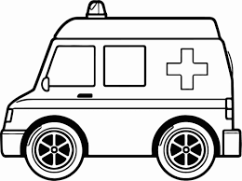 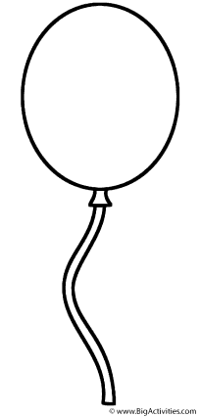 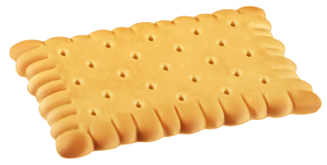

Balloon= balon

…………………………………………………………………………

……………………………………………………………………………

Balloon= balon

…………………………………………………………………………

……………………………………………………………………………

Ambulance= ambulans

……………………………………………………………………………………..

………………………………………………………………………………………

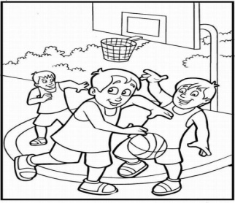 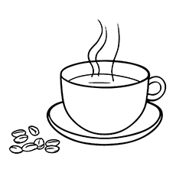 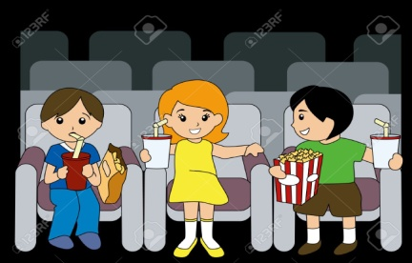

Cinema= sinema

……………………………………………………………………………………..

………………………………………………………………………………………

Coffee= kahve

……………………………………………………………………………………..

………………………………………………………………………………………

Basketball= basketbol

……………………………………………………………………………………..

………………………………………………………………………………………

 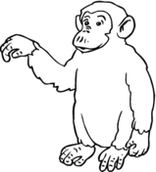 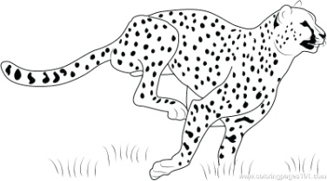

Cheetah= çita

……………………………………………………………………………………..

………………………………………………………………………………………

Chimpanzee= şempanze

……………………………………………………………………………………..

………………………………………………………………………………………

Cake= kek, pasta

……………………………………………………………………………………..

………………………………………………………………………………………

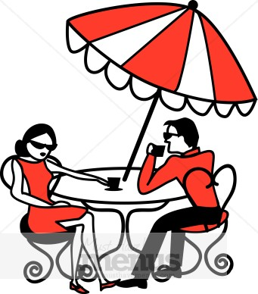 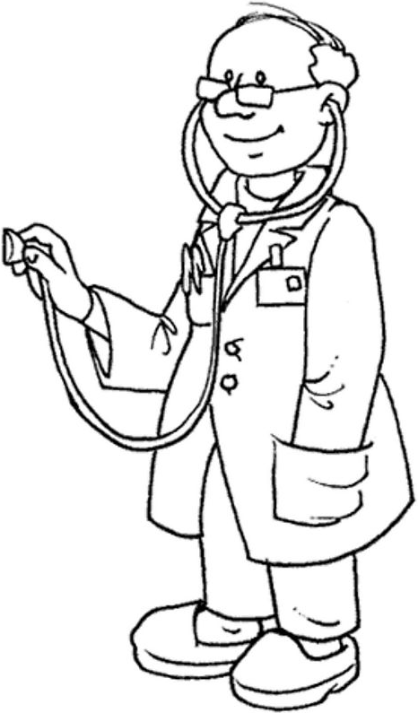 

e-mail= e posta

……………………………………………………………………………………..

………………………………………………………………………………………

Doctor= doktor

……………………………………………………………………………………..

………………………………………………………………………………………

Cafe= kafe

……………………………………………………………………………………..

………………………………………………………………………………………

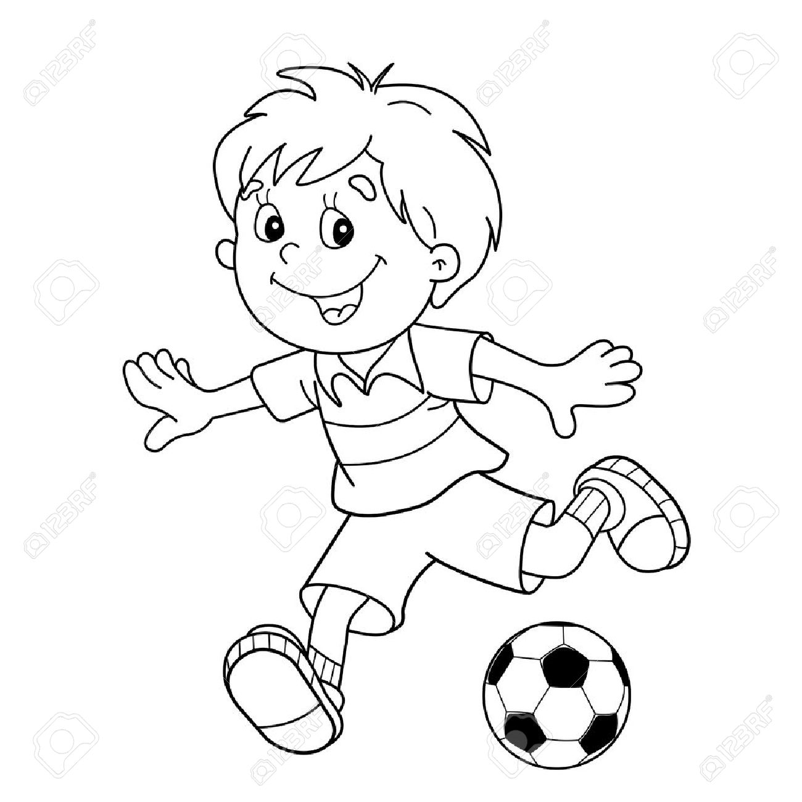 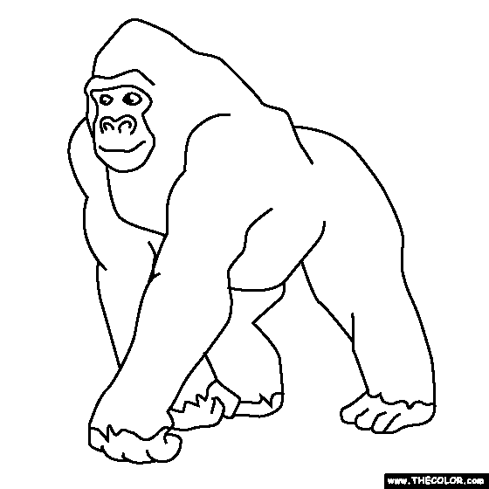 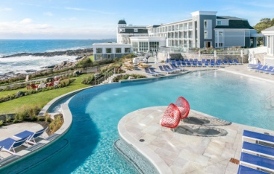

Hotel= otel

……………………………………………………………………………………..

………………………………………………………………………………………

Gorilla= goril

……………………………………………………………………………………..

………………………………………………………………………………………

Football= futbol

……………………………………………………………………………………..

………………………………………………………………………………………

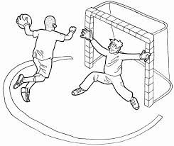 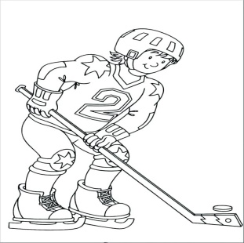 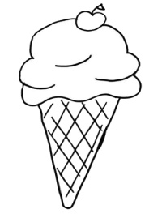

Ice-cream= dondurma

……………………………………………………………………………………..

………………………………………………………………………………………

Hockey= hokey

……………………………………………………………………………………..

………………………………………………………………………………………

Handball= hentbol

……………………………………………………………………………………..

………………………………………………………………………………………

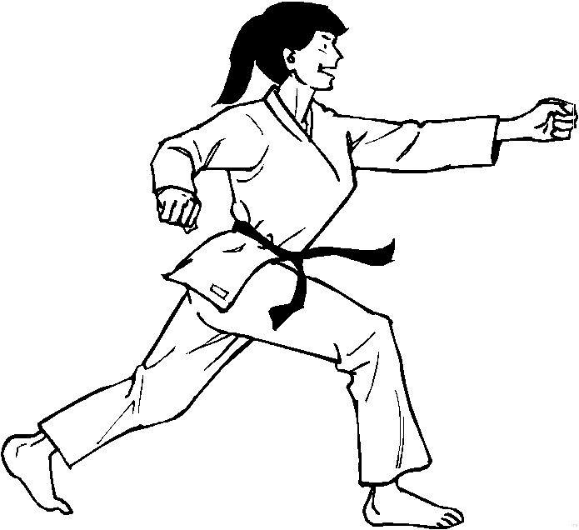 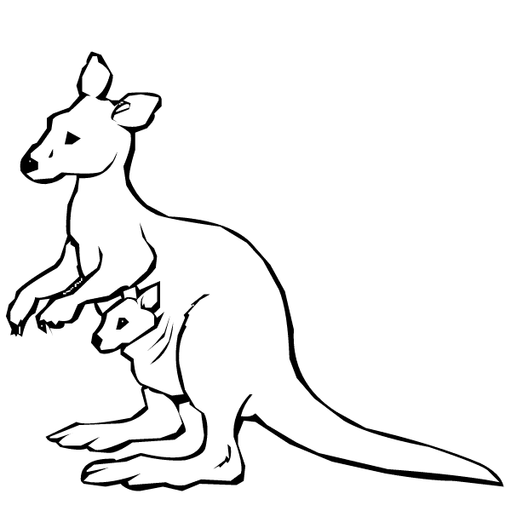 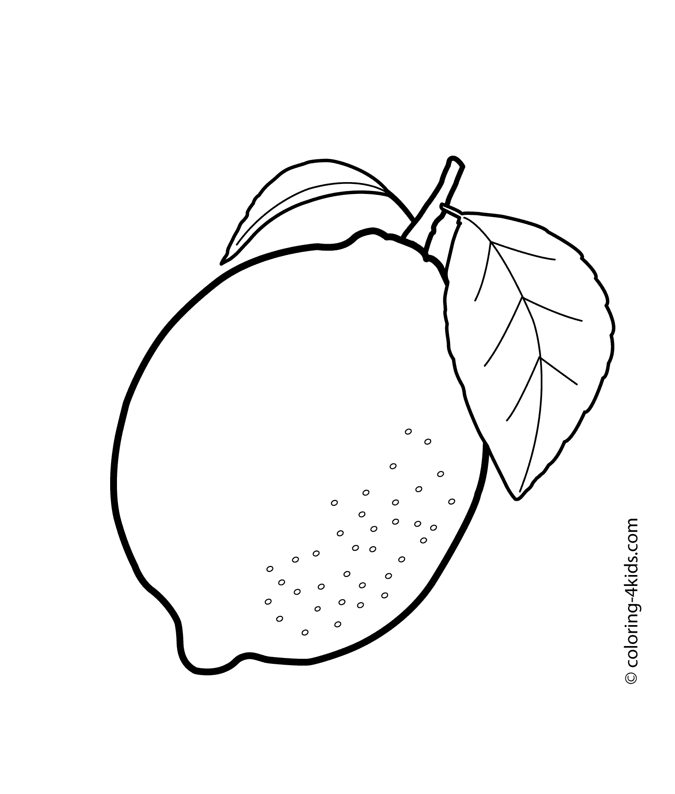

Lemon= limon

……………………………………………………………………………………..

………………………………………………………………………………………

Kangaroo= kanguru

……………………………………………………………………………………..

………………………………………………………………………………………

Judo= judo

……………………………………………………………………………………..

………………………………………………………………………………………

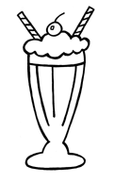 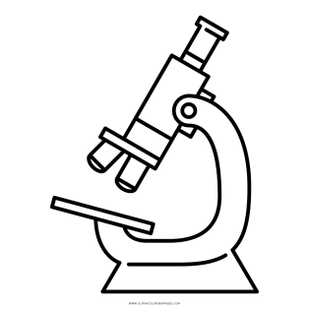 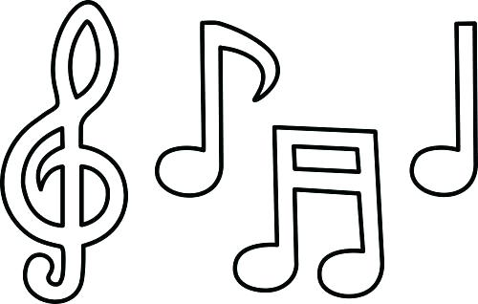

Note= nota

……………………………………………………………………………………..

………………………………………………………………………………………

Microscope= mikroskop

……………………………………………………………………………………..

………………………………………………………………………………………

Milkshake= aromalı süt

……………………………………………………………………………………..

………………………………………………………………………………………

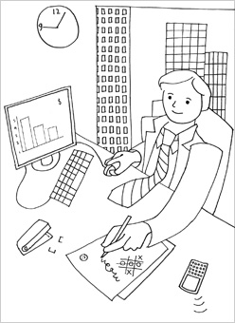 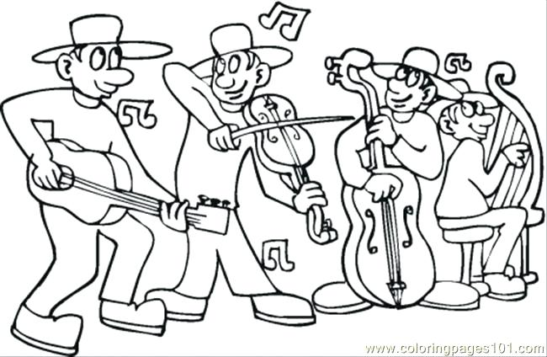 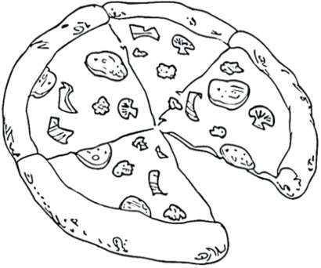

Pizza= pizza

……………………………………………………………………………………..

………………………………………………………………………………………

Orchestra= orkestra

……………………………………………………………………………………..

………………………………………………………………………………………

Office= ofisi iş yeri

……………………………………………………………………………………..

………………………………………………………………………………………

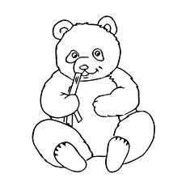 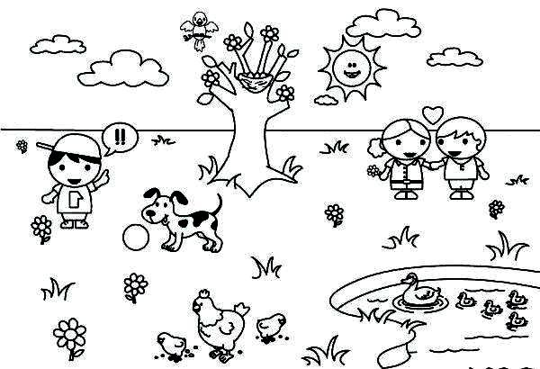 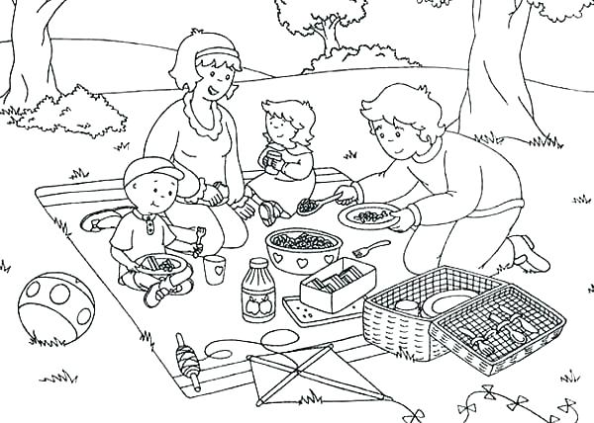

Picnic= picnic

……………………………………………………………………………………..

………………………………………………………………………………………

Park= park

……………………………………………………………………………………..

………………………………………………………………………………………

Panda= panda

……………………………………………………………………………………..

………………………………………………………………………………………

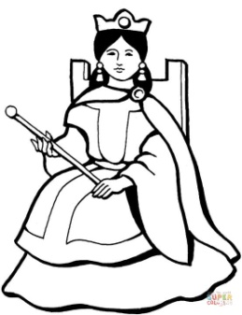 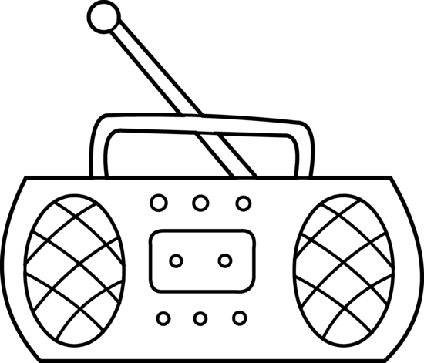 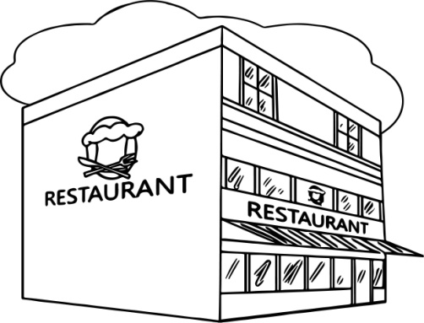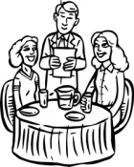

Restaurant= restoran

……………………………………………………………………………………..

………………………………………………………………………………………

Radio= radyo

……………………………………………………………………………………..

………………………………………………………………………………………

Queen= kraliçe

……………………………………………………………………………………..

………………………………………………………………………………………

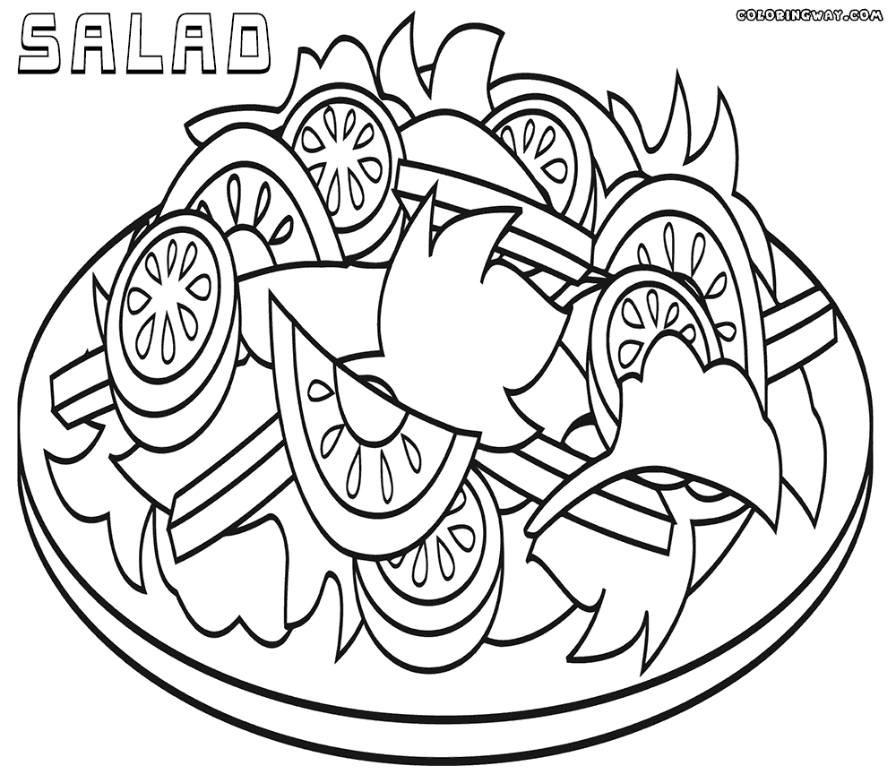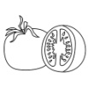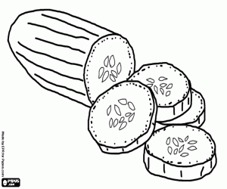 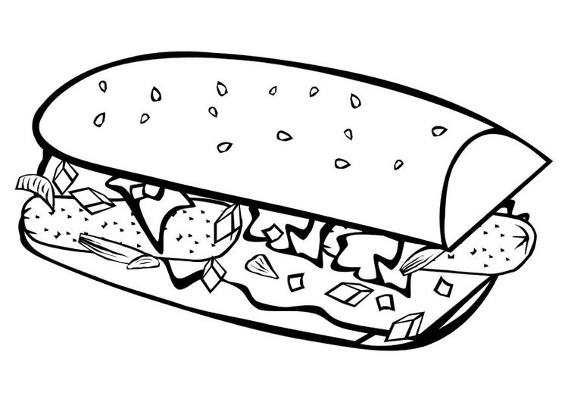 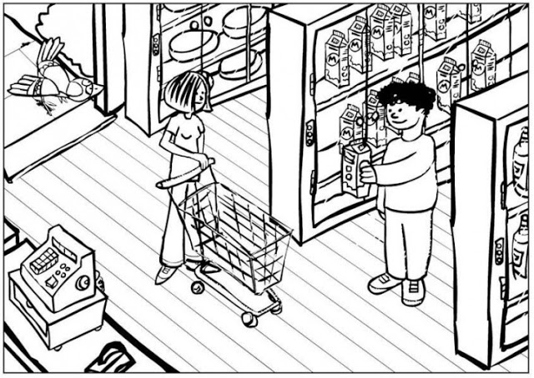

Supermarket= süpermarket

……………………………………………………………………………………………………..

………………………………………………………………………………………………………

Sandwich= sandviç

……………………………………………………………………………………..

………………………………………………………………………………………

Salad= salata

……………………………………………………………………………………..

………………………………………………………………………………………

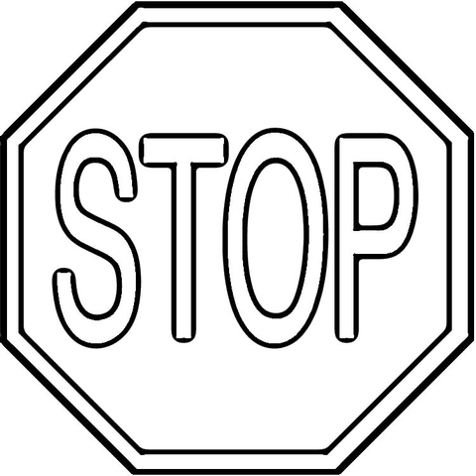 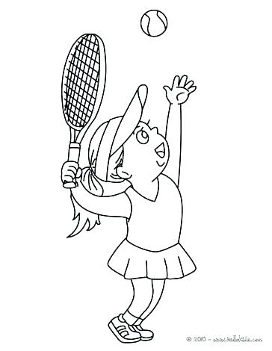 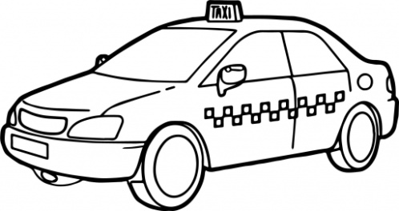

Taxi= taksi

……………………………………………………………………………………..

………………………………………………………………………………………

Tenis= tenis

……………………………………………………………………………………..

………………………………………………………………………………………

Stop= dur

……………………………………………………………………………………..

………………………………………………………………………………………

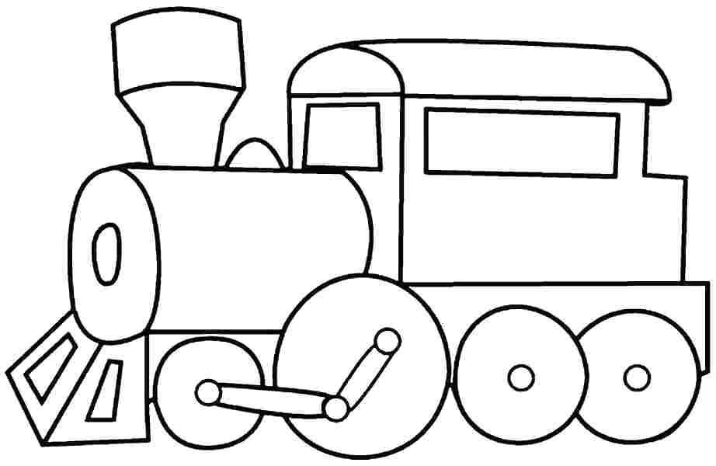 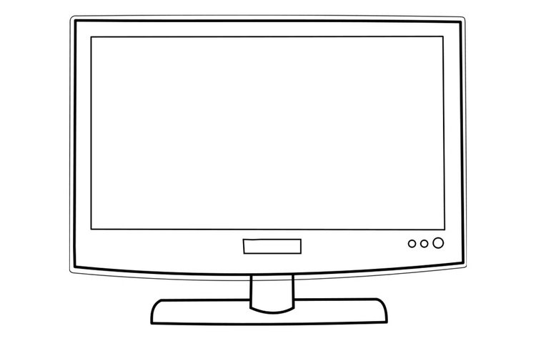 

University= üniversite

……………………………………………………………………………………..

………………………………………………………………………………………

Television= televizyon

……………………………………………………………………………………..

………………………………………………………………………………………

Train= tren

……………………………………………………………………………………..

………………………………………………………………………………………

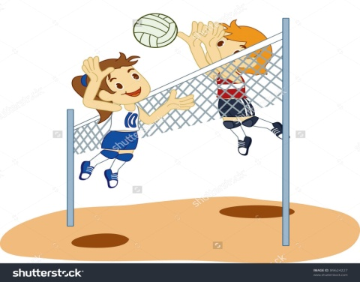 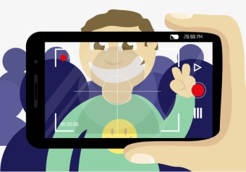 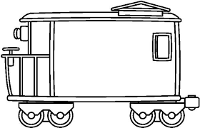

Wagon= vagon

……………………………………………………………………………………..

………………………………………………………………………………………

Video= video

……………………………………………………………………………………..

………………………………………………………………………………………

Volleyball= voleybol

……………………………………………………………………………………..

………………………………………………………………………………………

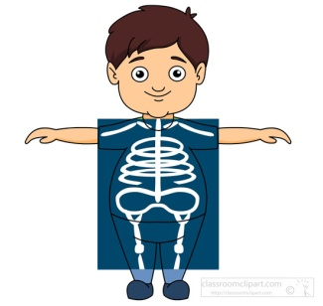 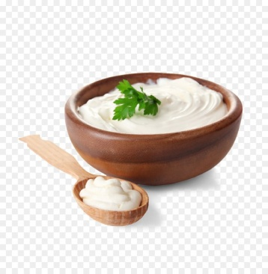 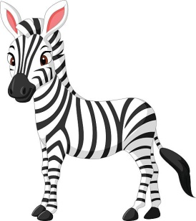

Zebra= zebra

……………………………………………………………………………………..

………………………………………………………………………………………

Yoghurt= yoğurt

……………………………………………………………………………………..

………………………………………………………………………………………

x-ray= röntgen

……………………………………………………………………………………..

………………………………………………………………………………………