**What is your name?** My name is____________________

**Colour and match (boya ve eşleştir)**

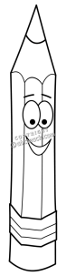

|  |  |
| --- | --- |
| 1.book | blue |
| 2. pencil | red |
| 3. computer | green |
| 4.rubber | purple |
| 5. sharpener | yellow |
| 6. crayons | pink |
| 7. notebook | black |
| 8. schoolbag | grey |
| 9. ruler | orange |
| 10. glue | brown |

