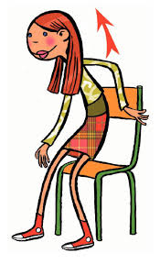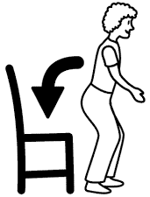

MATCHING 

**1**

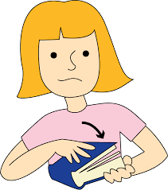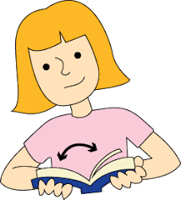

**2**

**3**

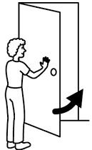

**4**

**5**

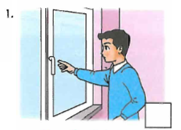

**6**

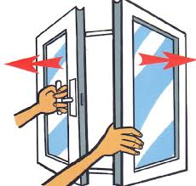

7

**8**



**9**



**10**

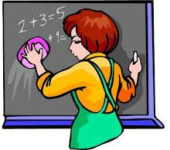

**11**

**12**

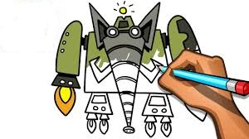



**13**

**14**

**Look-read and circle**

a) pencil

**1**

b) book



c) eraser

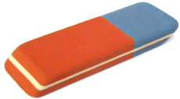

a) Eraser

**2**

b) Notebook

c ) Desk



a) Paper

**3**

b) Ruler

c) Schoolbag

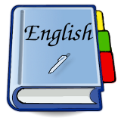

a) Book

**4**

b) Sharpener

c) Table

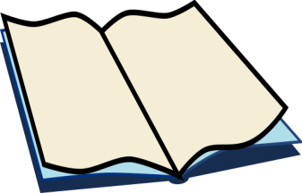

a) Notebook

**5**

b) Crayon

c) Pencilcase

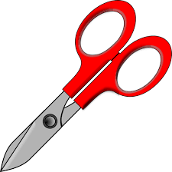

a) Scissors

**6**

b) Pen

c) Eraser

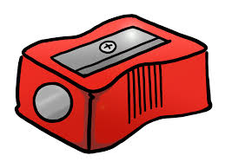

a) Sharpener

**7**

b) Whiteboard

c) Ruler

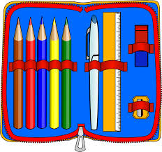

a) Pencilcase

**8**

b) Pencil

c) Pen

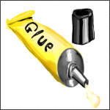

a) Glue

**9**

b) Book

c) Desk

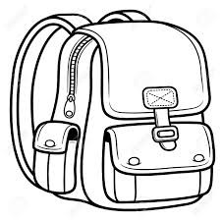

a) Schoolbag

**10**

b) Ruler

c) Table

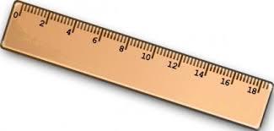

a) Ruler

**11**

b) Eraser

c) Paper

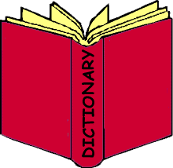

a) Book

**12**

b) Notebook

c) Dictionary

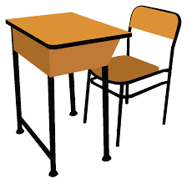

a) Desk

**13**

b) Book

c) Glue

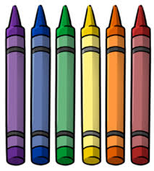

a) Crayon

**14**

b) Scissors

c) Pencil

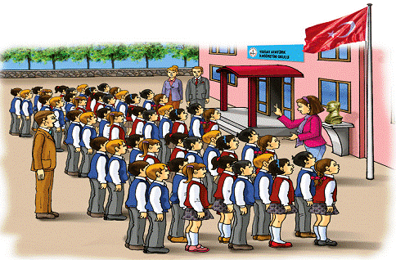

a) School

**15**

b) Desk

c) Table

 a) Whiteboard

**16**

b) Ruler

c) Pencilcase

[www.eegitimim.com](http://www.eegitimim.com/)