TEST
1. A. CAKE B. MILK C. STAR D. READ
2.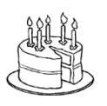 A. CAKE B. MOTORCYCLE C. COLOR D. STAR
3.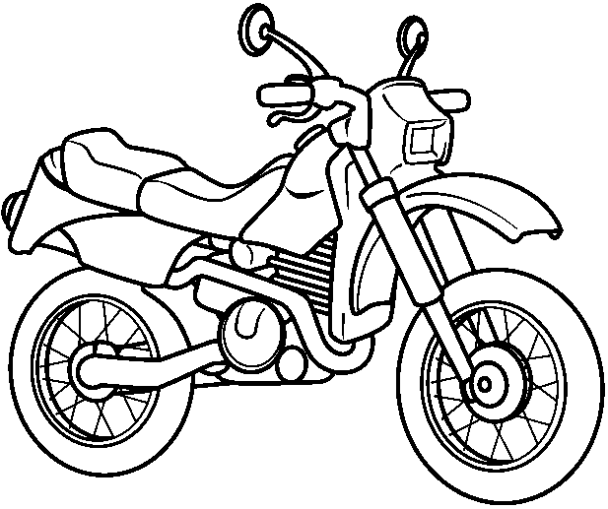 A. WRITE B. MOTORCYCLE C. TEACHER D. LISTEN
4. 22:00
A. GOOD MORNING B. GOOD NIGHT C. GOOD EVENING D. GOOD AFTERNOON
5: 08:00
A. GOOD MORNING B. GOOD NIGHT C. GOOD EVENING D. GOOD AFTERNOON
6. 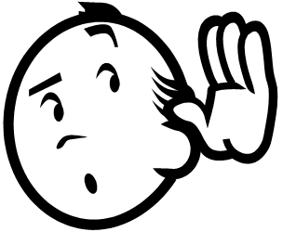 A. READ B. LISTEN C. POINT D. LOOK
7. 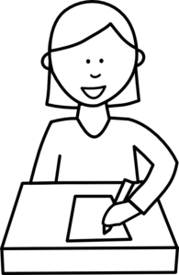 A. READ B. WRITE C. POINT D. OPEN
8. 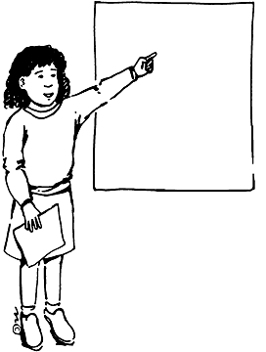 A. READ B. WRITE C CLOSE D. POINT
9. 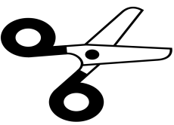 A. LOOK B. CUT C. STICK D. OPEN
10.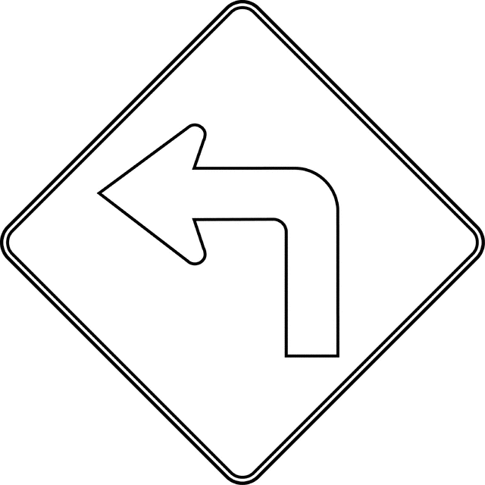 A. TURN RIGHT B. TURN LEFT
11.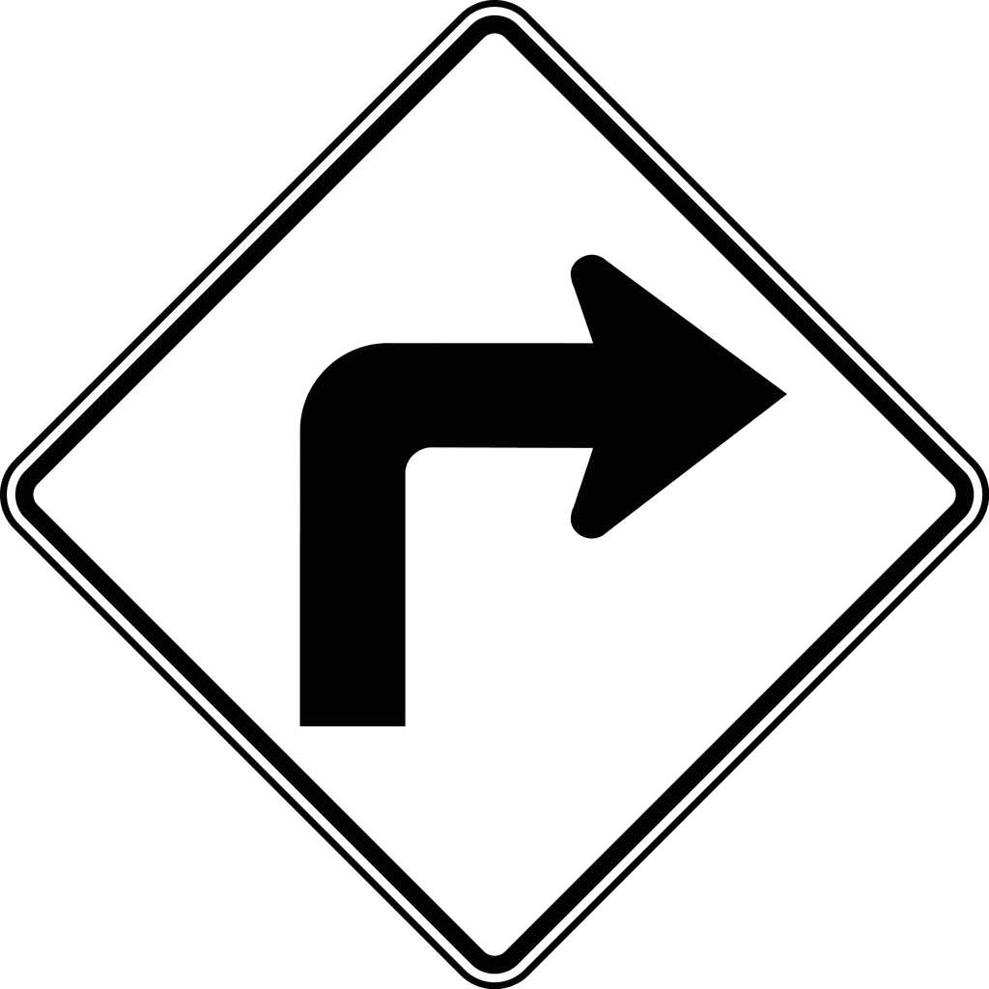 A. TURN RIGHT B. TURN LEFT
12.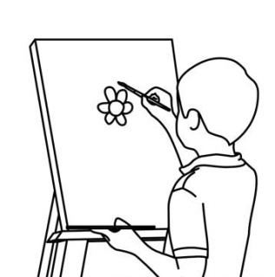 A. DRAW B. OPEN C. CLOSE D. CUT
13.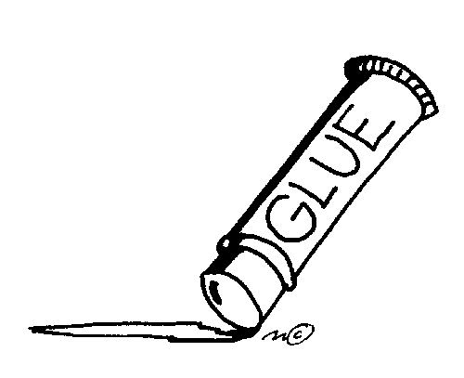 A. LOOK B. CUT C. STICK D. OPEN

14. ERDEM: HELLO! MY.............. IS ERDEM. WHAT IS YOUR........................?
SERDAR: HI! MY NAME IS SERDAR. ................ ARE YOU?
ERDEM: FINE, THANK YOU.
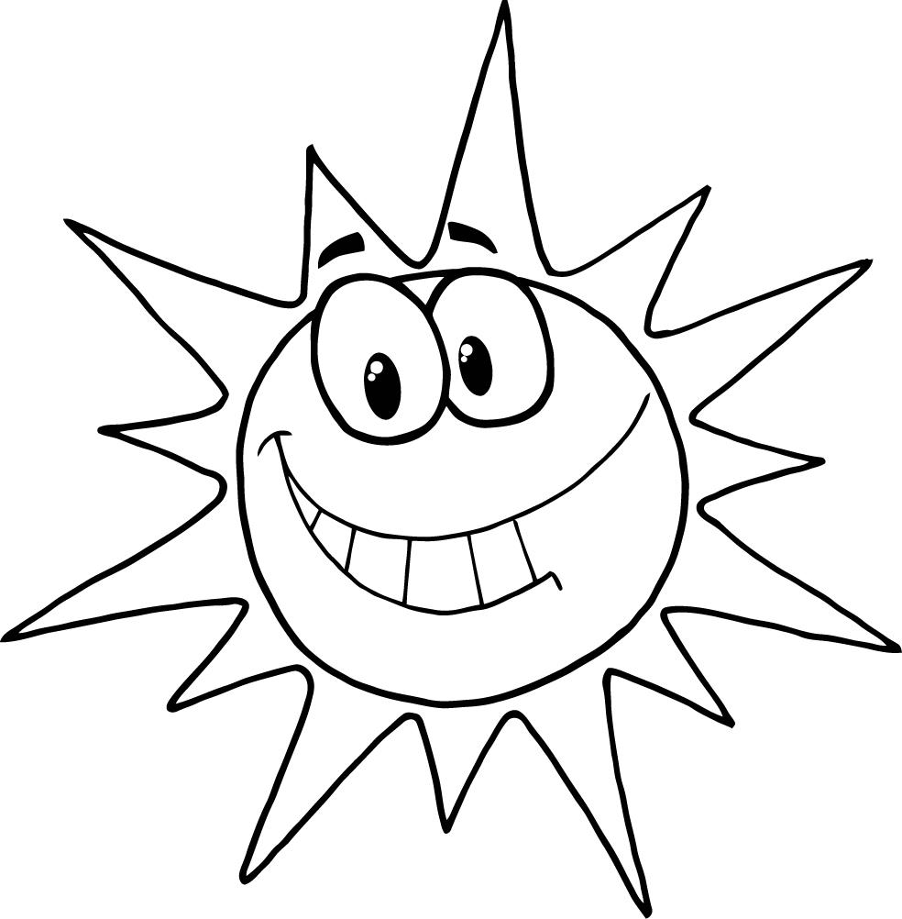TEST SORULARI 7'ŞER PUAN. SON SORU 9 PUAN. BAŞARILAR

