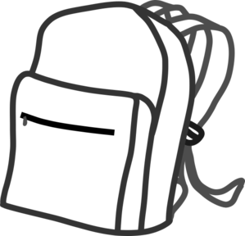
Classroom objects (5’er kez yazınız)

bag……………………………………………………………………
……………………………………………………………………………
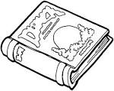
book……………………………………………………………………
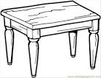
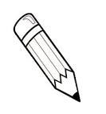
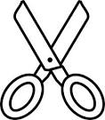
………………………………………………………………………………

table…………………………………………………………………………
………………………………………………………………………………

scissors…………………………………………………………………
……………………………………………………………………………

board……………………………………………………………………
………………………………………………………………………………

pencil…………………………………………………………………
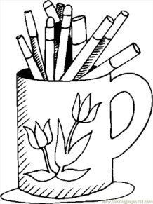
………………………………………………………………………………

crayon……………………………………………………………
……………………………………………………………………………..

