TEST

1. How many scissors? a)One b) two c)three
2. How many boards? a) four b) ten c) two
3. How many doors? a) two b) one c) four
4. How many pencils? a) seven b) two c)eight
5. How many pens? a) two b) one c) four
6. How many books? a)ten b) two c)three
7. How many teachers? a) seven b) two c)eight
8. How many crayons? a) four b) ten c) two
9. How many windows? a) seven b) two c)eight
10. How many desks? a) nine b) three c)eight
11. How many tables? a)One b) two c)three
12. How many schoolbags? a) two b) one c) five
13. How many glue? a)six b) four c)eight
14. How many teddies? a) seven b) two c)eight

[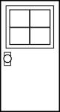](http://www.google.com.tr/url?q=http://courtneyhouse.com/search/clip-art-house-door&sa=U&ei=mxK8UqSiOam-0QWrlYD4DQ&ved=0CDIQ9QEwBQ&usg=AFQjCNGf6e5oKdAgWstcfMN7DCGgW_fHGw)[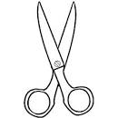](http://www.google.com.tr/url?q=http://familycrafts.about.com/library/color/blcolscissors.htm&sa=U&ei=aBG8Us3FPKrI0wXyrIBI&ved=0CCgQ9QEwAA&usg=AFQjCNGJILro2EoDUmNmlhlsGR-KZZFFIA)[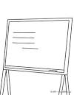](http://www.google.com.tr/url?q=http://www.hellokids.com/c_22681/coloring-pages/school-coloring-pages/school-supplies-coloring-page/a-blackboard&sa=U&ei=4xG8Urf2K6un0wXYqYDwDQ&ved=0CDQQ9QEwBg&usg=AFQjCNGPbDNuLmYmPRpfKGyKdP9BW2u_OA)[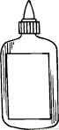](http://www.google.com.tr/url?q=http://www.coloringpages101.com/printable_page/44652/School/Glue_09&sa=U&ei=3Rm8UobdH4rB0QWbsYGYDw&ved=0CCoQ9QEwAA&usg=AFQjCNG8IF8MNQ-dRwjEHW_762zId0pvow)[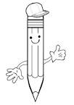](http://www.google.com.tr/url?q=http://www.kidspot.com.au/slideshow/slideshow/Kids-Activity-SheetsColouring-Pages+2+Pencil-Colouring-Page+1949+preview.htm&sa=U&ei=_xK8Uti-MYnO0wWNtoHgDw&ved=0CCgQ9QEwAA&usg=AFQjCNEPwAAMevQld-uGGg25wTJnxyrS5g)[](http://www.google.com.tr/url?q=http://hc-blackmilk.xf.cz/pen-coloring-pages&sa=U&ei=MRO8UtvLC--10QXnyoCADw&ved=0CDgQ9QEwCA&usg=AFQjCNH5SEEgyD6av4gCUViVTFLPzLPAWA)[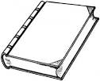](http://www.google.com.tr/url?q=http://www.supercoloring.com/pages/new-interesting-book/&sa=U&ei=WRO8Up6VMcSP0AWP1YEQ&ved=0CDAQ9QEwBA&usg=AFQjCNHdJaQKWJiTQSZ0MSBQhe37vzWqYA)[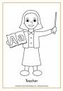](http://www.google.com.tr/url?q=http://www.activityvillage.co.uk/teacher-colouring-page-3&sa=U&ei=qBO8UvO6OYeU0QXE2YGIDw&ved=0CDQQ9QEwBjgU&usg=AFQjCNFlXXKo_R4a_E1NxytlP5Eb5X7bRw)[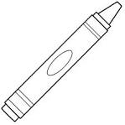](http://www.google.com.tr/url?q=http://www.bigactivities.com/coloring/back_to_school/crayons/crayon.php&sa=U&ei=Cxa8UsWCKKTS0QXxm4DgDQ&ved=0CCgQ9QEwAA&usg=AFQjCNG2RT1bxKRIonCTUXgJhVI0yDll0w)[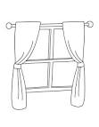](http://www.google.com.tr/url?q=http://printablecolouringpages.co.uk/?s=windows&sa=U&ei=NRa8UpbtF_GY0AWs44DYDg&ved=0CEoQ9QEwETgo&usg=AFQjCNHnB05d7LIrC_YI2sUiyXyuh4-Z0Q)[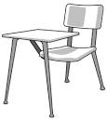](http://www.google.com.tr/url?q=http://www.clipartpal.com/clipart_pd/education/schoolclassroom1.html&sa=U&ei=Bxe8Utf9OaSV0QXE84DgDg&ved=0CDIQ9QEwBQ&usg=AFQjCNEIGEeYDiAC-edX-ElqeCz5jr2VsQ)[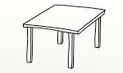](http://www.google.com.tr/url?q=http://www.bootkidz.co.uk/playtable-and-chairs/&sa=U&ei=GRe8UsDWBIGT0AWjsIGgAw&ved=0CCwQ9QEwAg&usg=AFQjCNFhVmAn74hVFRxb-uD4LYmUoOPd3g)[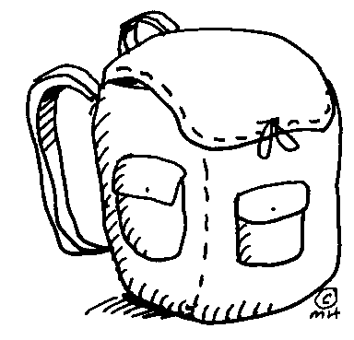](http://www.google.com.tr/url?sa=i&rct=j&q=&esrc=s&frm=1&source=images&cd=&cad=rja&docid=l13dIj8Vtu3ChM&tbnid=KUqdYIRovRmMWM:&ved=0CAUQjRw&url=http://school.discoveryeducation.com/clipart/clip/backpack.html&ei=MQ1MUpWGIcTfsgbf6oHoBQ&bvm=bv.53371865,d.Yms&psig=AFQjCNEgRsR0Tu9-jkb0EaHgv2EHjqEA8A&ust=1380802209742722) [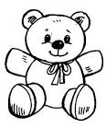](http://www.google.com.tr/url?q=http://bestclipartblog.com/24-teddy-clip-art.html/teddy-clip-art-7&sa=U&ei=xR68UpfgG6SV0QXE84DgDg&ved=0CFAQ9QEwEw&usg=AFQjCNGib91VhHGt1ezma3z-yQMn3XlomQ) [](http://www.google.com.tr/url?q=http://bestclipartblog.com/24-teddy-clip-art.html/teddy-clip-art-7&sa=U&ei=xR68UpfgG6SV0QXE84DgDg&ved=0CFAQ9QEwEw&usg=AFQjCNGib91VhHGt1ezma3z-yQMn3XlomQ)



One eight nine two three five six seven ten four

How old are you?

1.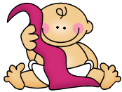I’m ………………………

2. 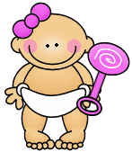 I’m ……………………… 

3.  I’m ……………………… 

4. 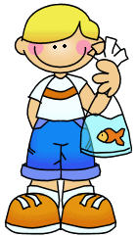 I’m ……………………… 

5.  I’m ……………………… 

6. 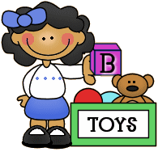 I’m ……………………… 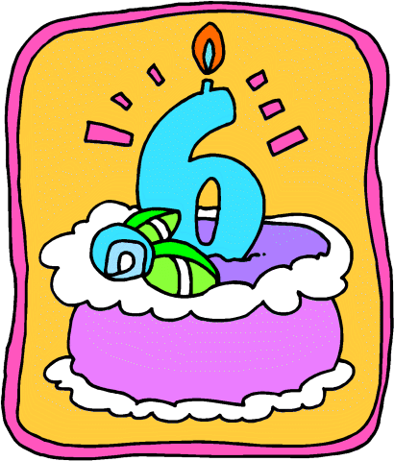

7.  I’m ……………………… 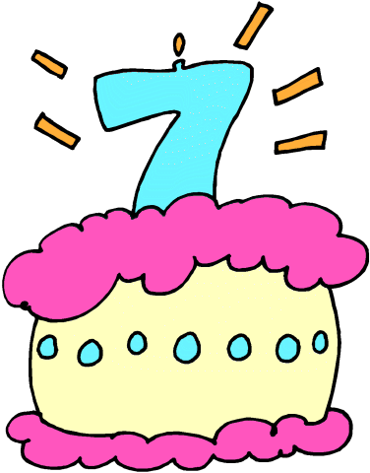

8.  I’m ……………………… 

9. 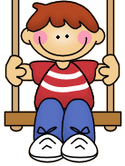 I’m ……………………… 

…………………………….English Teacher

10 I’m ……………………… 