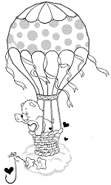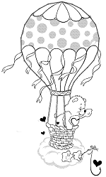

The ____________ balloon is number _____________

The ____________ balloon is number _____________

The ____________ balloon is number _____________

The ____________ balloon is number _____________

The ____________ balloon is number _____________

The ____________ balloon is number _____________

The ____________ balloon is number _____________

The ____________ balloon is number _____________

The ____________ balloon is number _____________

The ____________ balloon is number _____________