What colour ?
UNIT 5

pink

blue

green

brown

red
orange

white

yellow

green

purple

black
pencil
pen
sun
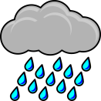
rain

rainbow

