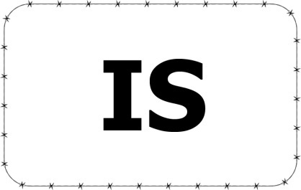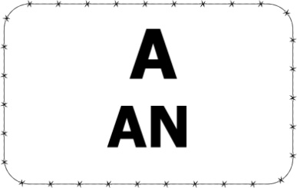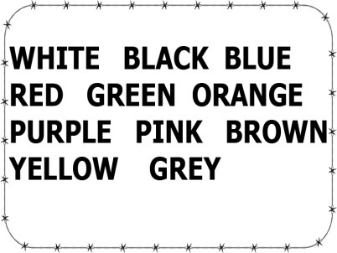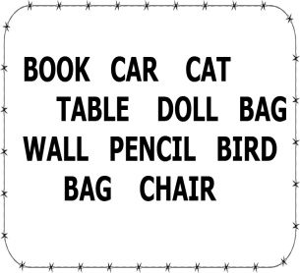
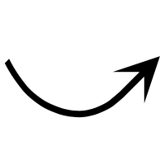
BEYAZ BİR ARABA VAR:________________________________________
SARI BİR SANDALYE VAR: ______________________________________
SİYAH BİR KİTAP VAR:_________________________________________
MAVİ BİR MASA VAR: _________________________________________
PEMBE BİR OYUNCAK BEBEK VAR:____________________________________
KAHVERENGİ BİR KALEM VAR: ______________________________________
YEŞİL BİR ÇANTA VAR:______________________________________________
GRİ BİR KUŞ VAR:________________________________________________
TURUNUC BİR DUVAR VAR: ______________________________________
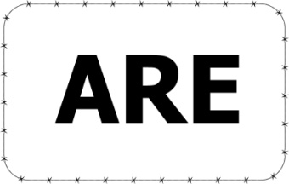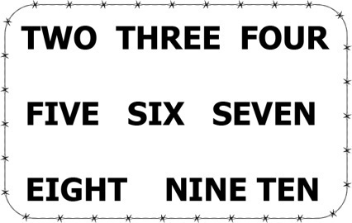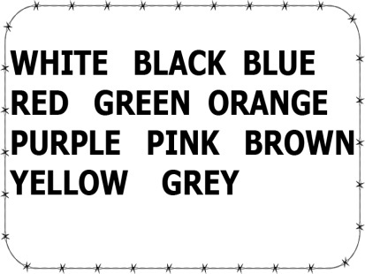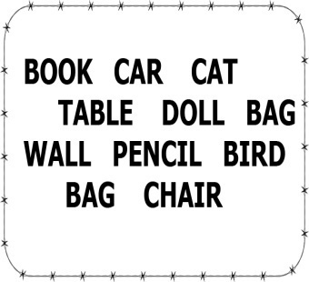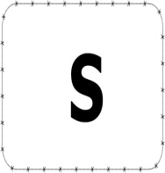
ÜÇ SARI KEDİ VAR:__________________________________
ALTI MAVİ KALEM VAR:_______________________________
YEDİ PEMBE ÇANTA VAR: ________________________________
ON SİYAH SANDALYE VAR: ________________________________
İKİ MOR MASA VAR: ____________________________________
BEŞ BEYAZ OYUNCAK BEBEK VAR: ____________________________
DÖRT MAVİ KUŞ VAR: _________________________________
DOKUZ YEŞİL KUŞ VAR: _________________________________
SEKİZ KIRMIZI ARABA VAR: _____________________________________

