**UNIT 7 : At The PLAYGROUND**

**Exercise 1 : Resimleri boyayınız.**

[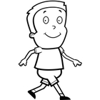](http://www.google.com.tr/url?sa=i&rct=j&q=&esrc=s&frm=1&source=images&cd=&cad=rja&docid=LZR2C3rImJK4xM&tbnid=NnknKpgwPci1qM:&ved=0CAUQjRw&url=http://www.toonvectors.com/clip-art?search=boy+walking+happy+cartoon+smiling+black+child+kid+little+youth&ei=f1AGU4v3OIeM0AWj1IGwDQ&bvm=bv.61725948,d.d2k&psig=AFQjCNG4OHc7C-1FU0KTFPN73ix830SrSA&ust=1393009091561498)[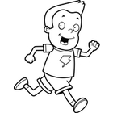](http://www.google.com.tr/url?sa=i&rct=j&q=&esrc=s&frm=1&source=images&cd=&cad=rja&docid=xy2nDg-DIKtOCM&tbnid=s843ZGWronhCeM:&ved=0CAUQjRw&url=http://www.toonvectors.com/clip-art?search=boy+running+happy+cartoon+smiling+child+jogging+kid+playing&ei=wVAGU-_vMerY0QXtuoGgAw&bvm=bv.61725948,d.d2k&psig=AFQjCNEcMzlpCndT1iB1ahYyKwx8sSTu2g&ust=1393009206443039)[](http://www.google.com.tr/url?sa=i&rct=j&q=&esrc=s&frm=1&source=images&cd=&cad=rja&docid=vTuA-TMYbCFj-M&tbnid=3Pj6syGV9MDyHM:&ved=0CAUQjRw&url=http://www.dog-walker.us/scouting/bsaclrti.htm&ei=ilUGU73IG8z60gWLv4HQAw&bvm=bv.61725948,d.d2k&psig=AFQjCNHYa9nnW6suVPNo0CwmVlApf2f46Q&ust=1393010404695833)

**Walk Run Jump**

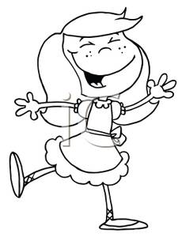 [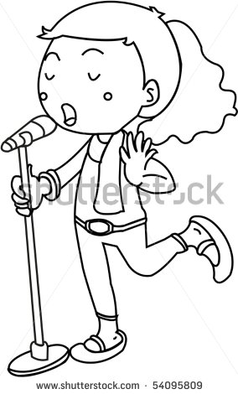](http://www.google.com.tr/url?sa=i&rct=j&q=&esrc=s&frm=1&source=images&cd=&cad=rja&docid=xynBt0nIwwKNVM&tbnid=j85Ya97ipNCslM:&ved=0CAUQjRw&url=http://www.shutterstock.com/pic-54095809/stock-vector-sketch-of-a-girl-singing-on-mic-on-white-background.html&ei=zloGU4uKBLKa0QWozIC4Cw&bvm=bv.61725948,d.d2k&psig=AFQjCNHdbNX6f-7cCzgnKYjnfrvPoNWkwg&ust=1393011758871239) 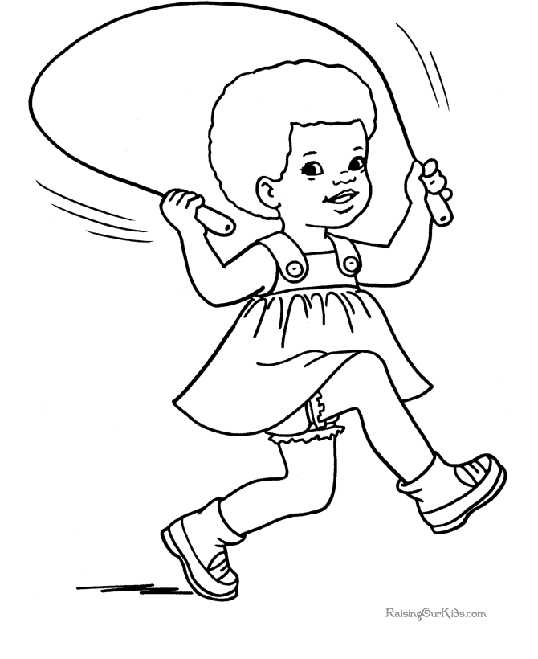

**Dance Sing Skip a rope**

**[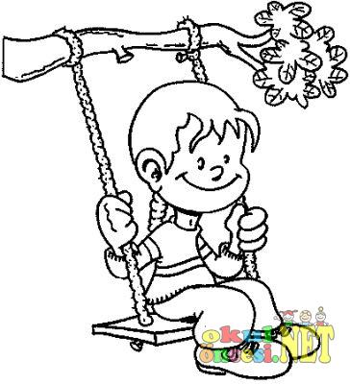](http://www.okuloncesi.net/vbimghost.php?do=displayimg&imgid=754)** 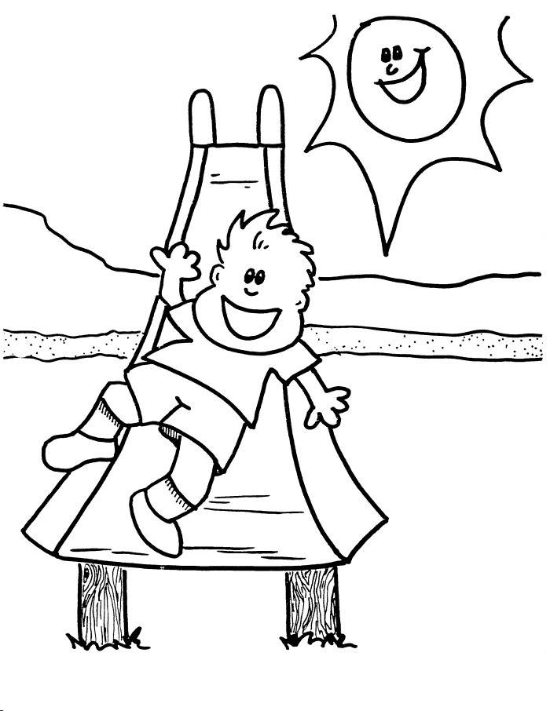[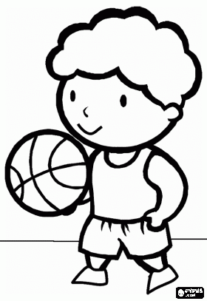](http://www.google.com.tr/url?sa=i&rct=j&q=&esrc=s&frm=1&source=images&cd=&cad=rja&docid=WxlmB3ApgS7NGM&tbnid=qXv-nDDjqcbPwM:&ved=0CAUQjRw&url=http://www.xn--boyamaoyunlar-gbc.com/basketbol-boyama_2.html&ei=72QGU9rYAfOZ0AW0x4GwBw&bvm=bv.61725948,d.d2k&psig=AFQjCNElRGI9tBBscRPS750YTYHN1knt1A&ust=1393014294539104)

**Swing Slide Play**

**Exercise 2 : Resimlerle kelimeleri eslestiriniz.**

**Ex. Slide……A……..**

**Walk………….**

**Jump………….**

**Run…………..**

**Swing………….**

**Dance………….**

**Sing…………….**

**Play…………..**

**Skip a rope……….**

**C**

**B**

**A**

 **[](http://www.okuloncesi.net/vbimghost.php?do=displayimg&imgid=754)** 

  

  

**G**

**H**

**I**

**E**

**D**

**F**

**Exercise 3 : Boşlukları doğru kelimelerle doldurunuz.**

1. **Let’s……………………..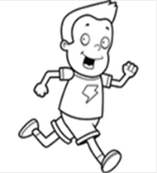 4. Let’s…………………….**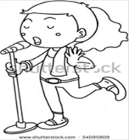
2. **Let’s…………………….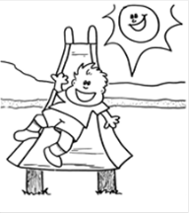 5.Let’s………………………**
3. **Let’s……………………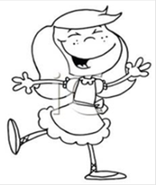 6.Let’s……………………….**