Name: ……………………………………………………………………….
AT THE PLAYGROUND
Resimlerin altındaki kelimeleri beşer kez yazınız.
Dance  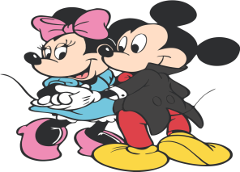  …………………….  ……………………  …………………….  …………………….  ……………………. | Walk  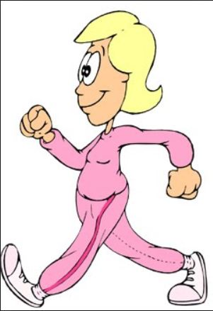  …………………….  ……………………  …………………….  …………………….  ……………………. | Sing  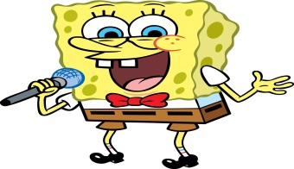  …………………….  ……………………  …………………….  …………………….  …………………….
Skip rope  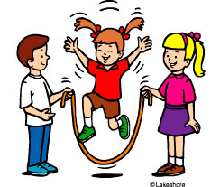  …………………….  ……………………  …………………….  …………………….  ……………………. | Slide  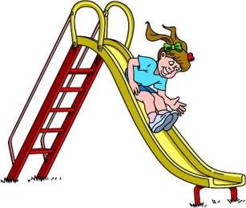  …………………….  ……………………  …………………….  …………………….  ……………………. | Play hide and seek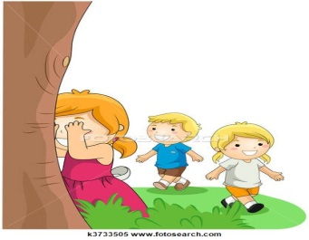  …………………….  ……………………  …………………….  …………………….  …………………….
Swing  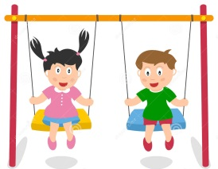  …………………….  ……………………  …………………….  …………………….  ……………………. | Jump  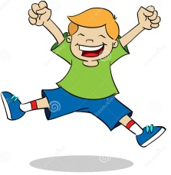  …………………….  ……………………  …………………….  …………………….  ……………………. | Run  …………………….  ……………………  …………………….  …………………….  …………………….
English Teacher
Tuğba İNCE

