1

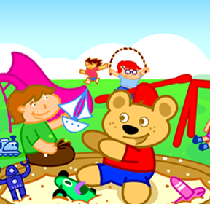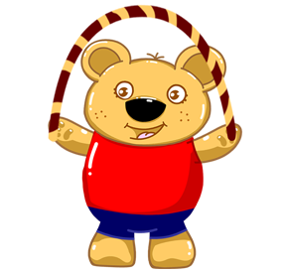

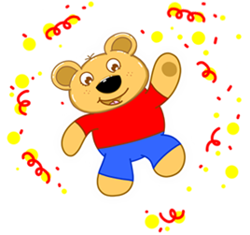

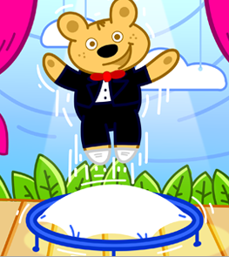

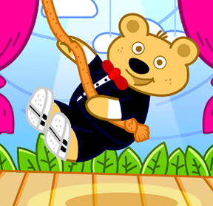

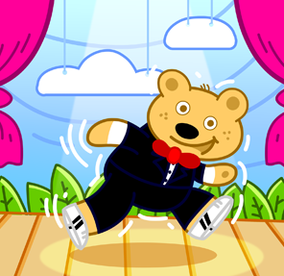

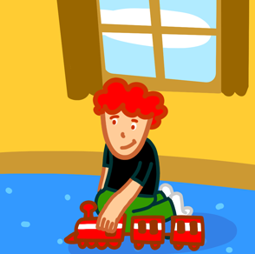

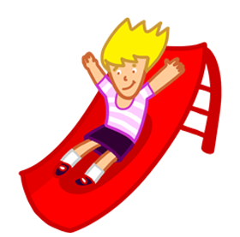



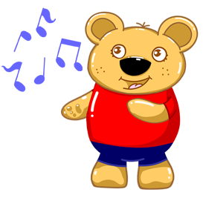

**a)**Let’s run!

**b)**Let’s skip a rope!

**c)**Let’s sing!

2

**a)**Let’s play!

**b)**Let’s skip a rope!

**c)**Let’s swing!

3

**a)**Let’s slide!

**b)**Let’s play!

**c)**Let’s swing!

4

**a)**Let’s play!

**b)**Let’s slide!

**c)**Let’s run!

**a)**Let’s play!

**b)**Let’s skip a rope!

**c)**Let’s run!

5

6

**a)**Let’s walk!

**b)**Let’s skip a rope!

**c)**Let’s swing!

7

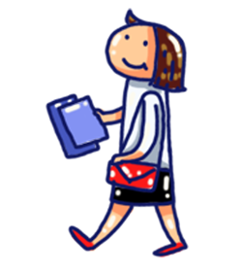

**a)**Let’s play!

**b)**Let’s walk!

**c)**Let’s slide!

8

**a)**Let’s jump!

**b)**Let’s skip a rope!

**c)**Let’s play!

**a)**Let’s play!

**b)**Let’s dance!

**c)**Let’s swing!

9

10

**a)**Let’s play!

**b)**Let’s run!

**c)**Let’s walk!

16

11

**a)** It is red.

**b)**It is green.

**c)**It is blue.

**a)**Let’s play!

**b)**Let’s skip a rope!

**c)**Let’s swing!

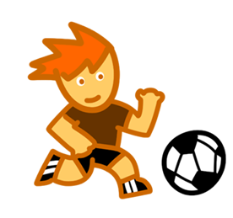

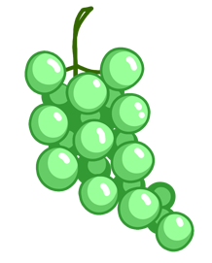

12

17

**a)** It is yellow.

**b)** It is red.

**c)** It is black.

**a)**Let’s play!

**b)**Let’s cut!

**c)**Let’s swing!

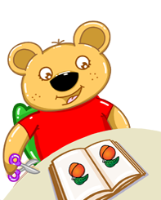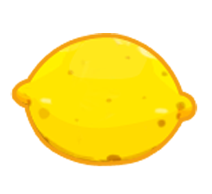

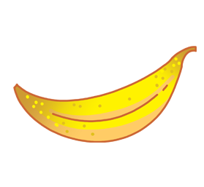



Bilge AKMAN

English Teacher

14

13

18

20

19

15

**a)**nine.

**b)**two

**c)**four.

**a)**Let’s play football!

**b)**Let’s play tennis!

**c)**Let’s swing!



**a)**It is orange.

**b)**It is white.

**c)**It is purple.

**a)** It is blue.

**b)** It is pink.

**c)** It is white.

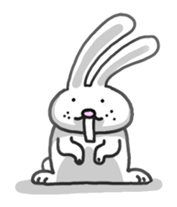

**a)**It is black.

**b)** It is brown.

**c)**It is red.

**a)** sun.

**b)** rain.

**c)** rainbow.



