**Exercise 5: Noktaları birleştiriniz, ortaya çıkan hayvanın İngilizcesini yazınız.**

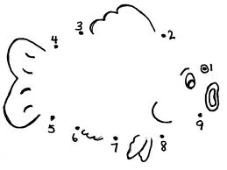

[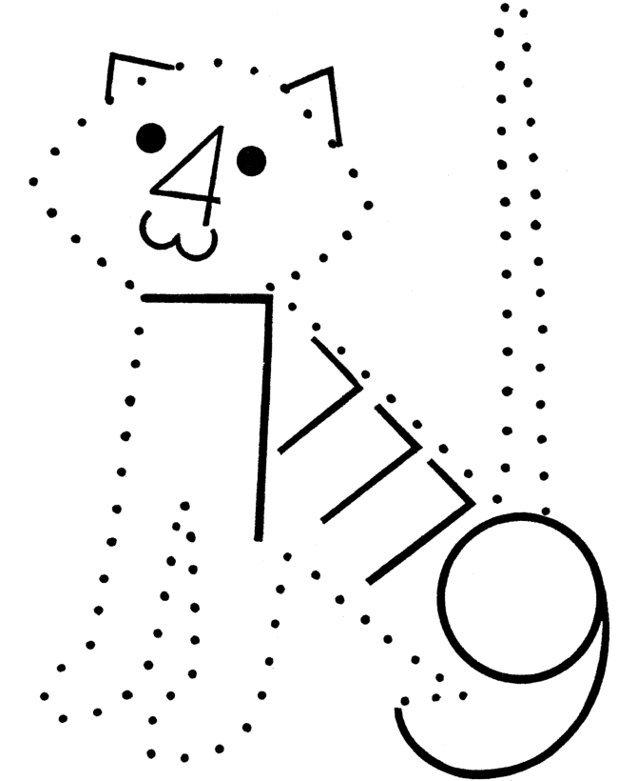](http://www.google.com.tr/url?sa=i&rct=j&q=&esrc=s&frm=1&source=images&cd=&cad=rja&uact=8&docid=bALvNe_dKfpEEM&tbnid=RZU6z7DuiAdGsM:&ved=0CAYQjRw&url=http://www.honkingdonkey.com/activity-pages/counting/number-dots-04-104.htm&ei=hI8kU7O2PKWi0QX5r4GoDw&bvm=bv.62922401,d.d2k&psig=AFQjCNFyd9Re_UfKNbDN3gfvTbyugZ6DxA&ust=1394991293152818)

**2) I am a ………………………**

**1) I am a ………………………**

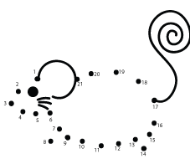

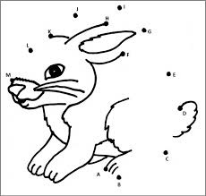

**4) I am a ………………………**

**3) I am a ………………………**

[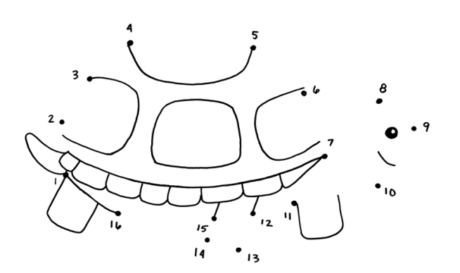](http://www.google.com.tr/url?sa=i&rct=j&q=&esrc=s&frm=1&source=images&cd=&cad=rja&uact=8&docid=elHgmIMyYQt58M&tbnid=r7kEobvZ_j_v_M:&ved=0CAYQjRw&url=http://brookeleasblog.blogspot.com/2008/07/im-happy-to-say-that-final-work-for-my.html&ei=Q5MkU83GB-i70QWJhoHAAg&bvm=bv.62922401,d.d2k&psig=AFQjCNGeHsdUjSygo7SMebh3LGOATbzRqg&ust=1394992307147225)

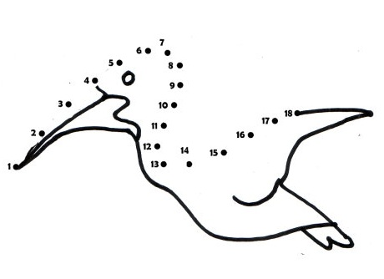

**6) I am a ………………………**

**5) I am a ………………………**