**Hello! My name is Tweety. I am a ……………….**

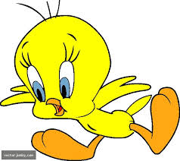

**Hi!. I am a Ninja. I am a ……………….**

[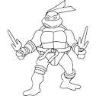](https://www.google.com.tr/url?q=http://baroquedx.com/ninja-turtles-coloring-pages/&sa=U&ei=IWc1U9iZEYe84ASY-4DgAQ&ved=0CFAQ9QEwEQ&usg=AFQjCNGbSkAHdHsbRp4YUcCzs9kkgB8t8g)

**Hi!. I am Kitty. I am a ……………….**

[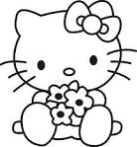](https://www.google.com.tr/url?q=http://free-coloring-for-kids.blogspot.com/2012/03/hello-kitty-coloring-sheet.html&sa=U&ei=X2M1U8S7AuWN4gT61oHAAw&ved=0CDQQ9QEwAw&usg=AFQjCNHoz4rzEeIHwBGqxM5e4cCemMVLNA)

**Hello! My name is Bugs Bunny. I am a …………..**



**Hi!. I am Jerry. I am a ……………….**

[](https://www.google.com.tr/url?q=http://anaokulum.org/BoyamaSayfalari/TomJerry.aspx&sa=U&ei=r2c1U7jMI8rh4QS12oGoDA&ved=0CDQQ9QEwAg&usg=AFQjCNEnyVdyAo3FB2vC2za7JmbfIVmMbg)

[](https://www.google.com.tr/url?q=http://free-coloring-for-kids.blogspot.com/2012/03/hello-kitty-coloring-sheet.html&sa=U&ei=X2M1U8S7AuWN4gT61oHAAw&ved=0CDQQ9QEwAw&usg=AFQjCNHoz4rzEeIHwBGqxM5e4cCemMVLNA)BİLGE AKMAN

ENGLISH TEACHER