**UNIT -8 PETS**

[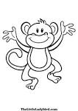](https://www.google.com.tr/url?q=http://printncolor.coolphotos.in/color/tag/monkey-coloring/page/2&sa=U&ei=XE81U53aLuuv7AaWu4DACg&ved=0CEwQ9QEwDw&usg=AFQjCNGNSQJmsyLfDrgZLEaktDAYd4jk2A)

[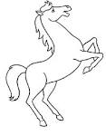](https://www.google.com.tr/url?q=http://www.bestcoloringpagesforkids.com/horse-coloring-pages.html&sa=U&ei=KE81U7b3DePH7AaQ2YDgAw&ved=0CDwQ9QEwBw&usg=AFQjCNGZKyjWWieE318JIN8GBqgbfQneZw)

[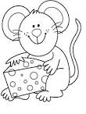](https://www.google.com.tr/url?q=http://www.coloringpages1001.com/coloring-pages/mouse/&sa=U&ei=t041U7S6HIrX7AbV54AY&ved=0CD4Q9QEwCA&usg=AFQjCNGxhu4Ti8kyWiGrIZSwBNISxfAhXA)

[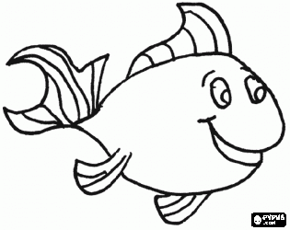](http://www.boyamaoyunları.com/boyamak-balık-boyama_292.html)

[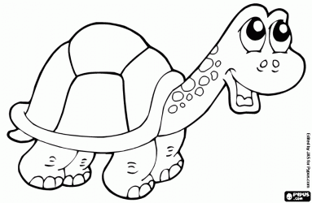](http://www.boyamaoyunları.com/boyamak-kaplumbağa-boyama_9643.html)

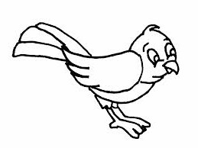

[](http://www.google.com.tr/url?sa=i&rct=j&q=&esrc=s&source=images&cd=&cad=rja&docid=wBPG5hk9-LfmfM&tbnid=m6fBQv64TxXqSM:&ved=0CAUQjRw&url=http://www.xn--boyamaoyunlar-gbc.com/tav%C5%9Fan-boyama.html&ei=ztDcUtG2NuuX0AX8noG4CQ&psig=AFQjCNGlPRK0OIvbA4q2oCOiTIXa0NUCAg&ust=1390289410743582)

[](http://www.google.com.tr/url?sa=i&source=images&cd=&cad=rja&docid=eCyH5P476ojqeM&tbnid=61RxW8pyBXJUDM&ved=0CAgQjRw&url=http://www.bolbilgi.net/konu/kopek-boyama-sayfalari.244/&ei=987cUsa2Nca_0QWwy4A4&psig=AFQjCNGeQId5klxrzKSDtVA50VcegR0Jkg&ust=1390289016019978)

**CUT**

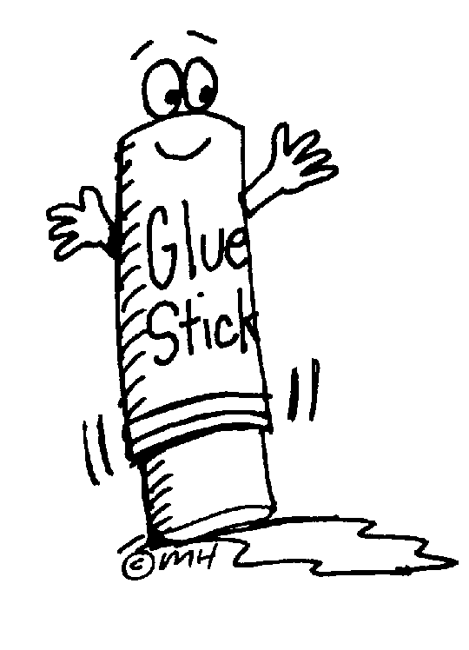

**GLUE**

**COLOR**



Cat

Rabbit

Dog

Monkey

Horse

Mouse

Turtle

Fish

Bird

[**www.eegitimim.com**](http://www.eegitimim.com)