**Exercise 2 : Resimlerle kelimeleri eslestiriniz.**

**C**

**A**

**B**

**Cat…………..**

**Dog…………**

**Turtle………**

**Rabbit………**

**Bird………….**

**Fish………….**

**Hamster…….**

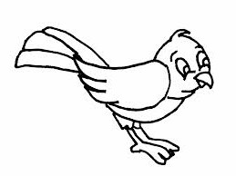 [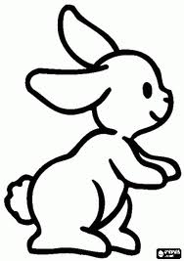](http://www.google.com.tr/url?sa=i&rct=j&q=&esrc=s&source=images&cd=&cad=rja&docid=wBPG5hk9-LfmfM&tbnid=m6fBQv64TxXqSM:&ved=0CAUQjRw&url=http://www.xn--boyamaoyunlar-gbc.com/tav%C5%9Fan-boyama.html&ei=ztDcUtG2NuuX0AX8noG4CQ&psig=AFQjCNGlPRK0OIvbA4q2oCOiTIXa0NUCAg&ust=1390289410743582) 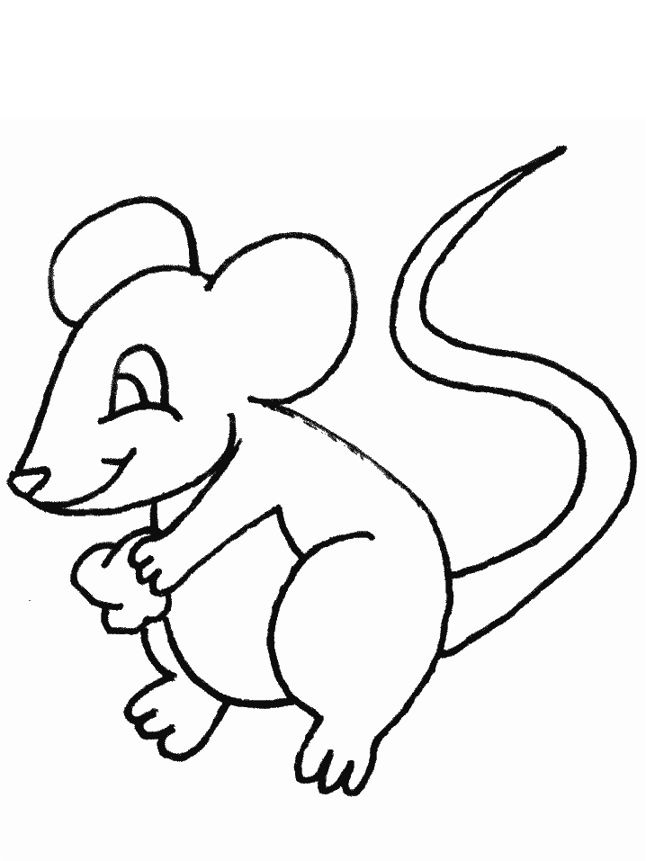

[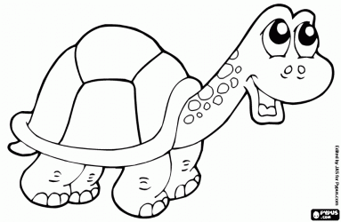](http://www.boyamaoyunları.com/boyamak-kaplumbağa-boyama_9643.html) [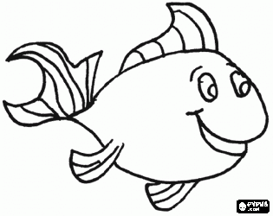](http://www.boyamaoyunları.com/boyamak-balık-boyama_292.html)

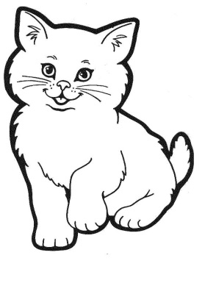 [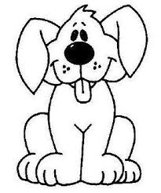](http://www.google.com.tr/url?sa=i&source=images&cd=&cad=rja&docid=eCyH5P476ojqeM&tbnid=61RxW8pyBXJUDM&ved=0CAgQjRw&url=http://www.bolbilgi.net/konu/kopek-boyama-sayfalari.244/&ei=987cUsa2Nca_0QWwy4A4&psig=AFQjCNGeQId5klxrzKSDtVA50VcegR0Jkg&ust=1390289016019978)

**E**

**D**

**F**

**G**

**Exercise 3 : Boşluklara doğru kelimeleri yazınız.**

1. **This is a………………………[](http://www.boyamaoyunları.com/boyamak-balık-boyama_292.html) 4) This is a……………………….**
2. **This is a……………………….[](http://www.google.com.tr/url?sa=i&rct=j&q=&esrc=s&source=images&cd=&cad=rja&docid=wBPG5hk9-LfmfM&tbnid=m6fBQv64TxXqSM:&ved=0CAUQjRw&url=http://www.xn--boyamaoyunlar-gbc.com/tav%C5%9Fan-boyama.html&ei=ztDcUtG2NuuX0AX8noG4CQ&psig=AFQjCNGlPRK0OIvbA4q2oCOiTIXa0NUCAg&ust=1390289410743582) 5) This is a……………………….[](http://www.boyamaoyunları.com/boyamak-kaplumbağa-boyama_9643.html)**
3. **This is a……………………….  6) This is a……………………….**