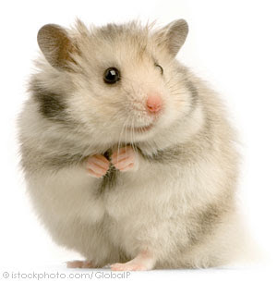

Soruları örnek cevaptaki gibi cevaplayınız.

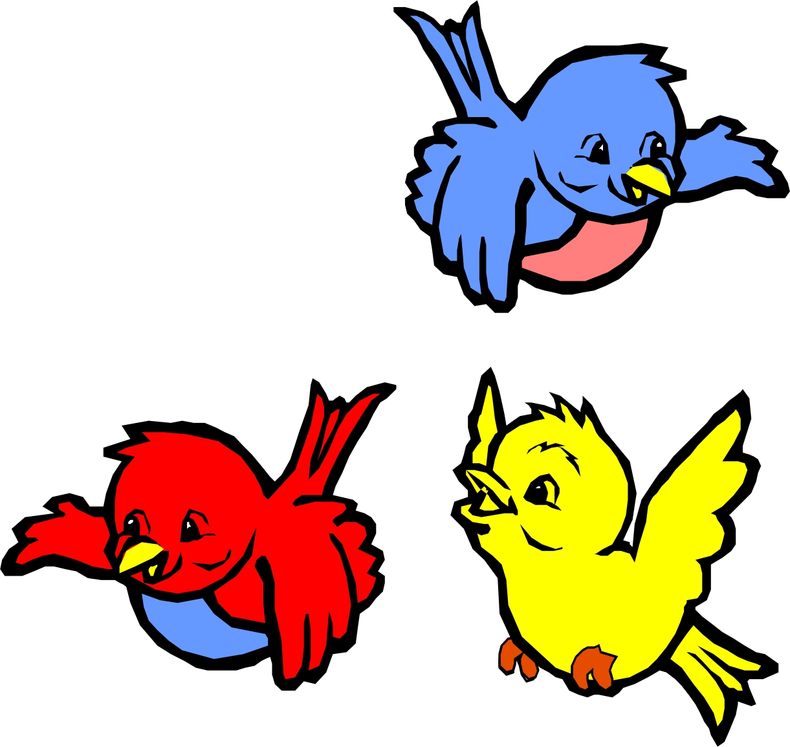

How many birds are there? ***three birds***

How many rabbits are there? ………

How many fish are there? ………

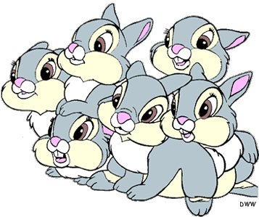

How many turtles are there?.......

How many hamsters are there?.........

How many dogs are there?...........

How many cats are there?..............

