**Exercise 6 : Sayıları kullanarak soruları cevaplayınız.**

**One / Two / Three / Four / Five / Six / Seven / Eight / Nine / Ten**

**How many hamsters ?**

**…………………………...**

**How many birds ?**

**…………………………...**

**How many turtles ?**

**…………………………...**

**How many rabbits ?**

**…………………………...**

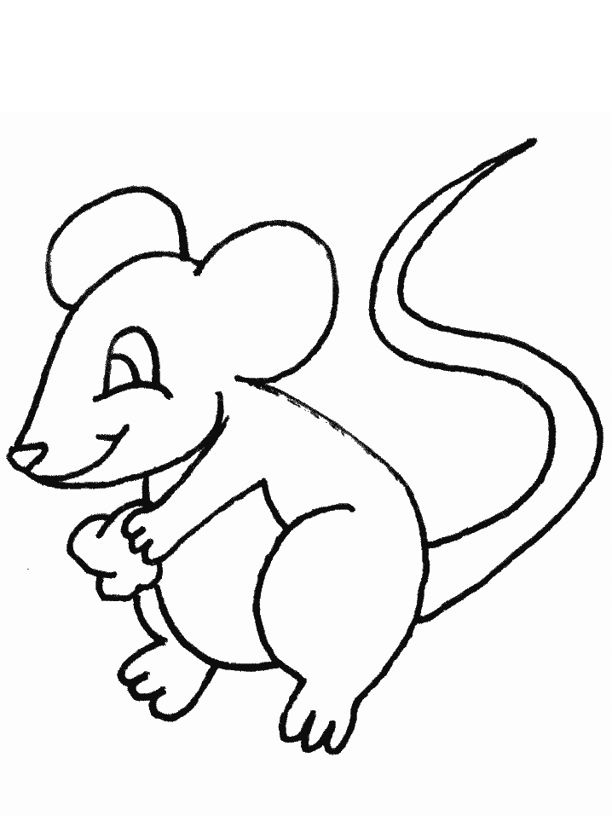

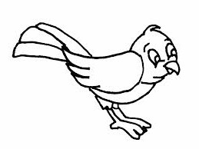



[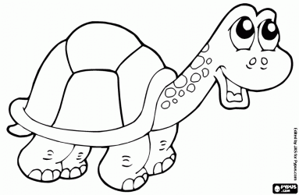](http://www.boyamaoyunları.com/boyamak-kaplumbağa-boyama_9643.html)

[](http://www.google.com.tr/url?sa=i&rct=j&q=&esrc=s&source=images&cd=&cad=rja&docid=wBPG5hk9-LfmfM&tbnid=m6fBQv64TxXqSM:&ved=0CAUQjRw&url=http://www.xn--boyamaoyunlar-gbc.com/tav%C5%9Fan-boyama.html&ei=ztDcUtG2NuuX0AX8noG4CQ&psig=AFQjCNGlPRK0OIvbA4q2oCOiTIXa0NUCAg&ust=1390289410743582)

**How many dogs ?**

**…………………………...**

[](http://www.google.com.tr/url?sa=i&source=images&cd=&cad=rja&docid=eCyH5P476ojqeM&tbnid=61RxW8pyBXJUDM&ved=0CAgQjRw&url=http://www.bolbilgi.net/konu/kopek-boyama-sayfalari.244/&ei=987cUsa2Nca_0QWwy4A4&psig=AFQjCNGeQId5klxrzKSDtVA50VcegR0Jkg&ust=1390289016019978)