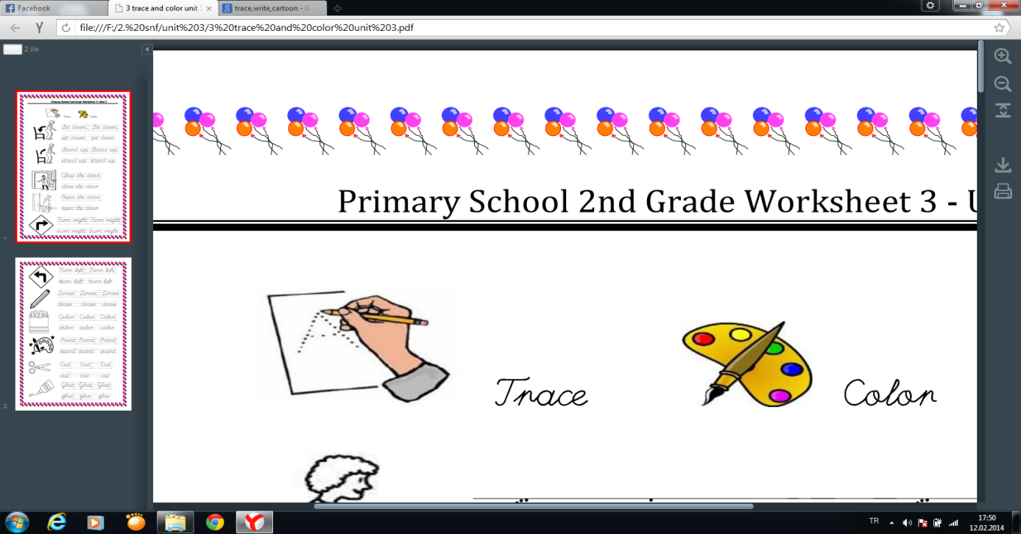



Cat

[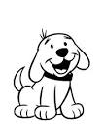](https://www.google.com.tr/url?q=http://www.cbssmm.com/printable-clifford-the-big-red-dog-coloring-pages-for-kids-color/&sa=U&ei=Llo1U7PHM8HV4wS4s4DYDQ&ved=0CEgQ9QEwDThQ&usg=AFQjCNHfir0S8yuwUpZpQ5cv7Jhb6tF14Q)[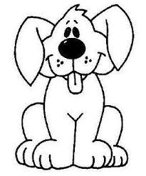](http://www.google.com.tr/url?sa=i&source=images&cd=&cad=rja&docid=eCyH5P476ojqeM&tbnid=61RxW8pyBXJUDM&ved=0CAgQjRw&url=http://www.bolbilgi.net/konu/kopek-boyama-sayfalari.244/&ei=987cUsa2Nca_0QWwy4A4&psig=AFQjCNGeQId5klxrzKSDtVA50VcegR0Jkg&ust=1390289016019978)

Dog

Rabbit

[](https://www.google.com.tr/url?q=http://www.cbssmm.com/easter-bunny-rabbit-coloring-pages-formore-coloringrabbits/&sa=U&ei=Q1o1U-fjD6Hk4wShm4HwBQ&ved=0CE4Q9QEwEA&usg=AFQjCNGAiZV381qYn_63c_SNmK8RinzRfw)

[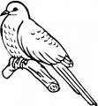](https://www.google.com.tr/url?q=http://www.supercoloring.com/pages/cuckoo-bird/&sa=U&ei=zlo1U_2xKMa74ATN4oCwAg&ved=0CEgQ9QEwDQ&usg=AFQjCNHGuCZXNaB8zywvzlGxXYBpb6MTBw)

Bird

[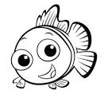](https://www.google.com.tr/url?q=http://www.supercoloring.com/pages/small-fish/&sa=U&ei=d1s1U_muGOaa4wTNgoC4CQ&ved=0CDwQ9QEwCA&usg=AFQjCNFNDCQ6KlgAEfS7loaAyeGoXYFvvQ)

Fish

[](https://www.google.com.tr/url?q=http://free-coloring-for-kids.blogspot.com/2012/03/hello-kitty-coloring-sheet.html&sa=U&ei=X2M1U8S7AuWN4gT61oHAAw&ved=0CDQQ9QEwAw&usg=AFQjCNHoz4rzEeIHwBGqxM5e4cCemMVLNA)BİLGE AKMAN

ENGLISH TEACHER

Horse

[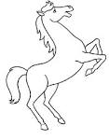](https://www.google.com.tr/url?q=http://www.bestcoloringpagesforkids.com/horse-coloring-pages.html&sa=U&ei=KE81U7b3DePH7AaQ2YDgAw&ved=0CDwQ9QEwBw&usg=AFQjCNGZKyjWWieE318JIN8GBqgbfQneZw)

Mouse

[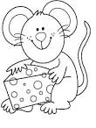](https://www.google.com.tr/url?q=http://www.coloringpages1001.com/coloring-pages/mouse/&sa=U&ei=t041U7S6HIrX7AbV54AY&ved=0CD4Q9QEwCA&usg=AFQjCNGxhu4Ti8kyWiGrIZSwBNISxfAhXA)

[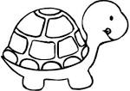](https://www.google.com.tr/url?q=http://www.bestcoloringpagesforkids.com/turtle-coloring-pages.html&sa=U&ei=jVw1U7PNJaLk4QT8nYHQDQ&ved=0CC4Q9QEwAA&usg=AFQjCNF6l468rLvpNqxn66uq9MFjuESYqQ)

Turtle

Doğru seçeneği işaretleyiniz.

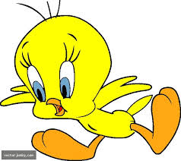 A) Dog B) Monkey C) Bird 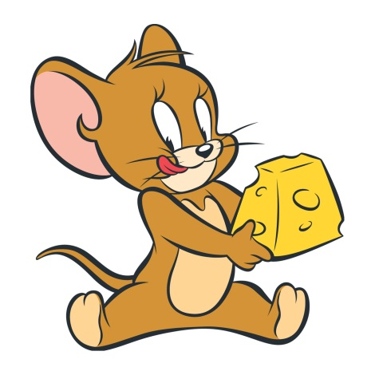A) Mouse B) Fish C) Turtle

 A) Turtle B) Dog C) Mouse A) Fish B) Dog C) Rabbit

Monkey

[](https://www.google.com.tr/url?q=http://printncolor.coolphotos.in/color/tag/monkey-coloring/page/2&sa=U&ei=XE81U53aLuuv7AaWu4DACg&ved=0CEwQ9QEwDw&usg=AFQjCNGNSQJmsyLfDrgZLEaktDAYd4jk2A)