**FRUITS**

**COLOR, CUT AND GLUE**

[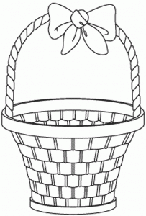](http://coloringhub.com/wp-content/uploads/2014/01/Basket-coloring-pages-2.gif)