**Sayıları kullanarak soruları cevaplayınız.**

**One / Two / Three / Four / Five / Six / Seven / Eight / Nine / Ten**

How many apples ?

…………………………...

How many melons ?

…………………………...

How many bananas ?

…………………………...

How many peaches ?

…………………………...

[](http://3.bp.blogspot.com/-DBjPOXjTyqs/UQV5cpEy_rI/AAAAAAAAGYU/pzUBQaXC6xI/s1600/apple+02.jpg)



[](http://www.google.com.tr/url?sa=i&rct=j&q=&esrc=s&frm=1&source=images&cd=&cad=rja&uact=8&docid=cYp73lm7WRAL_M&tbnid=h2ViaaP4gj_FyM:&ved=0CAUQjRw&url=http://imgarcade.com/1/banana-clipart-black-and-white/&ei=xO4zU5uKC4-Z0QXh2oGAAg&psig=AFQjCNF72IIsc43cIYwW0lb01Z43qrEUwA&ust=1395998776016298)

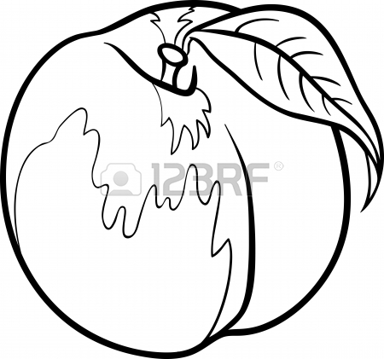

How many lemons ?

…………………………...

[](http://www.google.com.tr/url?sa=t&rct=j&q=&esrc=s&frm=1&source=images&cd=&cad=rja&uact=8&ved=0CAQQjRw&url=http://www.eskisohbet.com/limon-boyama-sayfalari.html&ei=4-4zU8iCKomJ4gT5woHIDg&usg=AFQjCNFZ4vfaV5OzpT3DDDqrYWKtSAApZQ&bvm=bv.63808443,d.bGE)