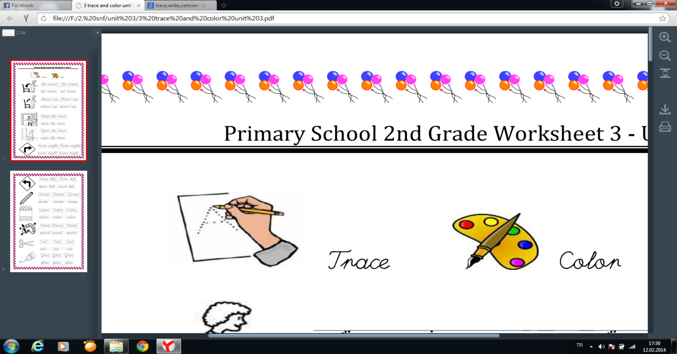

[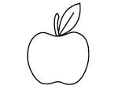](https://www.google.com.tr/url?q=http://coloring-page-book.com/apple-coloring-page-3552.html&sa=U&ei=lHFGU4uUGMTqywOctoCwBg&ved=0CEYQ9QEwDA&usg=AFQjCNH40D8jY_IXhAi2KCNtMpVAtQmTAw)

Apple

Banana

[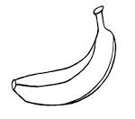](https://www.google.com.tr/url?q=http://www.laptopezine.com/printing-one-large-banana-coloring-page-for-kids/&sa=U&ei=iHJGU5KPGanAyQPE9oCYCA&ved=0CD4Q9QEwCA&usg=AFQjCNHHJxbGqOIsx95fNO5QKsUMgvTLdA)

[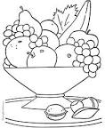](https://www.google.com.tr/url?q=http://www.bestcoloringpagesforkids.com/fruit-coloring-pages.html&sa=U&ei=tHJGU5-JAaS_ygOrkIGQBA&ved=0CDAQ9QEwAQ&usg=AFQjCNEwTKmmoVN91VcAHdYMeWJApN4qeg)

Fruit

Grapefruit

[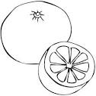](https://www.google.com.tr/url?q=http://www.spanishkidstuff.com/flashcards/food-fruit.html&sa=U&ei=RnNGU7XyD8bg4QT3pID4BQ&ved=0CFAQ9QEwETigAQ&usg=AFQjCNGoOF6Kn7aqDs3wI9bGQ2ticvjXvA)

[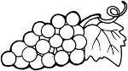](https://www.google.com.tr/url?q=http://www.supercoloring.com/color-online/pages/grape-15/&sa=U&ei=dHNGU6i4CNCO4gToyYHgDA&ved=0CEQQ9QEwCw&usg=AFQjCNE60A-bldlAmhgGtug8UQD9jqebAg)

Grape

[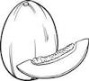](https://www.google.com.tr/url?q=http://www.123rf.com/photo_20171943_black-and-white-cartoon-illustration-of-blackberry-berry-fruit-food-object-for-coloring-book.html&sa=U&ei=u3NGU7ewIYOs4ASCvIH4Bg&ved=0CDQQ9QEwAzgo&usg=AFQjCNEPYhMgOkCXgU2il6KAj73Ab_zEOg)

Melon

Orange

[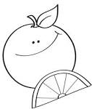](https://www.google.com.tr/url?q=http://pagestocolor.net/10247-happy-orange-coloring-pages/happy-orange-coloring-pages/&sa=U&ei=A3RGU86uIKWEyAHF4IDQDg&ved=0CDYQ9QEwBA&usg=AFQjCNHEG2ANtaZVM7Jo-_1Nxw32e75HeQ)

[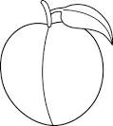](https://www.google.com.tr/url?q=http://sweetclipart.com/colorable-peach-line-art-544&sa=U&ei=TnRGU_bPFOyFyQHEr4DoAw&ved=0CFQQ9QEwEw&usg=AFQjCNHiAUB-UlLXgAbYeouD0i4hZIMt1Q)

Peach

[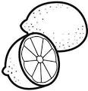](https://www.google.com.tr/url?q=http://imagenesparapintar.net/alimentos/limones-para-pintar-2.html&sa=U&ei=n3RGU479K-WbygHkx4CIBQ&ved=0CEQQ9QEwCw&usg=AFQjCNED6mA9mZwUOoREUnAHvUog_wT_Gg)

[](https://www.google.com.tr/url?q=http://free-coloring-for-kids.blogspot.com/2012/03/hello-kitty-coloring-sheet.html&sa=U&ei=X2M1U8S7AuWN4gT61oHAAw&ved=0CDQQ9QEwAw&usg=AFQjCNHoz4rzEeIHwBGqxM5e4cCemMVLNA)BİLGE AKMAN

ENGLISH TEACHER

Doğru seçeneği işaretleyiniz.

[](https://www.google.com.tr/url?q=http://www.laptopezine.com/printing-one-large-banana-coloring-page-for-kids/&sa=U&ei=iHJGU5KPGanAyQPE9oCYCA&ved=0CD4Q9QEwCA&usg=AFQjCNHHJxbGqOIsx95fNO5QKsUMgvTLdA)A) melon B) banana C) apple [](https://www.google.com.tr/url?q=http://coloring-page-book.com/apple-coloring-page-3552.html&sa=U&ei=lHFGU4uUGMTqywOctoCwBg&ved=0CEYQ9QEwDA&usg=AFQjCNH40D8jY_IXhAi2KCNtMpVAtQmTAw)A) grape B) lemon C) apple

[](https://www.google.com.tr/url?q=http://www.bestcoloringpagesforkids.com/fruit-coloring-pages.html&sa=U&ei=tHJGU5-JAaS_ygOrkIGQBA&ved=0CDAQ9QEwAQ&usg=AFQjCNEwTKmmoVN91VcAHdYMeWJApN4qeg) A) fruit B) peach C) watermelon [](https://www.google.com.tr/url?q=http://www.supercoloring.com/color-online/pages/grape-15/&sa=U&ei=dHNGU6i4CNCO4gToyYHgDA&ved=0CEQQ9QEwCw&usg=AFQjCNE60A-bldlAmhgGtug8UQD9jqebAg)A) grape B) orange C) apple

Watermelon

Lemon

[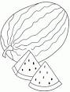](https://www.google.com.tr/url?q=http://99coloring.com/watermelon-coloring-pages-14756.html&sa=U&ei=J3VGU4H_ELCayQHQ2YHIBw&ved=0CEYQ9QEwDDg8&usg=AFQjCNG3rLfKn0qNYj3OX_5wL949FClC_w)