**Meyvelerle cümleleri eşleştiriniz, doğru renklere boyayınız.**

**Verilen cümleler doğruysa “True” (T) ,yanlışsa “False”(F) işaretleyiniz.**

**A.**I am a **green watermelon.**

**B.**I am a **red apple.**

**C.**I am a **yellow lemon.**

**D.**I am a **yellow banana.**

**E.**We are **orange apricots.**

**F.**We are **black grapes.**

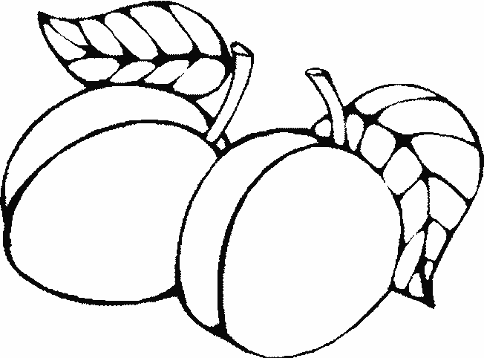 [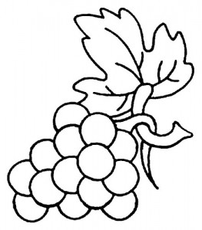](http://www.bilginim.com/resim/üzüm-boyama1.jpg) [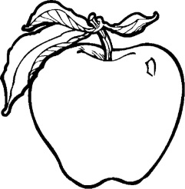](http://3.bp.blogspot.com/-DBjPOXjTyqs/UQV5cpEy_rI/AAAAAAAAGYU/pzUBQaXC6xI/s1600/apple+02.jpg)

[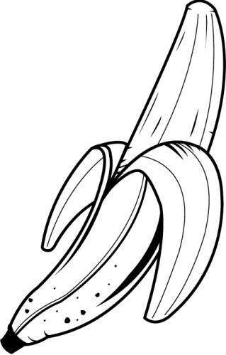](http://www.google.com.tr/url?sa=i&rct=j&q=&esrc=s&frm=1&source=images&cd=&cad=rja&uact=8&docid=cYp73lm7WRAL_M&tbnid=h2ViaaP4gj_FyM:&ved=0CAUQjRw&url=http://imgarcade.com/1/banana-clipart-black-and-white/&ei=xO4zU5uKC4-Z0QXh2oGAAg&psig=AFQjCNF72IIsc43cIYwW0lb01Z43qrEUwA&ust=1395998776016298) 

[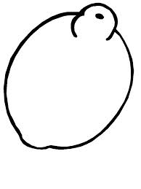](http://www.google.com.tr/url?sa=t&rct=j&q=&esrc=s&frm=1&source=images&cd=&cad=rja&uact=8&ved=0CAQQjRw&url=http://www.eskisohbet.com/limon-boyama-sayfalari.html&ei=4-4zU8iCKomJ4gT5woHIDg&usg=AFQjCNFZ4vfaV5OzpT3DDDqrYWKtSAApZQ&bvm=bv.63808443,d.bGE)

**T**

**F**

**F**

**F**

**F**

**T**

**T**

**T**

1. [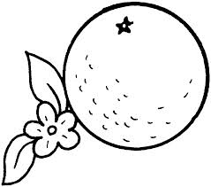](http://www.google.com.tr/url?sa=i&rct=j&q=&esrc=s&frm=1&source=images&cd=&cad=rja&uact=8&docid=OFvRu7H3ehkjDM&tbnid=KshCUSpzIsZhLM:&ved=0CAUQjRw&url=http://www.supercoloring.com/color-online/pages/orange-1/&ei=9e8zU8v0JKT00gW_xoD4DQ&bvm=bv.63808443,d.bGE&psig=AFQjCNFh5r3xogf0y8WpQLeIxX_iTOYO1w&ust=1395999088419655) This is an **apple.**

2.  This is a **watermelon.**

3. [](http://www.google.com.tr/url?sa=i&rct=j&q=&esrc=s&frm=1&source=images&cd=&cad=rja&uact=8&docid=cYp73lm7WRAL_M&tbnid=h2ViaaP4gj_FyM:&ved=0CAUQjRw&url=http://imgarcade.com/1/banana-clipart-black-and-white/&ei=xO4zU5uKC4-Z0QXh2oGAAg&psig=AFQjCNF72IIsc43cIYwW0lb01Z43qrEUwA&ust=1395998776016298) This is a **pear.**

4. 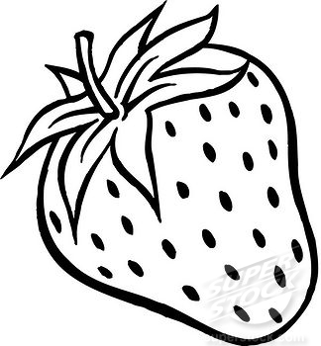 This is a **strawberry.**