Expressing likes and dislikes (sevdiklerini ve sevmediklerini ifade edebilmek)
I like……… ……… severim.
I don’t like ……. ……… sevmem.
I eat ………… ……… yerim.
I don’t eat…………. ………. yemem.
Do you like …………..? ……..sever misin?
Do you eat…………….? ……...yer misin?
(+) Yes, I do (-) No, I don’t
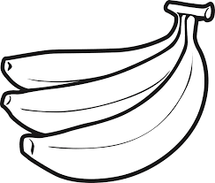Do you like banana? (+) ……………………
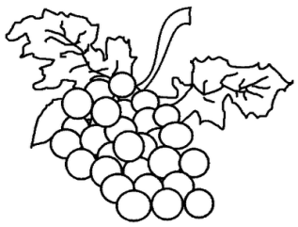Do you eat grapes? (-) …………………….
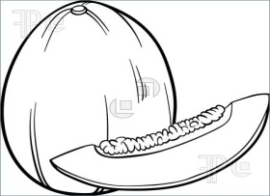 I like melon, I like melon, I like melon
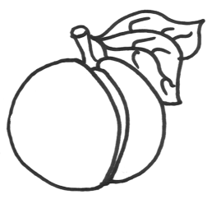I eat peach, I eat peach, I eat peach
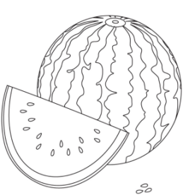I don’t like watermelon I don’t like watermelon
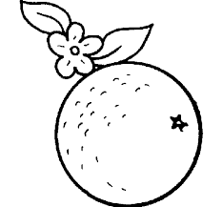 I don’t eat orange, I don’t eat orange

