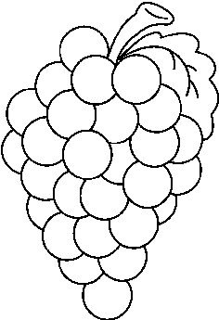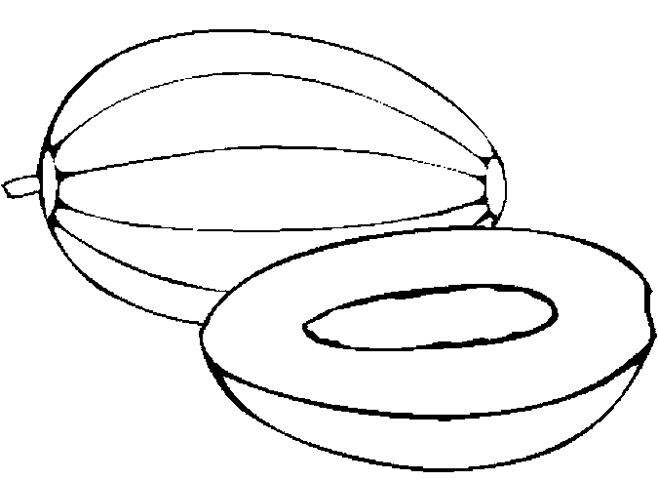
G _ _ _ _ _ M _ _ _ _
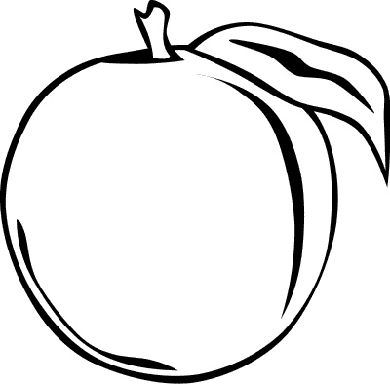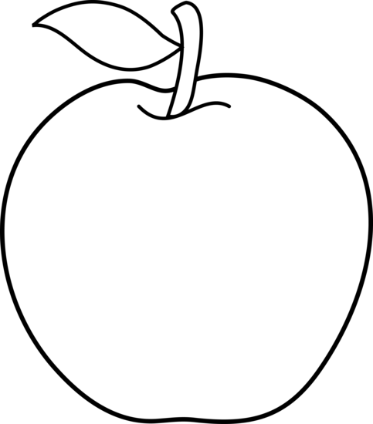
P _ _ _ _ A _ _ _ _
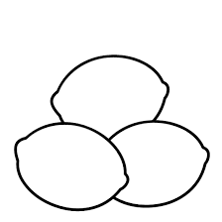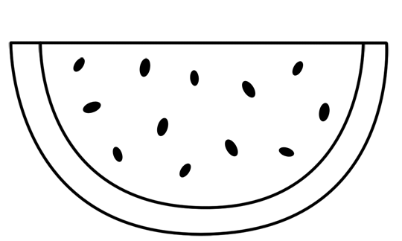
L _ _ _ _ W _ _ _ _ _ _ _ _ _
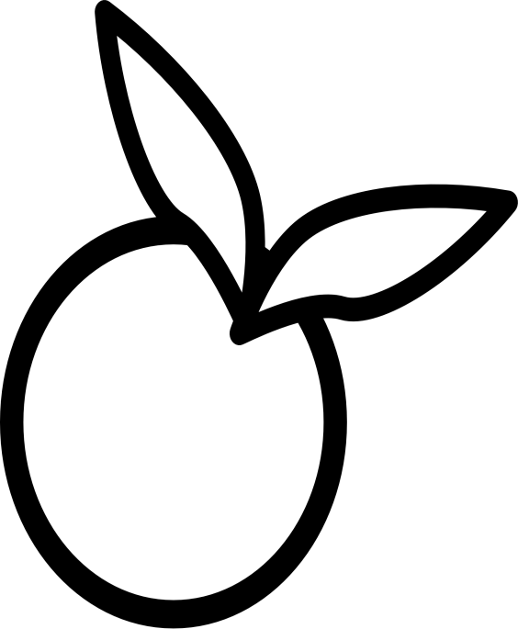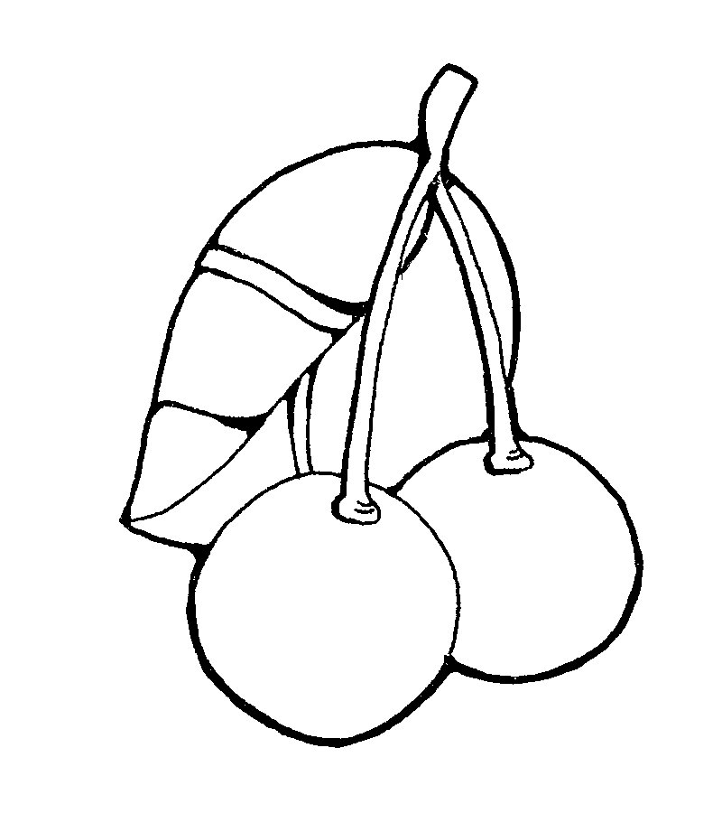
O _ _ _ _ _ C _ _ _ _ _ _ _
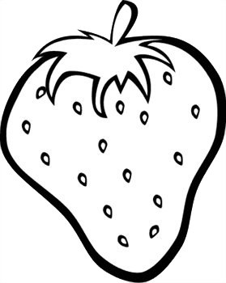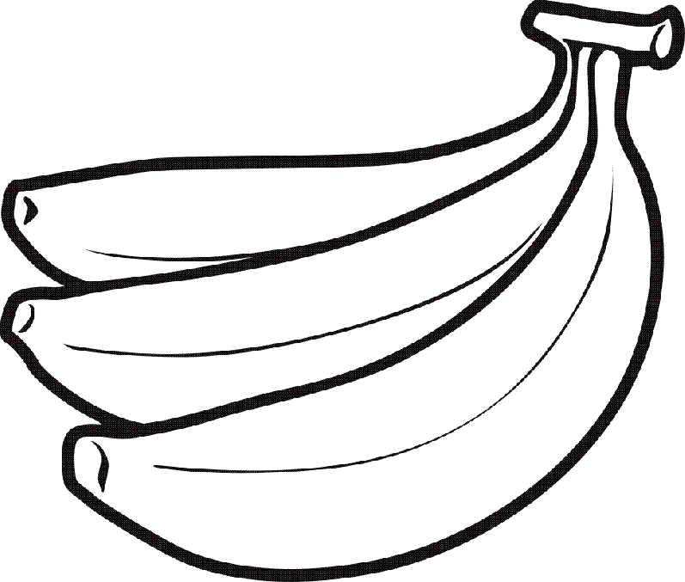
S _ _ _ _ _ _ _ _ _ B _ _ _ _ _ _
DO YOU LIKE BANANAS? _______________________.
DO YOU LIKE ORANGES? _______________________.
I LOVE _____________ AND _______________.

