 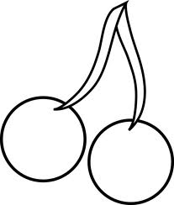

**it is yellow it is red**

[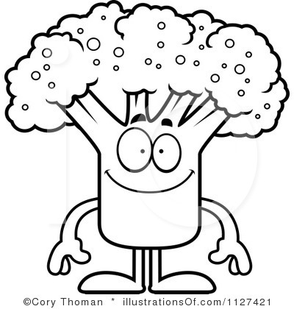](http://www.illustrationsof.com/1127421-royalty-free-broccoli-clipart-illustration) 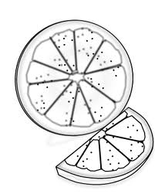

**it is green it is orange**

[](http://www.google.com.tr/url?sa=i&rct=j&q=&esrc=s&source=images&cd=&cad=rja&docid=FMWXZ79w2PblJM&tbnid=f1hBxZ4eWcf4RM:&ved=0CAUQjRw&url=http%3A%2F%2Fwww.canstockphoto.com%2Fchocolate-bar-doodle-11513555.html&ei=deHOUpGCBcKx0AXr7oDQAQ&bvm=bv.59026428,d.ZGU&psig=AFQjCNH3UEnlJhPv_nQzaOqDN2PLY_rssw&ust=1389376209962260) [](http://www.google.com.tr/url?sa=i&rct=j&q=&esrc=s&source=images&cd=&cad=rja&docid=A84__Y6BN12E7M&tbnid=2oFWGOLJBlVpBM:&ved=0CAUQjRw&url=http%3A%2F%2Fvector-images.com%2Fclipart%2Fclp111559%2F&ei=F-LOUol0rZTRBcr4gIAD&bvm=bv.59026428,d.ZGU&psig=AFQjCNHMqE9kzMOX--ftyi0Q6j1ikfZu7Q&ust=1389376382455871) **it is brown it is blue**

[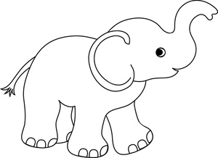](http://www.google.com.tr/url?sa=i&rct=j&q=&esrc=s&source=images&cd=&cad=rja&docid=aNQTjzEoTzIEQM&tbnid=IwOJZzGhkcwLCM:&ved=0CAUQjRw&url=http%3A%2F%2Fwww.babyclipart.net%2Fbaby_clipart_images%2Fcute_little_cartoon_baby_elephant_with_its_trunk_up_in_the_air_0515-1005-2517-5943.html&ei=s-LOUpfOMMSh0QXqioGgAQ&bvm=bv.59026428,d.ZGU&psig=AFQjCNEZF_ZV-BmTkvb8PcpU-BG88Ko22A&ust=1389376555204163) [](http://www.google.com.tr/url?sa=i&rct=j&q=&esrc=s&source=images&cd=&cad=rja&docid=s6RQN-0mLYwiOM&tbnid=8in5TdZBbWixTM:&ved=0CAUQjRw&url=http%3A%2F%2Fhqvectors.com%2Fimage%2Fshutterstock-eps-94659841&ei=f-POUrPRF-nG0QXO-4HgDA&bvm=bv.59026428,d.ZGU&psig=AFQjCNFiuJCflm9tScSuIV0aLyXsHosLnw&ust=1389376727248326)

**it is gray it is black**

**[](http://www.google.com.tr/url?sa=i&rct=j&q=&esrc=s&source=images&cd=&cad=rja&docid=PDLs692rKSQlVM&tbnid=OpPDmsgFX7xvsM:&ved=0CAUQjRw&url=http%3A%2F%2Fwww.floweryst.com%2Fbeautiful-flowers%2Fpicture-of-daisies-clip-art%2F&ei=LuTOUt3pL8LB0gWN04DoCw&bvm=bv.59026428,d.ZGU&psig=AFQjCNGJcISPWtq8tdxewydHDgKxIXdrAg&ust=1389376884933721) **

**it is pink it is purple**



**it is red it is white**