HOW MANY…? (KAÇ TANE?)

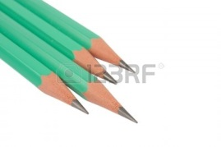
- How many pencils are there?
_______________

- How many books are there?

___________________

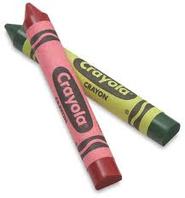
- How many crayons are there?

____________________

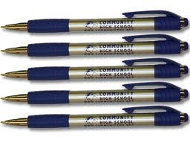
- How many pens are there?

______________________

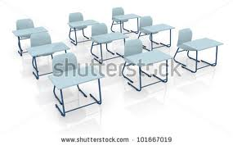
- How many desks are there?

_______________________

