NUMBERS ÇALIŞMA KÂĞIDI 4
AŞAĞIDAKİ CÜMLELERİN TÜRKÇELERİNİ YAZINIZ.
1- How many trains are there?
…………………………………………………………………………………
2- How many lemons are there?
……………………………………………………………………………….
3- How many wagons are there?
…………………………………………………………………………………
4- How many books are there?
…………………………………………………………………………………
5- How many helicopters are there?
…………………………………………………………………………………
6- How many robots are there?
…………………………………………………………………………………
7- How many zebras are there?
…………………………………………………………………………………
8- How many bags are there?
…………………………………………………………………………………
9- How many crayons are there?
…………………………………………………………………………………
10- How many telephones are there?
…………………………………………………………………………………

Soru: How many bags are there? (6)
Cevap: Six bags.
Cevabın Türkçesi: Altı çanta.
Soru: How many tables are there? (3)
Cevap: Three tables.
Cevabın Türkçesi: Üç masa.

AŞAĞIDAKİ SORULARIN CEVAPLARINI YAZINIZ.
Soru: How many lemons are there?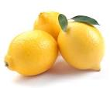
Cevap: …………………………………………………………..
Cevabın Türkçesi:……………………………………………
Soru: How many robots are there? 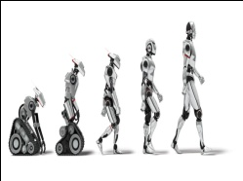
Cevap:…………………………………………………………...
Cevabın Türkçesi:……………………………………………

Soru:How many crayons are there?
Cevap:…………………………………………………………...
Cevabın Türkçesi:……………………………………………

Soru: How many bags are there? (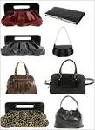
Cevap:…………………………………………………………...
Cevabın Türkçesi:……………………………………………

Soru: How many trains are there?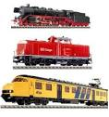
Cevap:…………………………………………………………...
Cevabın Türkçesi:……………………………………………
How many telephones are there? 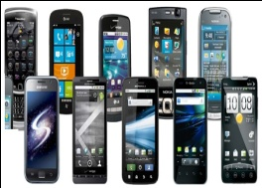
Cevap:…………………………………………………………...
Cevabın Türkçesi:……………………………………………
Soru: How many books are there?
Cevap:…………………………………………………………...
Cevabın Türkçesi:……………………………………………
Soru: How many zebras are there? 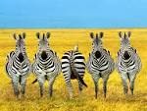
Cevap:…………………………………………………………...
Cevabın Türkçesi:……………………………………………
How many helicopters are there? 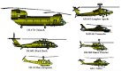
Cevap:…………………………………………………………...
Cevabın Türkçesi:……………………………………………
Soru: How many wagons are there? 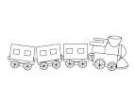
Cevap:…………………………………………………………...
Cevabın Türkçesi:……………………………………………

How old are you? Kaç yaşındasın?
I’m ten. On yaşındayım.

How old are you? ( 8 )
I’m eight.
(Sekiz yaşındayım)

Sude: 4, Sefa: 8, Mehmet: 5, Sıla: 9, Ela: 7, Ali: 10, Defne: 6, Yasemin: 3, Yaren:7
AŞAĞIDAKİ SORULARIN CEVAPLARINI YUKARIDAKİ KİŞİLERİN YAŞLARINA GÖRE İNGİLİZCE CEVAPLAYINIZ.
SORU: How old are you, Sude?
CEVAP: ………………………………………………………………
SORU: How old are you, Sefa?
CEVAP: ………………………………………………………………
SORU: How old are you, Mehmet?
CEVAP: ………………………………………………………………
SORU: How old are you, Sıla?
CEVAP: ………………………………………………………………
SORU: How old are you, Ela?
CEVAP: ………………………………………………………………
SORU: How old are you, Ali?
CEVAP: ………………………………………………………………
SORU: How old are you, Defne?
CEVAP: ………………………………………………………………
SORU: How old are you, Yasemin?
CEVAP: ………………………………………………………………
SORU: How old are you, Yaren?
CEVAP: ………………………………………………………………

