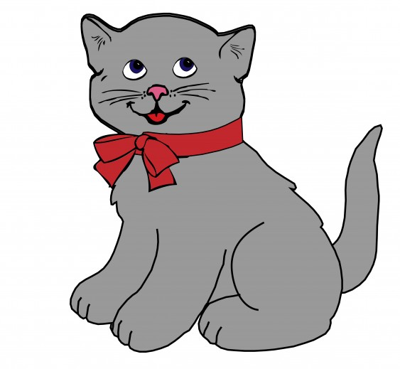

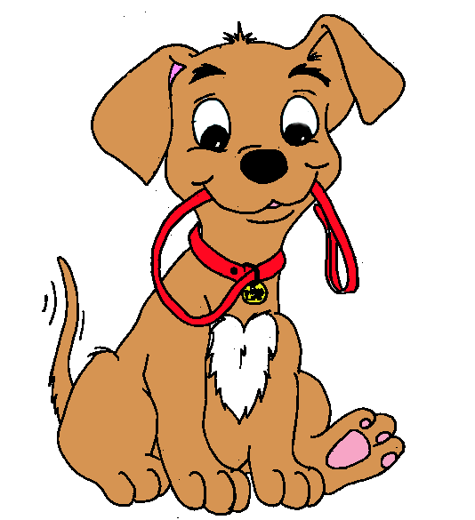
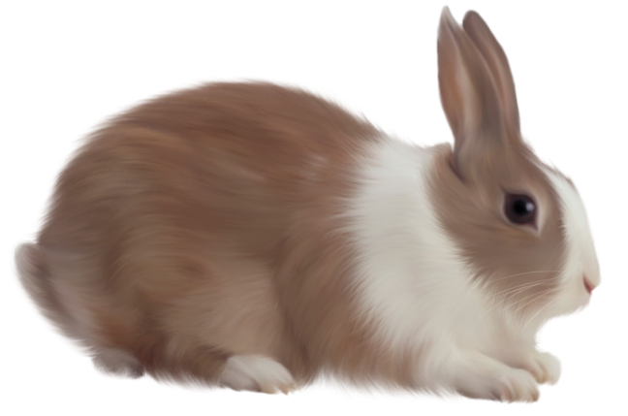

cat : kedi
____________________________________________
____________________________________________
____________________________________________
____________________________________________
____________________________________________

dog: köpek
____________________________________________
____________________________________________
____________________________________________
____________________________________________
____________________________________________

rabbit : tavşan
____________________________________________
____________________________________________
____________________________________________
____________________________________________
____________________________________________

turtle : kaplumbağa
____________________________________________
____________________________________________
____________________________________________
____________________________________________
____________________________________________

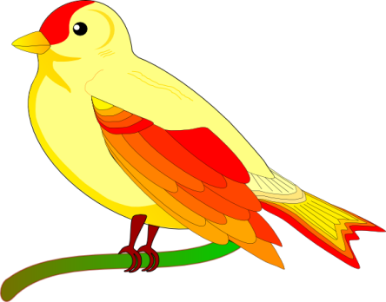

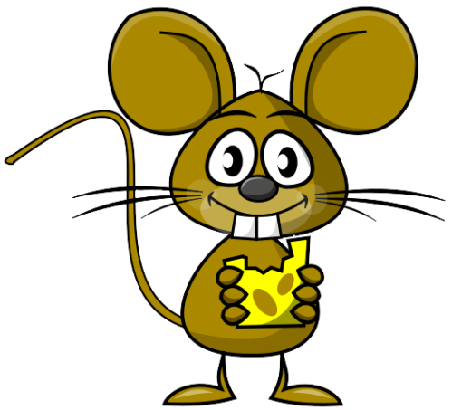

bird : kuş
____________________________________________
____________________________________________
____________________________________________
____________________________________________
____________________________________________

fish : balık
____________________________________________
____________________________________________
____________________________________________
____________________________________________
____________________________________________

mouse : fare
____________________________________________
____________________________________________
____________________________________________
____________________________________________
____________________________________________

www.eegitimim.com

