www.eegitimim.com
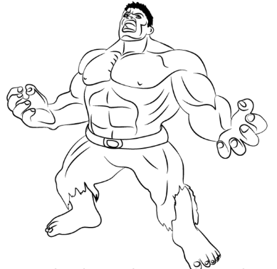
Hello, I am Hulk. I like green and purple.
I don’t like red

Hello, I am Jerry. I like brown. I don’t
like purple

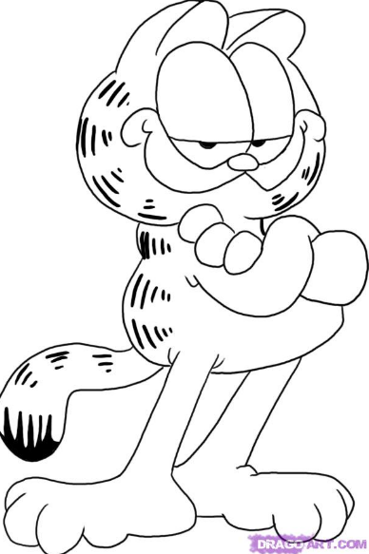
Hello, I am Garfield. I like orange. I don’t
like blue

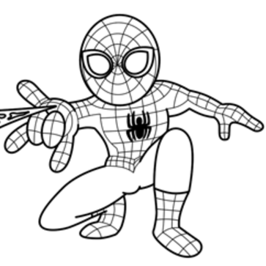

Hello, I am Spiderman. I like blue and red.
I don’t like black

