2.SNIF İNGİLİZCE RENKLER VE RAKAMLAR

ONE 2
THREE 6
FOUR 8
TEN 9
TWO 3
NİNE 1
SİX 5
EİGHT 4
SEVEN 10
FİVE 7

BLUE
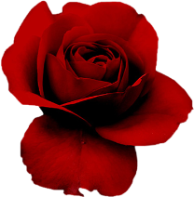
PİNK
RED
ORANGE

BAŞARILR

ZEKİ06

