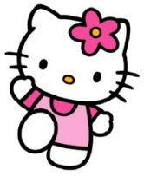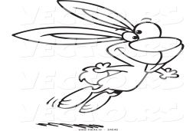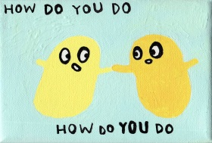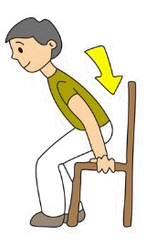
HELLO GOOD BYE THANK YOU JUMP HOW DO YOU DO? SIT DOWN
_______ __________ __________ _________ _________________ ___________
_______ __________ __________ _________ _________________ ___________
_______ __________ __________ _________ _________________ ___________
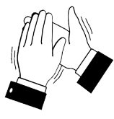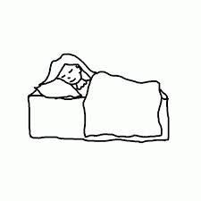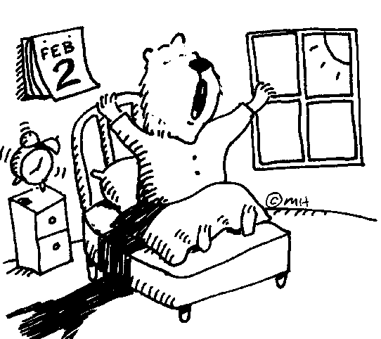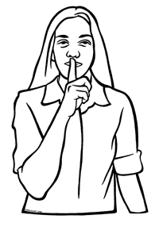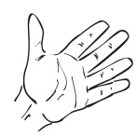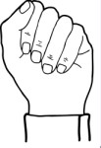
CLAP SLEEP WAKE UP PLEASE, BE QUIET OPEN CLOSE
_______ __________ ___________ ________________ ________ ________
_______ __________ ___________ ________________ ________ ________
_______ __________ ___________ ________________ ________ ________
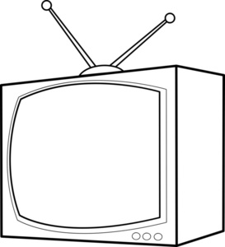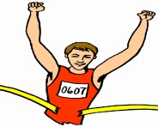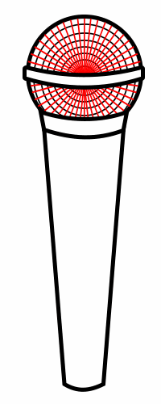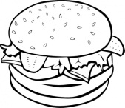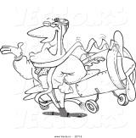
TELEVISION SPORT MICROPHONE DOCTOR HAMBURGER PILOT
__________ ________ ____________ __________ _____________ __________
__________ ________ ____________ __________ _____________ __________
__________ ________ ____________ __________ _____________ __________
ALKIŞLA: AÇ: ZIPLA:
MERHABA: KAPAT: NASILSIN?:
TEŞEKKÜR EDERİM: HAMBURGER: OTUR:
TELEVİZYON: PİLOT: LÜTFEN SESSİZ OL:
SPOR: UYU:
DOKTOR: UYAN:
MİKROFON: SESSİZ OL:

