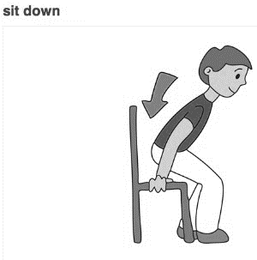

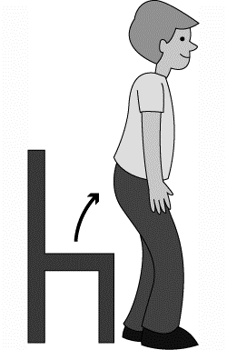



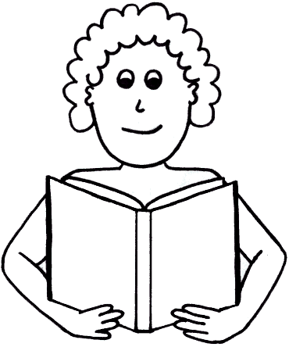

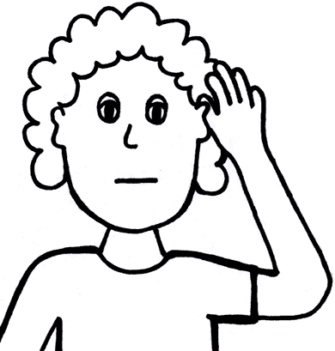

[](http://thumbs.dreamstime.com/z/smartoon-pointing-bullet-point-9696419.jpg)

[](http://1.bp.blogspot.com/_jijUd32uPts/TA_ZxxEw8RI/AAAAAAAAADg/0yHhLvjOM8w/s1600/Writing_1.gif)

[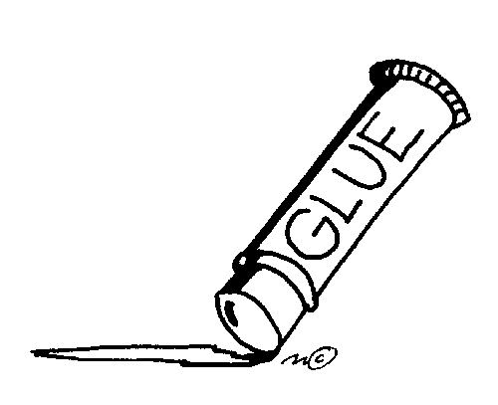](http://school.discoveryeducation.com/clipart/images/gluestik.gif)

[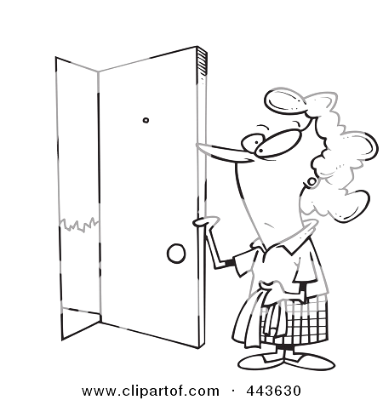](http://images.clipartof.com/Royalty-Free-RF-Clip-Art-Illustration-Of-A-Cartoon-Black-And-White-Outline-Design-Of-A-Woman-Opening-A-Door-1024443630.jpg)

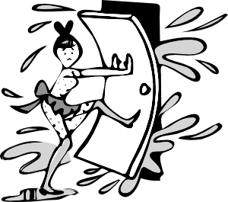

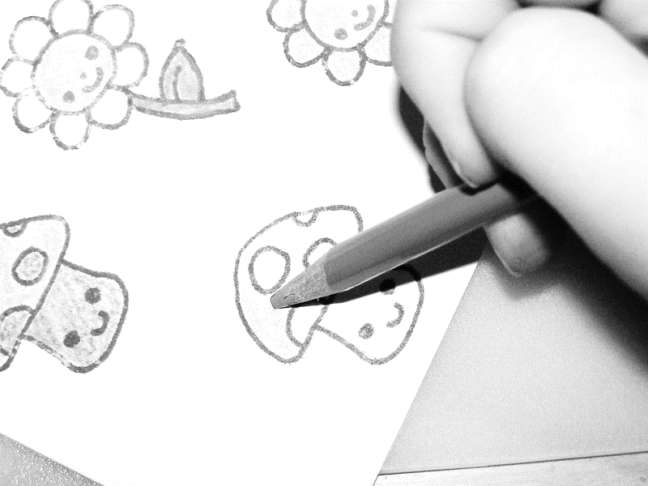



[](http://images.clipartof.com/Royalty-Free-RF-Clip-Art-Illustration-Of-A-Cartoon-Black-And-White-Outline-Design-Of-A-Woman-Opening-A-Door-1024443630.jpg)

[](http://school.discoveryeducation.com/clipart/images/gluestik.gif)

[](http://1.bp.blogspot.com/_jijUd32uPts/TA_ZxxEw8RI/AAAAAAAAADg/0yHhLvjOM8w/s1600/Writing_1.gif)

[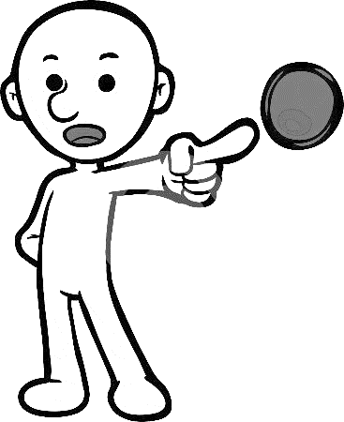](http://thumbs.dreamstime.com/z/smartoon-pointing-bullet-point-9696419.jpg)



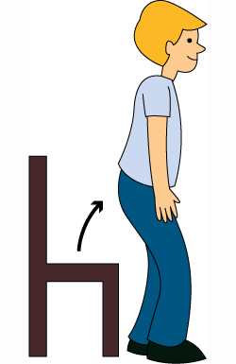

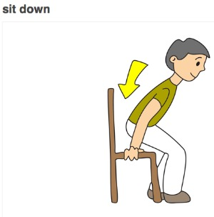

**Sit down**

**Stand up**

**Read**

**color**

**Open**

**Cut**

**Listen**

**stick**

**point**

**close**

**Write**