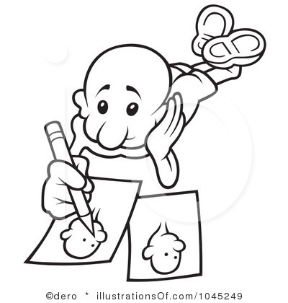

**Draw**

**Color** **paint**

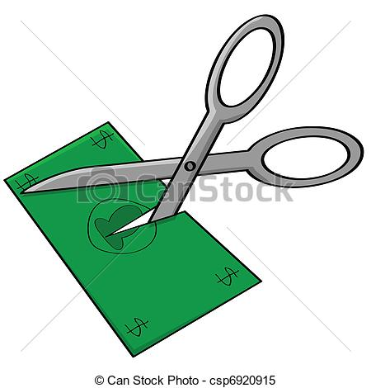

**Cut**

[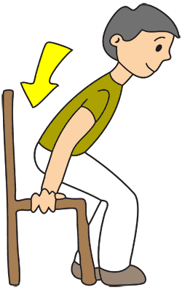](http://www.google.com.tr/url?sa=i&rct=j&q=&esrc=s&frm=1&source=images&cd=&cad=rja&docid=D2XBhbpD6wyerM&tbnid=lhYwKde6Rdk1XM:&ved=0CAUQjRw&url=http%3A%2F%2Fwww.quia.com%2Fjg%2F2454753list.html&ei=DBaBUrPEEI-TswbWkIGACw&bvm=bv.56146854,d.Yms&psig=AFQjCNFFYjYsz4R0vWjaHTGmGR6l3u2rLA&ust=1384277893277645)

**Sit down**

[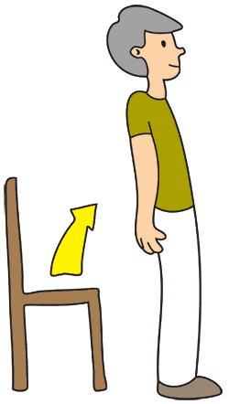](http://www.google.com.tr/url?sa=i&rct=j&q=&esrc=s&frm=1&source=images&cd=&cad=rja&docid=5lVBE6WYajRp6M&tbnid=no8gQN1SS7QpKM:&ved=0CAUQjRw&url=http%3A%2F%2Fwww.thepainauthority.com%2F2012%2F12%2F07%2Fa-simple-and-natural-cure-for-back-pain%2F&ei=nhaBUqvPDYnMswaN1IDYAQ&bvm=bv.56146854,d.Yms&psig=AFQjCNHr3XA0NPpFKdNUzHHLmBthZqhkWA&ust=1384277988632116)

**Stand up**

[](http://www.google.com.tr/url?sa=i&rct=j&q=&esrc=s&frm=1&source=images&cd=&cad=rja&docid=ip-O9mSc-rqbTM&tbnid=yOK7OOEvoPszDM:&ved=0CAUQjRw&url=http%3A%2F%2Fwww.americansinfrance.net%2Fdriving%2FObligationSignsSee.cfm%3FPhotoNumber%3DB21c1%26PhotoDescription%3DTurn%2520Right%2520At%2520Next%2520Intersection&ei=zxaBUuDmEMaztAa5tYDgDA&bvm=bv.56146854,d.Yms&psig=AFQjCNEfR9DOZ0_Dd2bL-u0C1HjaJzJfjA&ust=1384278085493817)

**Turn right**

[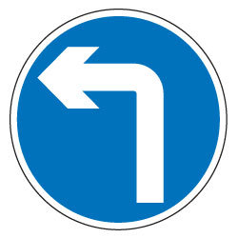](http://www.google.com.tr/url?sa=i&rct=j&q=&esrc=s&frm=1&source=images&cd=&cad=rja&docid=vgJw-WKsS1nmDM&tbnid=jRGNbbGnEo2iVM:&ved=0CAUQjRw&url=http%3A%2F%2Fwww.directa.co.uk%2Fsite%2Fscripts%2Fproduct_browse.php%3Fproduct_id%3D16010&ei=KheBUuu2OMidtQbo-4CACA&bvm=bv.56146854,d.Yms&psig=AFQjCNHebS6dnqE6i0uogdpNk_KuBQiGog&ust=1384278181708416)

**Turn left**

[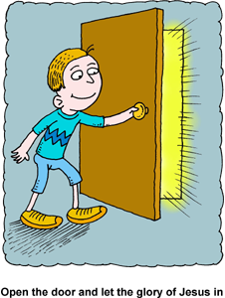](http://www.google.com.tr/url?sa=i&rct=j&q=&esrc=s&frm=1&source=images&cd=&cad=rja&docid=xlWLBeR6XQX1LM&tbnid=9_WZA81d779NFM:&ved=0CAUQjRw&url=http%3A%2F%2Fwww.christart.com%2Fclipart%2Fimage%2Fglory-door&ei=lheBUrCQKMKXtQbFo4CgBQ&bvm=bv.56146854,d.Yms&psig=AFQjCNF0QSzPyGn563tLE4zYx1L7yVealg&ust=1384278227736849)

**Open the door**

[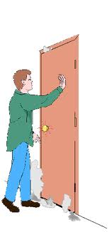](http://www.google.com.tr/url?sa=i&source=images&cd=&cad=rja&docid=UcK5elULF1Wr5M&tbnid=RWhaAZjpuVM_0M:&ved=0CAgQjRwwAA&url=http%3A%2F%2Fppo.tamuk.edu%2Fehs%2FFire_Brochure%2Fpage_2.htm&ei=CxiBUvPdAovLswao64CICQ&psig=AFQjCNHqHQVtdgyyJJyHZck_qh6k4kP39w&ust=1384278411102759)

[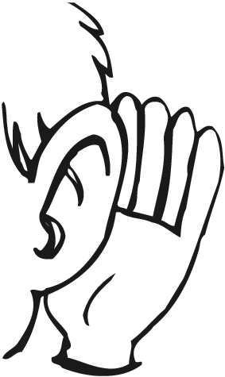](http://www.google.com.tr/url?sa=i&rct=j&q=&esrc=s&frm=1&source=images&cd=&cad=rja&docid=6MSNCBdSfPoPZM&tbnid=Aj1GJKR8e5-a-M:&ved=0CAUQjRw&url=http%3A%2F%2Frkb-lbc-09.blogspot.com%2F2010%2F03%2Flook-dont-see-listen-dont-hear.html&ei=KxmBUrS4H8bVtAan74HwCw&bvm=bv.56146854,d.Yms&psig=AFQjCNGWUO45DXc7FO_KhfHG0yaLkz2-dw&ust=1384278697115289)[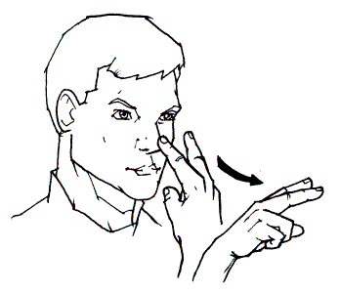](http://www.google.com.tr/url?sa=i&rct=j&q=&esrc=s&frm=1&source=images&cd=&cad=rja&docid=FYFo5gbO9DeOnM&tbnid=NQyIgp-E8ILTiM:&ved=0CAUQjRw&url=http%3A%2F%2Flifeprint.com%2Fasl101%2Fpages-signs%2Fl%2Flook.htm&ei=phiBUpaWKsGEtAbRkoGACQ&psig=AFQjCNHmWoJINRYZ7xaTA7bIQm7gFyxFaA&ust=1384278560973239)**Close the door**

**LOOK listen**