HOW MANY …..? (KAÇ TANE….?) (Soruları örnekteki gibi cevaplayıp resimleri boyayınız)

1.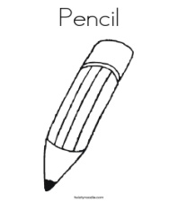How many pencils are there? ………One pencil……… .

2.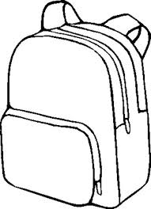 How many school bags are there? …………………………………………………….. .. 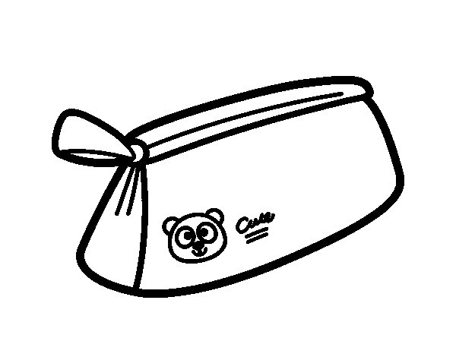How many pencil cases are there? ………………………………………… .

4. 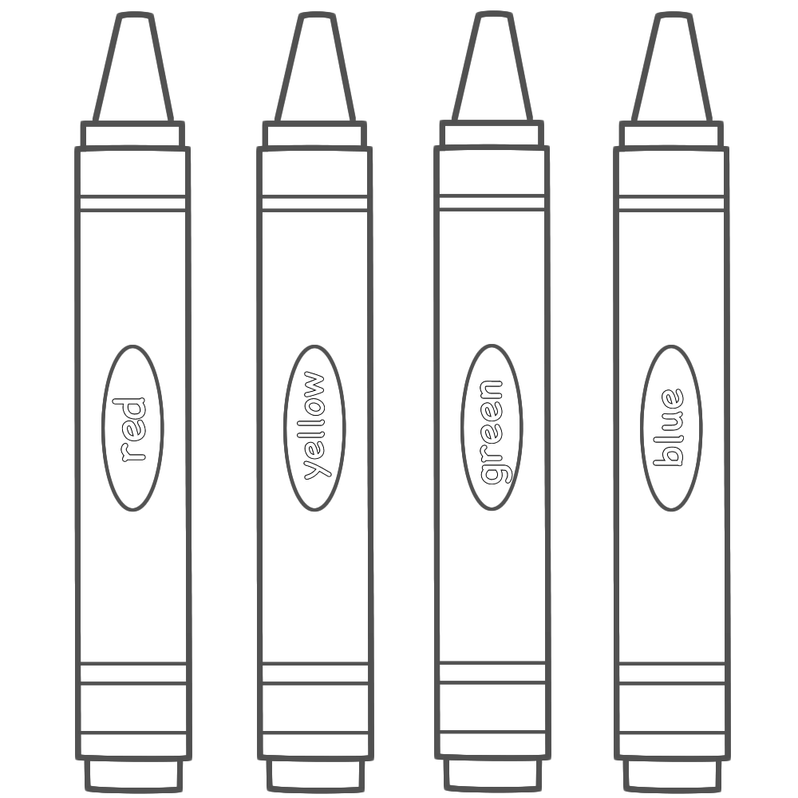How many crayons are there? ……………………………………………. .

5.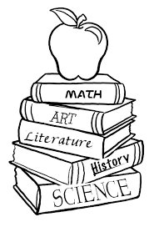How many books are there? ……………………………………………. .

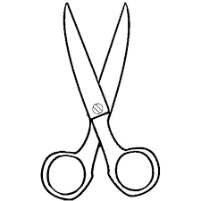  How many scissors are there? …………………………………………

7.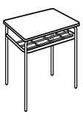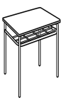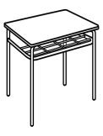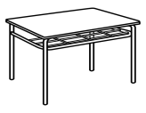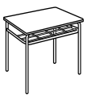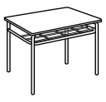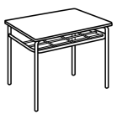How many desks are there? …………………………………..

8.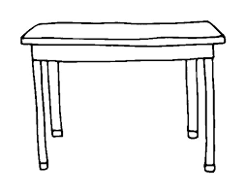How many tables are there? …………………………

9.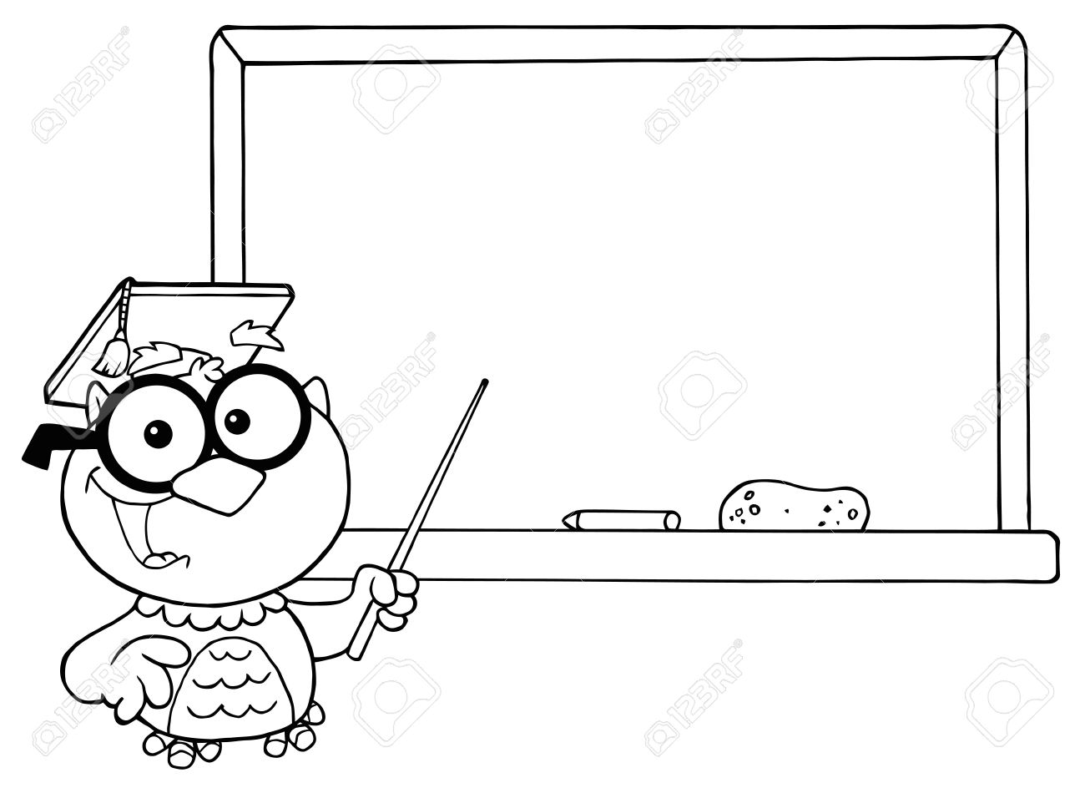 

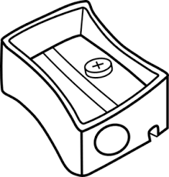How many boards are there?........................................

10.How many sharpeners are there ? ……………………………………………………….

