1st AND 2nd UNITS REVISION TEST FOR 3rd GRADERS

1.What is this? 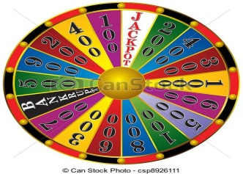
a) Wheel b) letter
c) banana d) orange
2.How many apples are there?
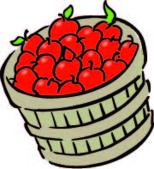
a) fifteen
b) sixteen
c) seventeen
d) eighteen
3. 9+5= ?
a) fifteen b) twenty
c) sixteen d) fourteen
4.Aşağıda ilk harfleri verilmeyen üç kelimeyi tamamlayacak ortak harf hangisidir?
__pell __pin __tart
a) C b) D c) W d) S
5. nine X two = ?
a) sixteen b) eighteen
c) nineteen d) seventeen
6. What colour is a banana?
a) red b) blue c) white d) yellow

7. Start X ……………………. Kelimenin zıt anlamlısı hangisidir?
a) ask b) stop c) spin d) win
8. 24 – 4 = ?
a) twenty b) six
c) twelve d) eleven
9. Resmi verilen kelime hangisidir?
a) spell b) look
c) wait d) answer
10. Aşağıda verilen kelimelerle oluşturulan kurallı cümle hangisidir?
again- that –please –say
a) Say please that again
b) Say that again,please.
c) That say please again.
d) That again say please.
11. He is my ………………………….
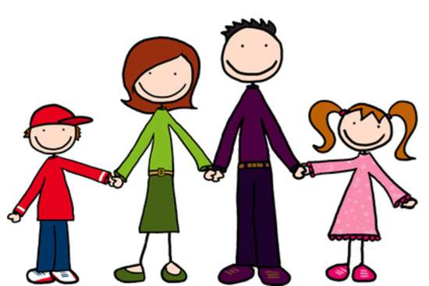
a) mother b) aunt c) uncle d) sister
12. This is my …………
a) aunt b) family
c) cousin d) uncle

13. My mother’s sister is my ………………
a) brother b) father
c) aunt d) uncle
14. Aşağıdaki kelimelerdeki eksik harfler hangi seçenekte doğru sıra ile verilmiştir?
C_USIN – SI_TER – MO_HER - GRA_DFATHER
a) O - S -T - N b) T - S - O - N
c) N - T - S - O d) N - T - S - O
15. She is my ____________.
a) uncle b) father
c) sister d) brother.
16. Seçeneklerdeki kelimeler cinsiyete göre gruplandırıldığında hangisi dışarıda kalır?
a) sister b) grandfather
b) mother d) grandmother
17. Who is this?
a) father b) grandfather
b) mother c) grandmother

18. My uncle is my father’s ……….
a) brother b) sister
c) cousin d) aunt

