QUIZ FOR THE 3rd GRADES

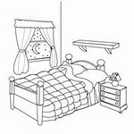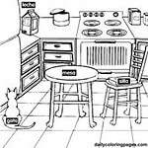1- 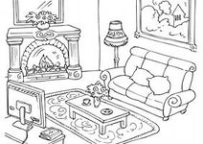

Yukarıdaki resimlere göre aşağıdaki sıralamalardan hangisi doğrudur?

a) kitchen – bedroom – living room

b) bedroom – kitchen – living room

c) living room – kitchen – bedroom

d) living room – bedroom – kitchen

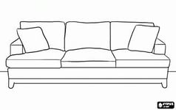2- Resme uygun seçenek

hangisidir?

a) sofa b) chair

c) bed d) table

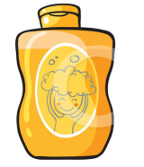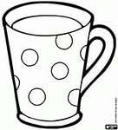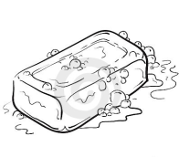

3-

Yukarıdaki resimlere göre aşağıdaki sıralamalardan hangisi doğrudur?

a) cup – shampoo – soap

b) soap – shampoo – cup

c) shampoo – soap – cup

d) soap – cup – shampoo

4- 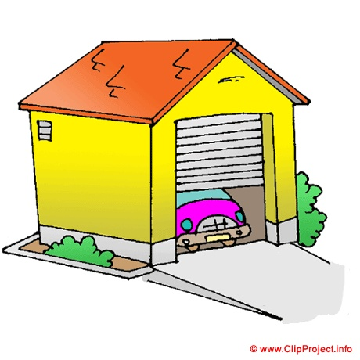 Where is the car?

a)Yes,it is.

b)It is in the garage.

c)No, it isn’t.

d)It is in the bathroom.

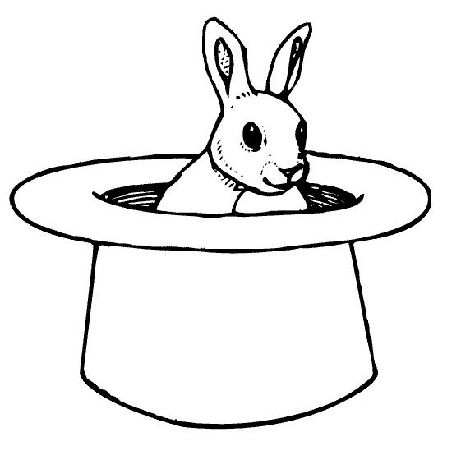5- A: Where is the rabbit?

B: It is……………..the hat.

a)on b)in

c)under d)next to

6- A: Where is the teddy bear?

B: It is …………the box.

a)on b) behind

c) in front of d) between

7- A: Where is the box?

B:It is ……….the teddy bears.

a) in b) next to

c) between d) behind

8- A: Where is the teddy bear?

B: It is ………………the box.

a) on b) in front of

c) under d) behind

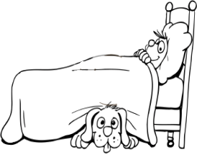

9- A:Where is the dog?

B:It is………….the bed.

a) in b) on

c) under d) near

MC900299853[1]MC900297899[1]10-

Yukarıdaki resimlere göre aşağıdaki sıralamalardan hangisi doğrudur?

a) puzzle – kite – board game

b) kite – board game – puzzle

c) board game – kite – puzzle

d) puzzle – board game – kite



11-

How many robots are there?

a)eleven b) ten c) eight d) twenty

[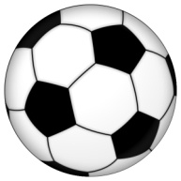](http://www.google.com.tr/url?sa=i&rct=j&q=&esrc=s&frm=1&source=images&cd=&cad=rja&uact=8&ved=0CAcQjRw&url=http://www.gaziantep.com/tr/spor/futbol-topu&ei=MGbxVIXcKYnCPLmqgYgD&bvm=bv.87269000,d.bGQ&psig=AFQjCNGvraPsB2Q7stj8u6E3C_G75lrPxw&ust=1425192864867854)12- The ball is…………………

a) square b) triangle

c) rectangle d) round

13- “purple – blue – yellow – white – red”

Yukarıda verilmeyen renk hangisidir?

a)mor b) kırmızı c) sarı d) siyah

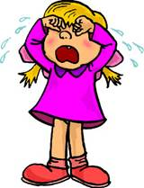14- What is she doing?

a) She is cooking.

b) She is eating.

c) She is crying.

d) She is studying.

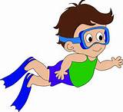15- Is he swimming?

a)Yes, he is.

b) No, he isn’t.

c) Yes, she is.

d) No, she isn’t.

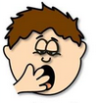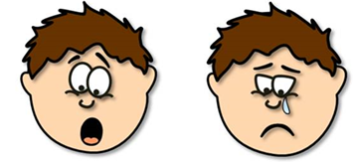16-

Yukarıdaki ifadeler hangi şıkta sırasıyla doğru verilmiştir?

a) tired – surprised – sad

b) tired – happy – surprised

c) angry – sad – happy

d) energetic – surprised – sad

17- 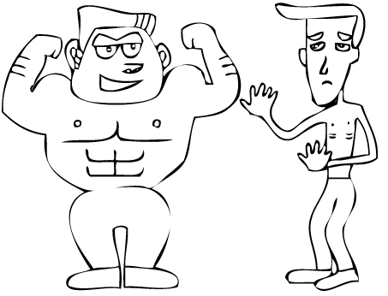 Resmi ifade eden zıt

anlamlı kelimeler

hangisidir?

a) fast x slow

b) strong x weak

c) tall x short

d) fat x thin

18- He is my ……………………….

a) grandmother

b) aunt

c) grandfather

d) sister

19- “twelve – sixteen – nine – twenty”

Yukarıda verilmeyen sayı hangisidir?

a)yirmi b)on altı c) dokuz d) on üç

20- “Cevap verebilir miyim?” sorusunu nasıl sorarız?

a) Can I answer? b) Can I ask?

c) Can I say? d) Can I go?

21- A: Can you play football?

B: ……………………………………..

a) Yes, he can. b) No, he can’t.

c) Yes, I can. d) No, she can’t.

22- Resimde hangi eylem

anlatılıyor?

a) wait b) stop

c) win d) spell

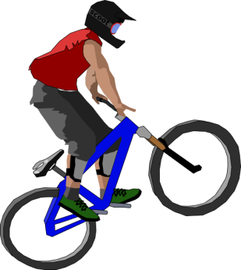23- Yandaki görsele uygun

cümle hangisidir?

a) I can drive a car.

b) I can ride a bike.

c) I can climb trees.

d) I can ride a horse.

24-BIG X …………. Kelimesinin zıt anlamlısı hangisidir?

a) young b) tall c) fast d) small

25- A: Where is Egemen?

B:……………………………………………

a) He is in the bedroom. b) He is thin.

c) Yes, he is. c) He is seven.

GOOD LUCK ☺☺☺