OSMANBEY PRIMARY SCHOOL 2014-2015 ACADEMIC YEAR
3RD GRADES 1ST TERM 1ST EXAM
Name-Surname: Class: Number: Mark:
A)Answer the questions.(Sorulara cevap veriniz.)(2x6=12pts.)

1)What is your name?
……………………………………………………..
2)How old are you?
……………………………………………………..

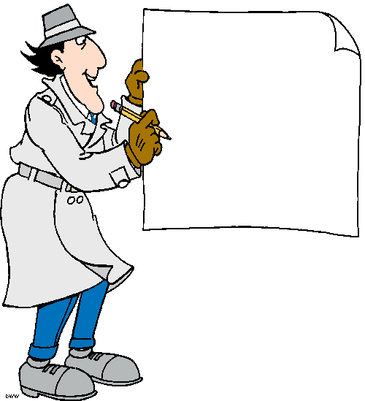
B)Match the pictures with the words. (Resimleri kelimelerle eşleştiriniz.)(6x4=24pts.)
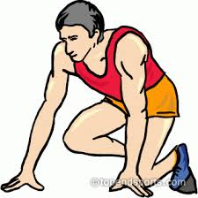
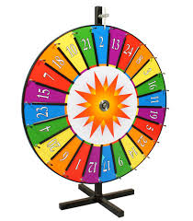
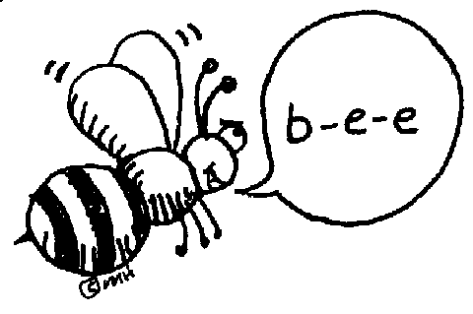

C)Write the numbers.(Sayıları yazınız.)(5x2=10pts.)
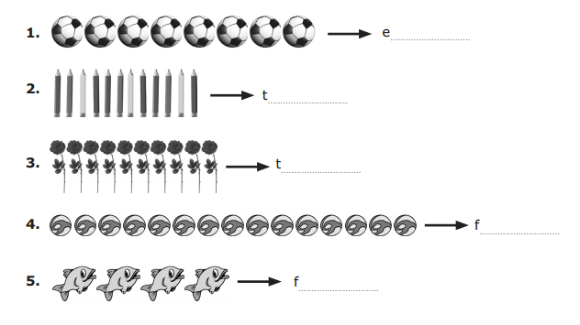
D)Write the names of the family members.(Aile üyelerinin isimlerini yazınız.)(6x4=24pts.)
Brother Grandmother Father Sister Grandfather Mother

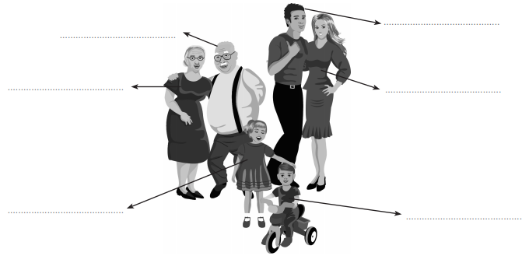
E)Answer the questions.(Sorulara cevap veriniz.)(6x5=30pts.)
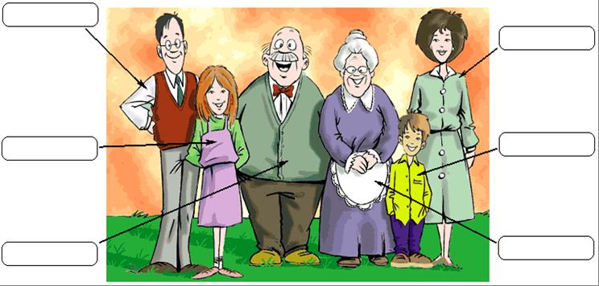
SAM
SALLY
MARRY
JOHN
BILL
GLORIA
1)Who is Gloria?
She is my ……………...............
2)Who is Sam?
He is my ………………………..
3)Who is Bill?
……………………………………..

4)Who is Sally?
……………………………………
6)Who is John?
5)Who is Marry?
…………………………………..

…………………………………….
TEACHER OF ENGLISH 