**Resme uygun şıkkı işaretleyin.**

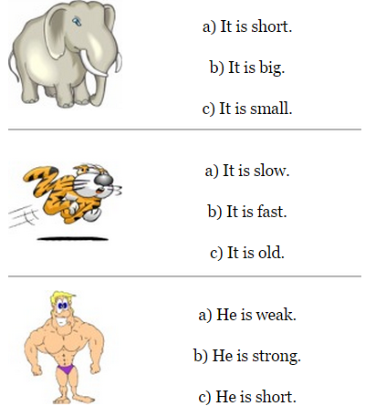

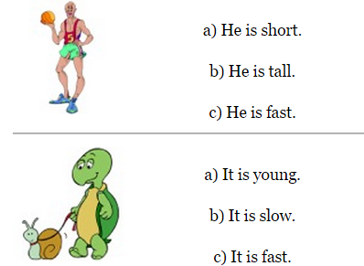

**Sayıların İngilizcelerini yazın.**

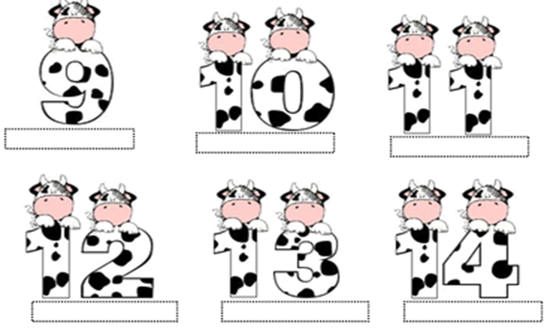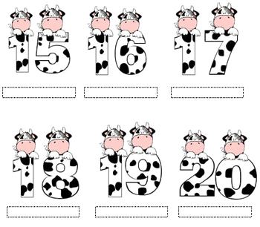

**How do you feel?(Nasıl hissediyorsun?)**

**Resme uygun şıkkı işaretleyin.**



1. **I feel surprised. a) I am sad.**
2. **I feel angry. b) I am angry.**



1. **I feel energetic. a) I am happy.**
2. **I feel angry. b) I am sad.**



1. **I am tired. a) I am hungry.**
2. **I am good. b) I am bad.**

**UNIT 4 (Şu anda gerçekleştirdiğimiz eylemler)**

**Verilen kelimeleri kullanarak soru sorun ve cevaplayın.**

***(eat-study-sing-cook-cry-swim)***

** **

**- What is he doing? -What is she doing?**

**- He is studying. -…………………………………**

** **

**-…………………..……….? -……………………………………?**

**-……………………….…... -……………………………….…..**

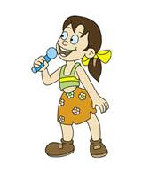 

**-…..………………………………? -…………………………………….?**

**-……………….……………………. -…………………………………….**

**MY FAMILY**

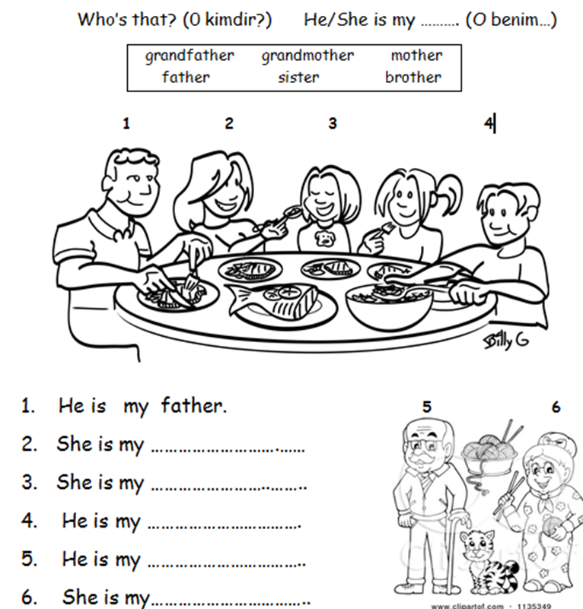

**WHEEL OF FORTUNE**

Resme uygun ifadeyi işaretleyin.

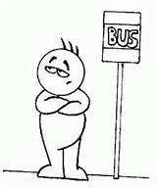 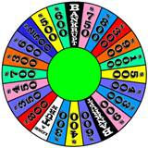

1. **Win a) Answer a)Wheel**
2. **Wait b) Letter b)Start**
3. **Spin c) Stop c)Win**

**  **

1. **Ask a) Start a) Win**
2. **Start b) Stop b) Letter**
3. **Win c) Spin c) Wait**

**Abilities (Can /Can’t) –e bilmek/-e bilememek**

**Resimlere bakın, verilen kelimelerle can ve can’t kullarak cümleler kurun.**

***(run fast - climb a tree – play the piano – jump)***



**She can swim. He can’t ride a bike.**

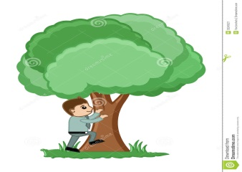

**……………………………… …………………………………………**



**………………………… …………………………………….**



**100.YIL PRIMARY SCHOOL**

**My English**

**Booklet**

**3/A -3/C -3/E -3/G- 3/J-3/L- 3/N- 3/Ö GRADES**

**My name is ………………………………………………..**

**TEACHERS: ÖZLEM ZORLU**

**Have a nice winter holiday!!**

***EXERCISE : Answer the questions -Soruları cevaplayınız.***

1.  **Is it square? 2.** **Is it rectangle?**

**------------- ----------------**

**3.  Is it oval ? 4.  Is it triangle ?**

**------------------- ---------------------**

**HOW MANY………? -Kaç tane……?**

**1.How many trains are there?………………………**

**2.How many balls are there ?.............**

**3. How many cars are there?...................**

**4. How many robots are there ?.................**

***Do you have a/an……….? : Bu soru kalıbı bir kişinin bir şeye sahip olup olmadığını sormak için kullanılır.***

***Example: Do you have a bike? – Yes, I do.***

***Do you have a teddy bear ? – No, I don t.***

**Answer the questions - Soruları cevaplayınız**

**1. Do you have a train ?(+) ……………………………………………………...**

**2. Do you have a kite? (-) …………………………………………………..**

**3. Do you have a board game? (+) ……………………………………..**

**4. Do you have a truck ? (-) ………………………………………………….**

**5. Do you have plane ? (-) ……………………………………………..**

**6. Do you have a doll ? (+) …………………………………………………….**

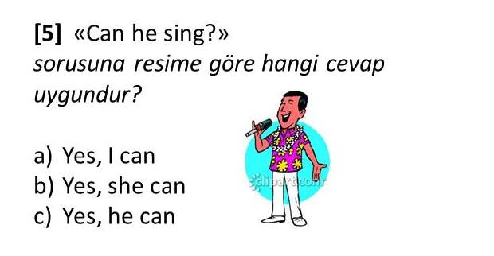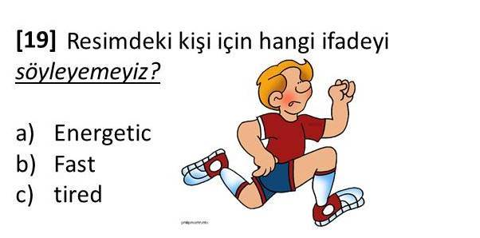

2

1

**3.YİRMİ : ..................  
A)Nineteen    B)Twenty     C)Twelve**

**4:.........is my cat.   
A)She B) He C)It**

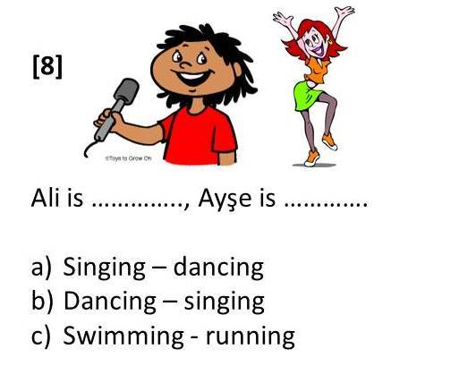

5

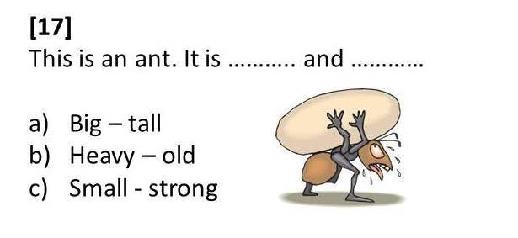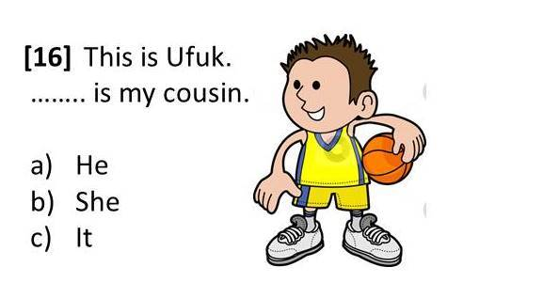

7

6

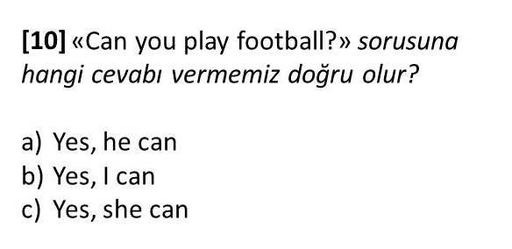

8

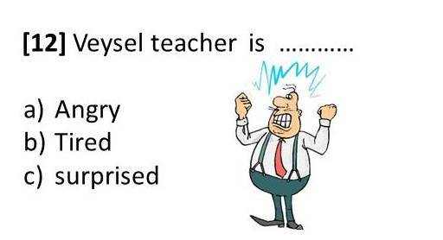**10. 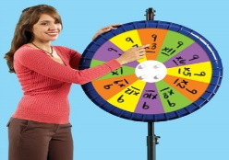 Resmi anlatan ifade hangisidir?**

9

**A)ask a question b)wait your turn c)spin the wheel d) spell it**

**11)Look! She.................mysister.**  
  
**A)**Are     **B)** Is     **C)**It

**12. “ __OOK” kelimesinin ilk harfi hangisi olmalıdır?**

**a) T b) C c) W d) H**

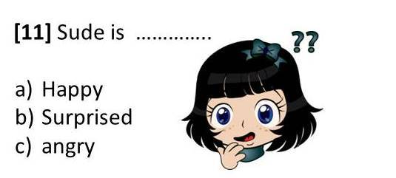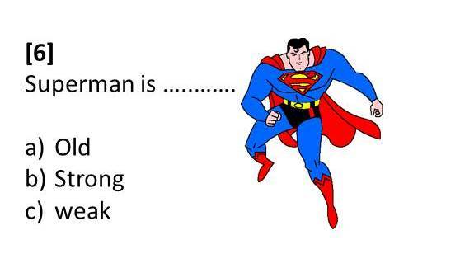

14

13