**REVISION TEST FOR 3rd GRADERS**

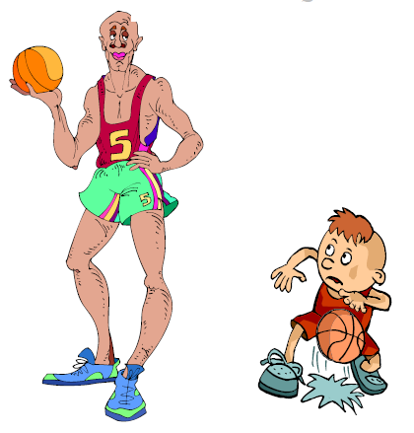**1. Resimdeki kişiler için hangi sıfatların kullanılması uygun olur?**

**a)** Tall – Short **b)** Heavy– Thin

**c)** Old- Young **d)** Fast- Slow

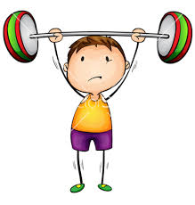**2. Resimdeki kişi için hangisi söylenemez?**

**a)** Strong **b)** Young

**c)** Fast **d)** Short

**3. *“ Ben bisiklete binemem”* cümlesinin İngilizcesi hangi seçenekte verilmiştir?**

**a)** I can’t play guitar.

**b)** I can’t ride a bike.

**c)** I can’t fly a kite.

**d)** I can’t dance

**4.Aşağıda ilk harfleri verilmeyen üç kelimeyi tamamlayacak ortak harf hangisidir?**

**__all __ired __eddy bear**

**a)** C **b)** D **c)** W **d)** T

**5. How does he feel?  *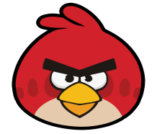***

**a)** happy **b)** angry

**c)** sad **d)** energetic

**6. What is this?** 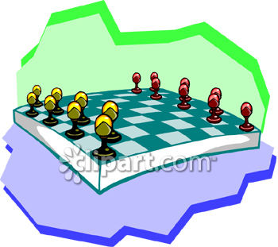

**a)** ball **b)** doll

**c)** board game **d)** teddy bear

**7. Happy X ……………………. Kelimenin zıt anlamlısı hangisidir?**

**a)** sad **b)** energetic **c)** angry **d)** tired

**8. 18 – 5 = ?**

**a)** ten **b)** thirteen

**c)** fifteen **d)** seventeen

**9. Today is my birthday. I feel ________** 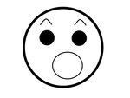

**a)** okay **b)** happy

**c)** bad **d)** surprised

**10. 12 + 7= ?**

**a)** twenty **b)** fifteen

**c)** twelve **d)** nineteen

**11. The rabbit is ______ but the turtle is ________**

**a)** tall / short

**b)** heavy / thin

**c)** fast / slow

**d)** old / young

**12. 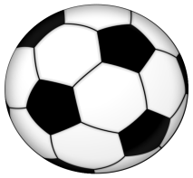 My ball is ______ and ______.**

**a)** black- white **b)** blue – yellow

**c)** red – orange **d)** purple - pink

**13. Aşağıdaki kelimelerdeki eksik harfler hangi seçenekte doğru sıra ile verilmiştir?**

**R__AD – PLA__ FOOTBALL SWI__ - J__MP**

**a)** U – M – E – Y **b)** A – P – U - M

**c)** E – Y – M – U **d)** Y – M – E – U

**14.** Resimdeki nedir? 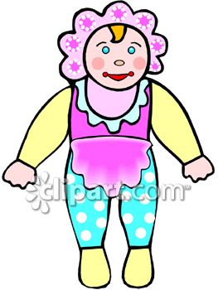

**a)** ball **b)** doll

**c)** button **d)** blocks

**15. BIG X …………. Kelimesinin zıt anlamlısı hangisidir?**

**a)** young **b)** tall **c)** fast **d)** small

**16. I feel __________*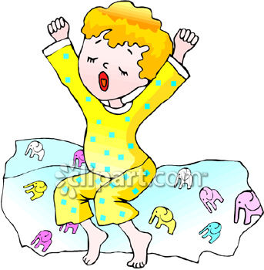***

**a)** tired  **b)**happy **c)** angry  **d)** bad

**17. I can run fast because I feel __________**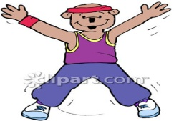

**a)** tired

**b)** angry

**c)** energetic

**d)** bad

**18. “Ben yüzebilirim” cümlesinin İngilizcesi hangisidir?**

**a)** I can play football

**b)** I can read

**c)** I can climb a tree

**d)** I can swim

**19. Let’s play ________**

**a)** football **b)** guitar

**c)** tennis **d)** basketball

**20. “ __OOK” kelimesinin ilk harfi hangisi olmalıdır?**

**a) T b) C c) W d) H**