Is she fat?  a. Yes, she is.  b. No, she isn’t. | 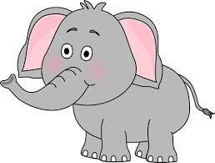  Is it small?  a. Yes, it is.  b. No, it isn’t.
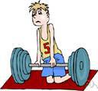  Is he weak?  a. Yes, he is.  b. No, he isn’t. | Is it slow?  a. Yes, it is.  b. No, it isn’t.
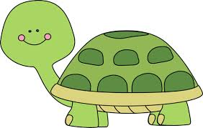  Is it slow?  a. Yes, it is.  b. No, it isn’t. | 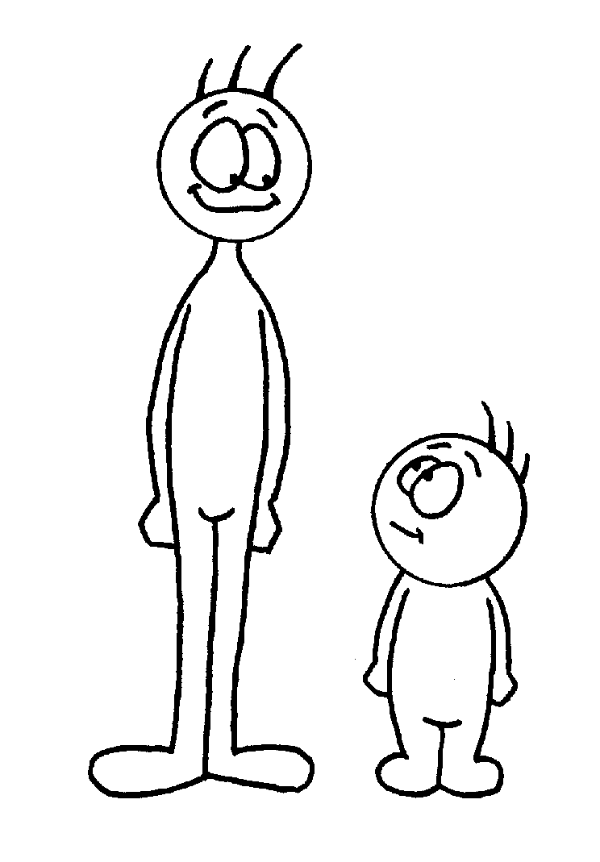  Is he short?  a. Yes, he is.  b. No, he isn’t.
Is he young?  a. Yes, he is.  b. No,he isn’t. | Is she thin?  a. Yes, she is.  b. No, she isn’t
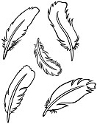  Is it heavy?  a. Yes, it is.  b. No, it isn’t. | 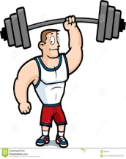  Is he strong?  a. Yes, he is.  b. No,he isn’t.
Choose the correct options. (Doğru seçeneği işaretleyiniz.)

