NAME:

**Onlar neredeler? ( resimlerin altındaki doğru şıkkı yuvarlak içine alınız.**)

At the airport

At the library

At the zoo

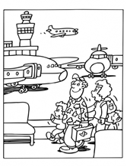

At the post office

At the library

At the museum

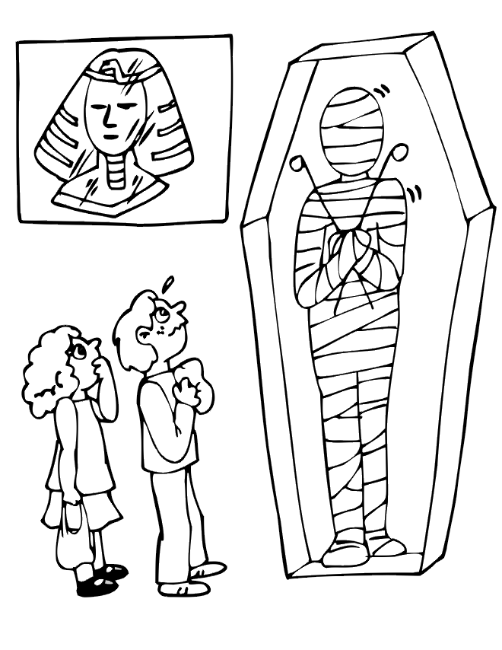

At the post office

At the library

At the museum

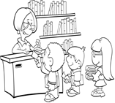

At the shoping centre

At the zoo

İn the park

At the hospital

At the zoo

At the cinema

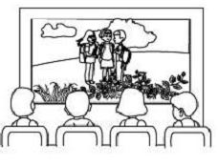

At the shoping centre

At the school

İn the park



At the hospital

At the zoo

İn the park

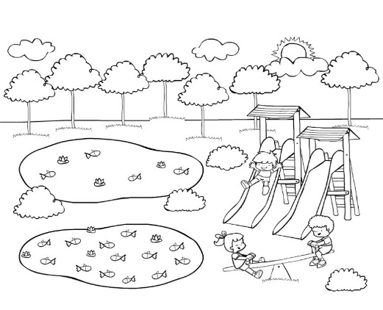

At the bank

At the cinema

İn the park

At the hospital

At the zoo

At the theater

At the hospital

At the zoo

At the cinema

