COLOURS
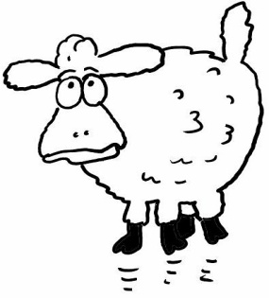
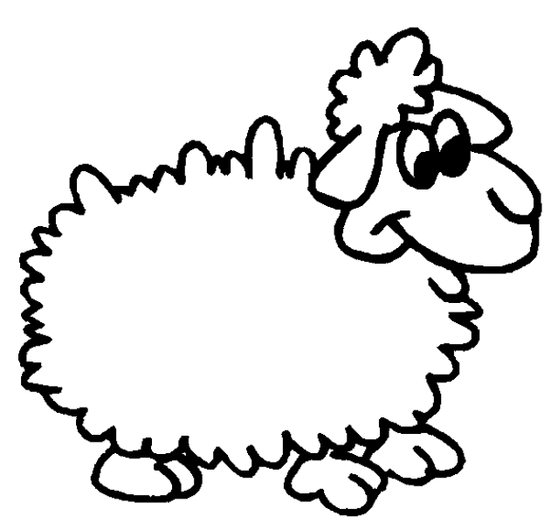
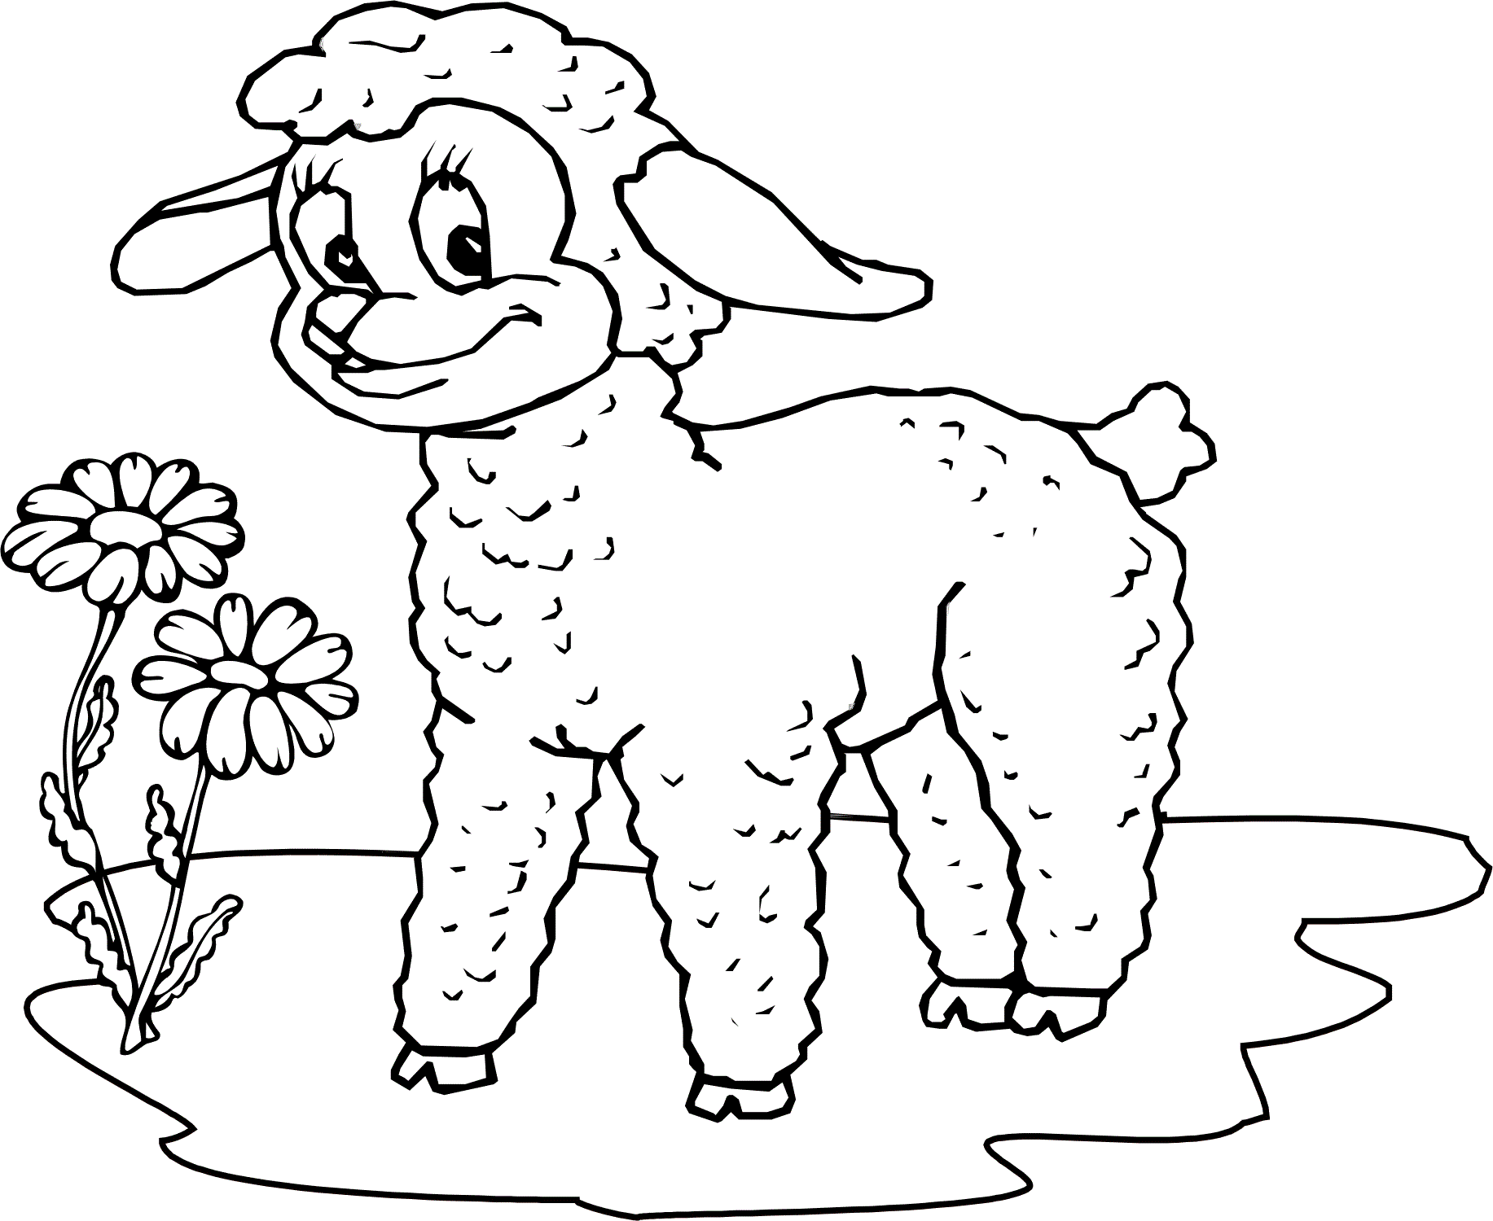
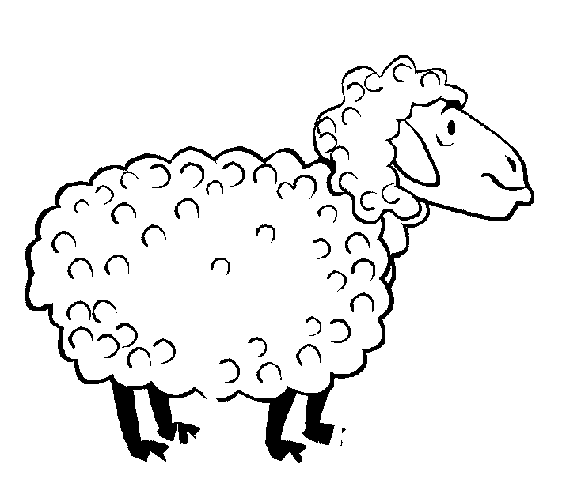
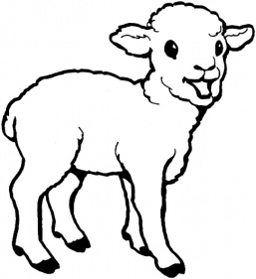
1. Paint

red blue yellow pink green

brown purple white black grey

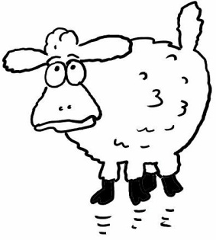

orange dark blue light blue dark green light green

What colour is it?
- What colour is it? (red) (O, ne renktir?)
İt is red. (O, kırmızıdır.)
- What colour is it? (yellow)
İt is …………….
- What colour is it? (orange)
- İt is …………….
- What……………... is it? (blue)
It is …………….
- What…………….. is it? (black)
It is …………….
- ………… colour is it? (pink)
…………………. pink.
- ………… colour is it? (white)
…………………. white.
- What colour ………………? (purple)
It ……. purple.
- What colour ………………? (green)
It ……. green.

