 

carry a rock

read a book

 

climb a tree

ride a horse

 

play guitar

**swim**

 

drive a car

take a photo

 

cook meal

catch

 

play piano

do puzzles

 

carry a rock

ride a bike

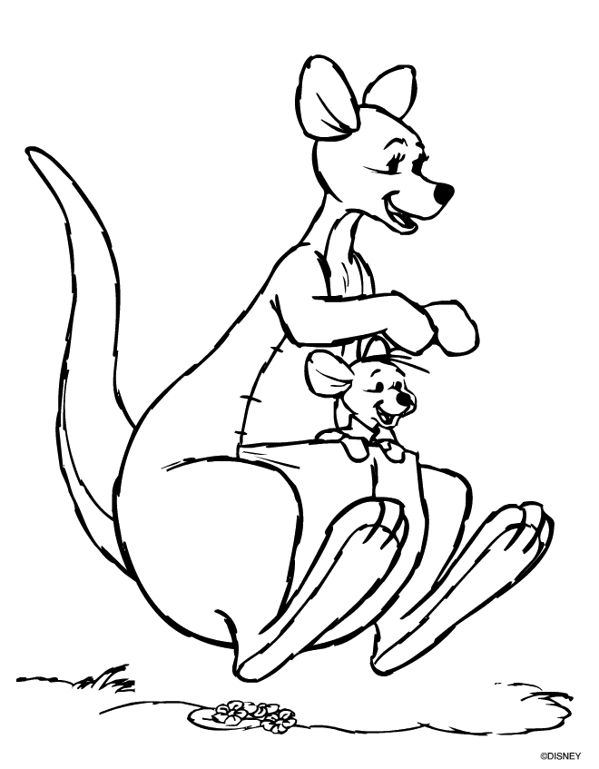 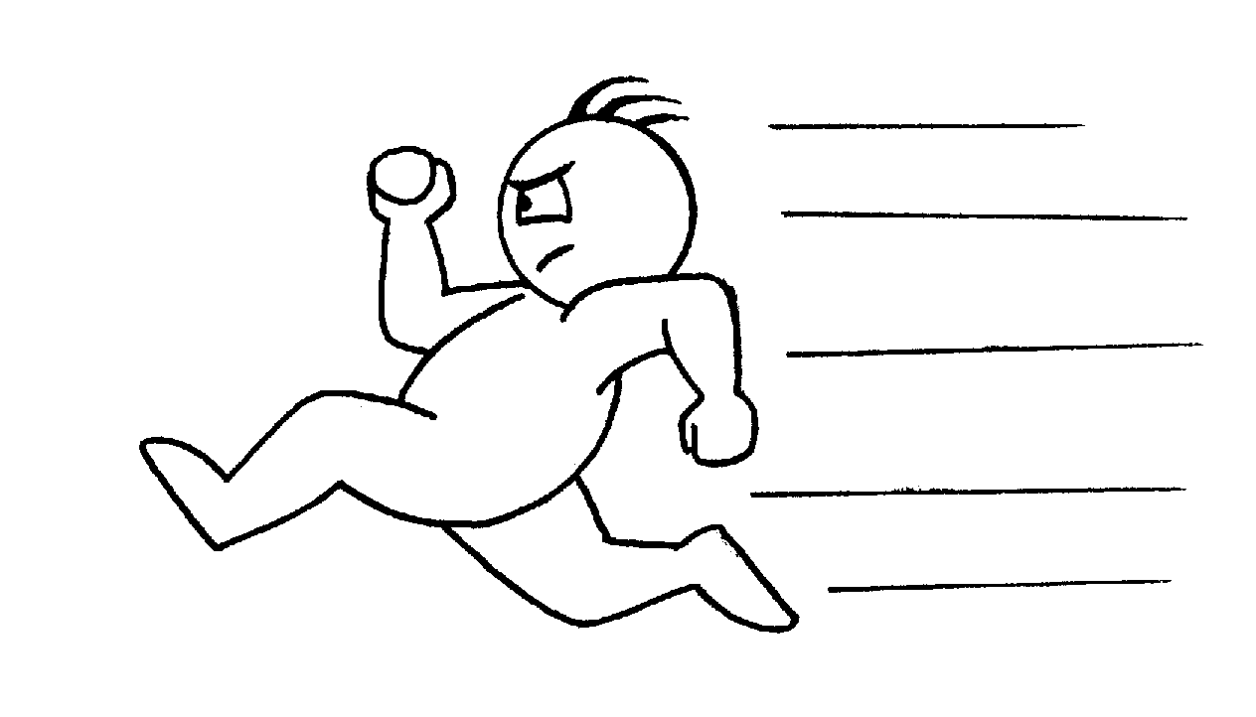 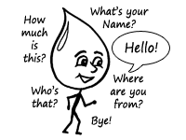

fly

jump

run

speak English

 

carry a rock

read a book

 

climb a tree

ride a horse

 

play guitar

**swim**

 

drive a car

take a photo

 

cook meal

catch

 

play piano

do puzzles

 

carry a rock

ride a bike

  

fly

jump

run

speak English