Revision unit1-6

1. What’s your name?
a.My name is Mary . c.I is Mary.
b.I Mary. d.Name is Mary

2. 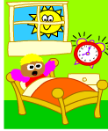 Good………!
a.afternoon c.hello
b.morning d.evening

3.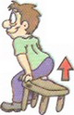
a.listen c.sit down
b.be quiet d.stand up

4. 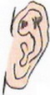
a.listen c.repeat
b.read the sentences d.write your name

5.Raise your………..
a.quiet c.hand
b.board d.down

6………………..the question.
a.sit c.raise
b.look d.answer

7. 1-3 -5
a.one-five three c.one-tree-five
b.one-three-five d.three-five one
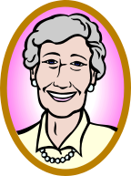
8. a.father
b.grandfather
c.brother
d.grandmother

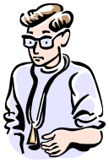
9.
a.uncle
b.mother
c.sister
d.aunt

a.t-shirt
b.sweater
c.hat
d.dress

11 a.hat

b.gloves
c.socks
d.coat


12 a.boots
b.shoes
c.sneakers d.sleepers

13. blue-red-brown
a.mavi-kırmızı-turuncu
b.mavi-kırmızı-kahverengi c.mavi-sarı-kahverengi
d.mavi-kırmızı-siyah

14.yeşil-sarı-beyaz
a.blue-yellow-white
b.green-yellow-black
c.green-yellow-white
d.green-yellow-orange

15. a.notebook
b.book
c.desk
d.pen

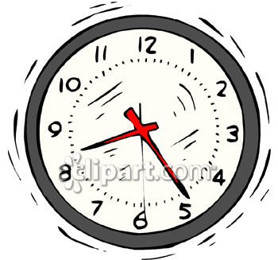
16 a.board
b.clock
c.chair
d.table



17.

a.pen c.pencil
b.chalk d.pencilcase

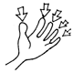
18.
a. hands
b.fingers
c.legs
d.eyes


19.
a.nose
b.foot
c.hand
d.mouth

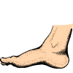
20. a.arm
b.foot
c.leg
d.finger

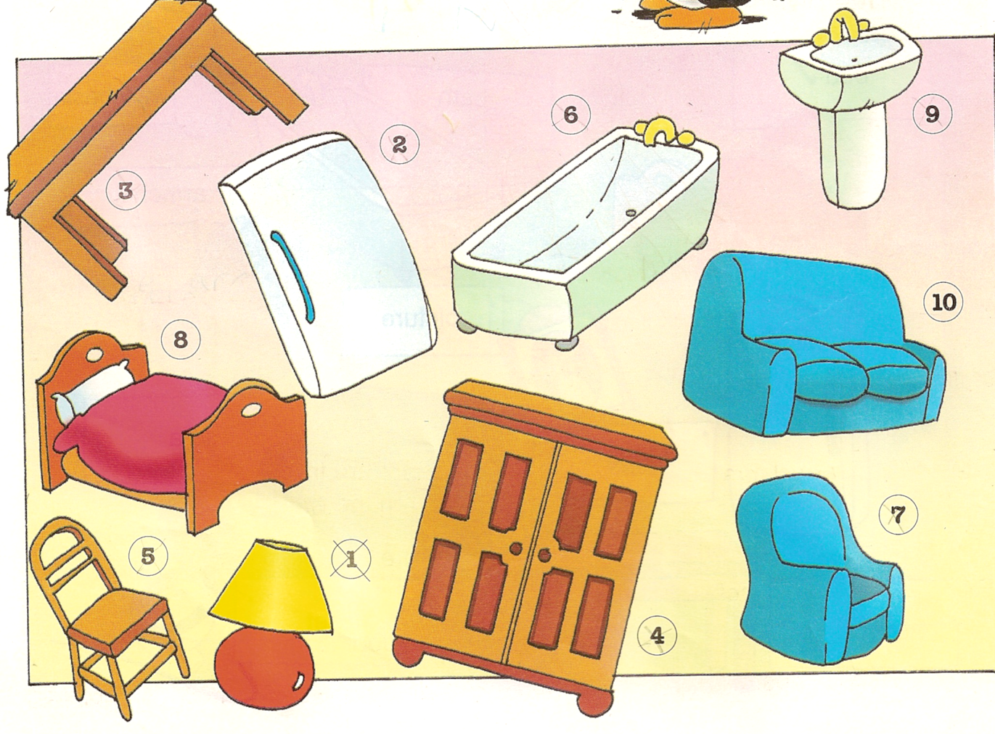
21

a.sofa c.rug
b.armchair d.clock

22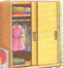

a.wardrope c.toilet
b.bathtup d.bed

23.Bathroom
a.bathtub c.sofa
b.bed d.fridge

24.Kitchen
a.bookcase c.toilet
b.wardrope d.fridge

25.Livingroom
a.sofa c.shower
b.watdrope d.cooker

26.Bedroom
a.tap c.washbasin
b.bed d.fridge

27. 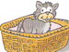
a.in c.next to
b.on d.under

28
a.in c.next to
b.on d.under

29. 
a.in c.next to
b.on d.under

30. 
a.in c.next to
b.on d.under

