**SBS EXAM FOR 4TH GRADE STUDENTS**



**1)** I have got and

A) T-shirt / jeans

B) shirt / a short

C) coat / shorts

D) a T-shirt / shorts

**2)** Aşağıdaki seçeneklerden hangisi ***yanlıştır?***

A) My father’s father is my grandpa.

B) My father’s wife is my mother.

C) My mother’s brother is my aunt.

D) My uncle’s son is my cousin.

**3)** Aşağıdaki seçeneklerden hangisi

***yanlıştır?***

[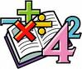](http://images.google.com.tr/imgres?imgurl=http://www.fotosearch.com/bthumb/UNC/UNC201/u21266601.jpg&imgrefurl=http://www.fotosearch.com/clip-art/maths.html&usg=__Nm6YT2slWdn2voDhRburOWWp3Vg=&h=143&w=170&sz=11&hl=tr&start=2&itbs=1&tbnid=c2qmGCsffn2BEM:&tbnh=83&tbnw=99&prev=/images?q=clipart+maths&gbv=2&hl=tr)A) 15 – 10 = five

B) 3 X 3 = six

C) 20 : 2 = ten

D) 6 + 1 = seven

**4)** Aşağıdaki cümleyi tamamlamak için

hangi seçeneği ***kullanamayız?***

**This is ………………..**

**school bag.**

A) Zeynep B) Ecem’s

C) Ata’s D) Ömer’s

**5)** Aşağıdaki kelimelerin hangisi yanlış

***yazılmıştır?***

**sutudent**

**book**

A) B)

**notebook**

**teacher**

C) D)

**6)**

F S C R A

A) Scarf C) Sfarc

B) Srcaf D) Srafc

**7. 8. 9. 10. 11. ve 12. soruları aşağıdaki aile ağacına göre cevaplayınız.**

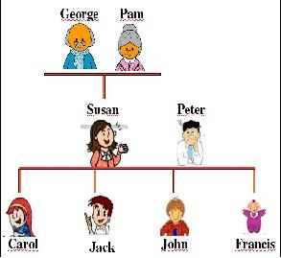

**7)** Carol is Jack’s ----------------

A) mother C) father

B) sister D) aunt

**8)** Susan is John’s ---------------

A) aunt C) mother

B) grandmother D) sister

**9)** George is Francis’s --------------

A) father C) uncle

B) brother D) grandfather

**10)** Peter is Carol’s ----------------

A) father C) brother

B) uncle D) cousin

**11)** John is Carol’s -----------------

A) sister C) father

B) brother D) uncle

**12)** Pam is Jack’s --------------------

A) grandmother C) mother

B) sister D) aunt

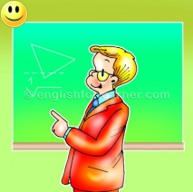**13)** Resimdeki sınıf kuralı hangisidir?

A) Close the window

B) Repeat after me

C) Stand up

D) Look at the board

**14)** What are these?

A)They are pencils.

B)It’s a pencil.

C)They are rulers.

D)It’s a ruler

**15)** She ____________glasses

A)has got B)have got C)is D)isn’t

**16) Resme göre yanıtlayınız.**



A) They are erasers. B) It is an umbrella.

C) They are umbrellas. D) It is an erasers.

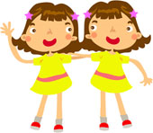

**17)**  ____is she?

She is my sister.

A)what

B)name

C)who

D)whose

**18)** A: Who are they?

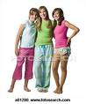 B: They ______ my friends

A) am

B) are

C) is

D) names

**19)** A: What is your uncle’s name?

B: _______ name is Ali.



A) His

B) Her

C) My

D) He

**20)** Boşluğa gelebilecek kelimeyi bulunuz.

It is a ________.

A) flag B) umbrella

C) eraser D) elephant

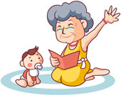**21)** Hangisi “Grandmother” ile aynı anlama gelir?

A) grandfather

B) grandpa

C) grand-daughter

D) grandma

**22)** My mother's brother is my ............

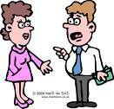

A) aunt

B) uncle

C) sister

D) father

**23)** Bu saatte ne söylenmelidir?

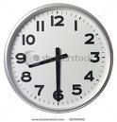

A) Good morning

B) Good evening

C) Good afternoon

D) Good night

**24)** “I miss you.” Türkçe karşılığı hangisidr?

A) Seni özledim

B) seni görmek güzel

C) iyi görünüyorsun.

D) Biraz dinlen.

**25)** “Seni görmek güzel” cümlesinin İngilizce karşılığı kangisidir?

A) It’s good to see you.

B) I miss you

C) I am happy to see you

D) They arfe fine