QUIZ FOR THE 4th GRADES

Name-Surname: Class: Number:
1- ……………….red and white, you get pink.
a)Mix b) Plant c) Stir c) Brush

2-What is “bilim adamı” in English?
a) bottle b) experiment
c) glass d) scientist

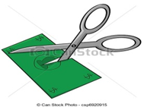
3- “…………….the paper”
cümlesinde boşluğa
hangi kelime gelmelidir?
a) Fold b) Water
c) Cut d) Put
I do …………………….
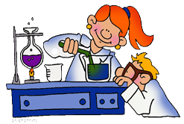
4-
a) homework
b) experiment
c) shopping
d) plant

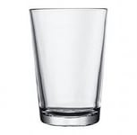
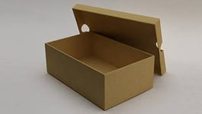
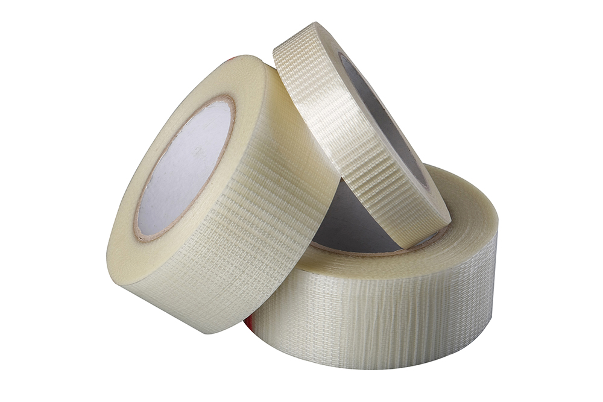
5-

Yukarıdaki resimlere göre aşağıdaki sıralamalardan hangisi doğrudur?
a) box – glass – bottle
b) glass – box – tape
c) plant – box – glass
d) brush – bottle – tape

6- A:Where is the ball?
B: It is ………the box.
a) on b) in
c) under d) behind

7- A: Where is the ball?
B: It is …………….the box.
a) in b) behind
c) in front of d) on

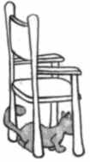
8- A: Where is the cat?
B:………………………………….
a) It is on the chair.
b) He is behind the chair.
c) She is next to the chair.
d) It is under the chair.

9- “behind – in front of – between” kelimelerinin anlamları hangi şıkta sırasıyla verilmiştir?
a) önünde – arasında – üstünde
b) arkasında – arasında – önünde
c) arkasında – önünde – arasında
d) yanında – önünde – içinde

10- “purple – blue – yellow – white – red”
Yukarıda verilmeyen renk hangisidir?
a)mor b) kırmızı c) sarı d) siyah
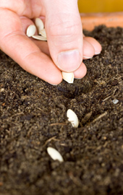
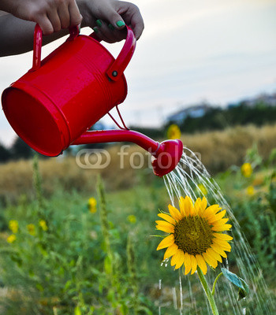
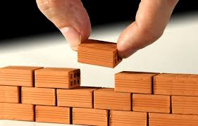
11-

Yukarıda resmi olmayan seçenek hangisidir?
a) put b) fold c) plant d) water
12:15
12- What time is it?
a) It is twelve, fifteen.
b) It is twenty, fifteen.
c) It is twelve, five.
d) It is fifteen, twelve.
13- What time is it?
9:30

a) It is half past nine.
b) It is quarter past nine.
c) It is nine o’clock.
d) It is quarter to nine.

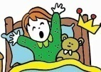
14-Aşağıdaki resim-cümle eşleştirmelerinden hangisi yanlıştır?

a) I get up early.
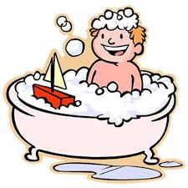

b) I have a shower.

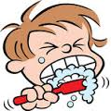

c) I wash my face.

d) I read a book

15- Resmi ifade eden seçenek hangisidir?
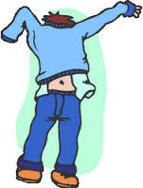
a) have breakfast
b) get dressed
c) wake up
d) go shopping

16- Can Ege swim?
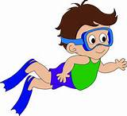
a)No, she can’t.
b) Yes, it can.
c) No, it can’t.
d) Yes, he can.

www.eegitimim.com

17- A: Can you ride a bike?
B: Yes,………………………….
a) he can. b) she can’t.
c) I can. d) I can’t.

18- “I like running” cümlesini hangi çocuk söylemiştir?
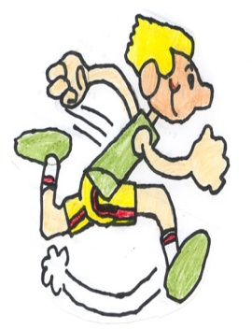
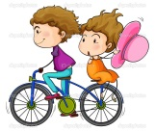
a) b)

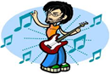
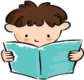
c) d) d)

19-Aşağıdaki eşleştirmelerden hangisi yanlıştır?
a ) Give me the pencil,please.= Bana kalemi ver lütfen.
b) May I take the eraser? = Silgiyi alabilir miyim?
c) Say that again ,please.= Tekrar söyle ,lütfen.
d) May I leave the classroom?= Sınıfta kalabilir miyim?

20) A:………………………………………?
B: I am from Turkey.
a) What nationality are you?
b) Where are you from?
c) Are you Turkish?
d) Where is Turkey?
GOOD LUCK☺☺☺

