_____________ İ.Ö.O
2014-2015 ACADEMIC YEAR-2 ^{nd} TERM
4TH GRADES-1ST EXAM
I-Fill in the blanks with do or does, please (Tabloda eksik olan yerleri do veya does ile doldurun.)
(5*4=20)
1-I ______ not drink coke.
2- ________ she like me?
3- He _______ not like cats.
4- _______ they swim?
5- It ______ not like sleeping.

II- Match the pictures. (Resimlerle harfleri eşleştirin) (10*2=20)
a-teacher b-chef c- singer d-vet e-doctor f-police g-firemen h- pilot i-farmer g- businessman

1 2 3 4 5 6 7 8 9 10
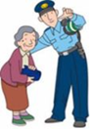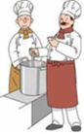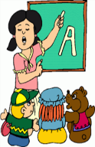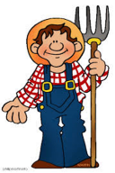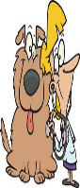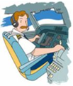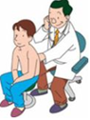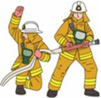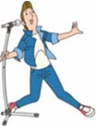
_______ _______ _______ _______ _____ ______ ______ ______ ______ ______

III- Where is the ball? Please use: near, in front of, on, in, under. (Boşlukları near, in front of, on, in, under ile doldurun) (5*4=20)
- The ball is _________ the box.

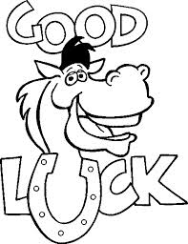
2- The ball is ________ the box.

3- The ball is _________ the box.

4- The ball is ________ the box.

5- The ball is _______ the box.

IV- Change the sentences , please. (Cümleleri değiştirin) (5*4=20)
1-Henry likes playing marbles.
(-) ____________________________________________.
(?)____________________________________________.
- We don’t like jumping.
(+)____________________________________________.
(?)____________________________________________.
- My fish doesn’t like swimming.
(+)____________________________________________.
V- Choose the correct answer. (10*2=20)

1-What time is it ? It is ___(01:15)
a-one fifty b-one fifteen
c-one forty-five d-one twenty
2-
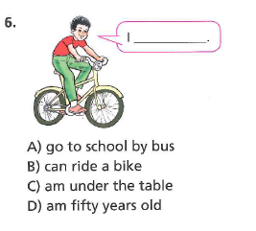
3-A: ________? B: No, I can’t.
a-Can your father drive?
b-Are you from Turkey?
c-Where is your cat?
d- Can you ride a horse?

4-What do you do at one p.m?
a-I wake up b-I get up
c-I have lunch d-I go to bed

5-Which is false? (Hangisi yanlış?)
a-Scientists do experiments
b- Police protect people
c- Farmers teach English
d-Nurses help doctors

6-Tom is a firemen. He works at a___.
a-fire station b-hospital
c-school d- farm

7-I am a pilot. _________.
a-I can’t fly a plane
b-He is from Turkey
c-She lives in Germany
d-I can fly a plane.

8-I protect the country. I am a _____.
a-doctor b-soldier
c-nurse d-architect

9- Do you like swimming?
a-No, he doesn’t b-Yes, she does
c-Yes, I do. d-No, they don’t

10- 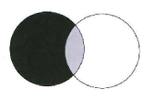
a-mix black and white b-fold the paper
c-cut the paper d-plant trees

